You As A Leader
Step 1: Leadership Quote
Find a quote online that inspires you as a leader. Print the quote in large font on 8 ½ x 11 paper (landscape). Be sure to include the person’s name under the quote. These quotes will be posted in the classroom. Your name can be written on the back.
Never doubt that a small group of thoughtful, concerned citizens can change world. Indeed it is the only thing that ever has.

—Margaret Mead

Step 2: Magazine Cover Assignment
You are going to create an imaginary magazine cover that features you as a leader!
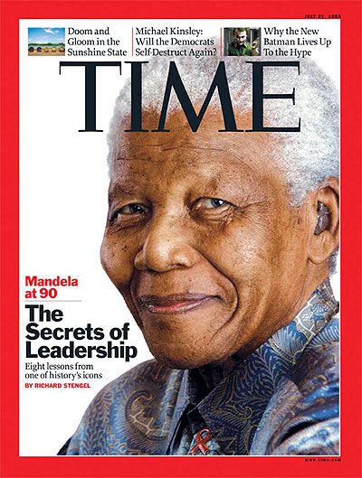

Scenario:
It is 10, 20, 30 or even 50 years from now and you are a recognized leader in the world! The magazine has chosen you for their cover. I would like you to imagine why they chose you. What qualities do you possess that they feel deserve to be highlighted? What contributions have you made to the world? How are you seen in the world? Remember that this is about you, so focus on your passions and how you would like to positively change the world.

You are to also answer 3 of the following questions:

- How did it feel to think about yourself in the future and on a magazine?
- What makes it difficult or easy to think of yourself as a leader?
- When you see a magazine cover with a well-known person, what distinguishes the person as a respected leader versus a celebrity?
- Do you think being on a magazine cover means the person is a leader? Why or why not?
- Why do you think many people believe a person has to do something monumental to be considered a leader?

Magazine Cover Criteria:

- One Page (one sided)
- Magazine Name (Masthead; ex: TIME, Newsweek, PEOPLE etc)
- Headline (the main article about you)
- Central Image (you)
- Other Feature Articles (other articles that are found in the magazine)
- Magazine Info (price, date etc.)
- Colour/Layout (should be clear and attract attention)
- Secondary Images (optional)

