Video Conferencing Guideline for Parents and Students

Permission
- Any participation in video conferencing with your teacher should have parental/guardian consent.
- You should not record or capture any part of the presentation.

Web Camera
- Consider your background and any personal information you will be displaying like photographs or personal items.
- Be careful of capturing other people in view of the web camera.
- Be careful of who can be overheard when your microphone is on.
- This is a school activity and you should be dressed appropriately.

Behaviour  - Be a respectful listener while a teacher or another student is speaking.  - Do not be a distraction to others.  - Your teacher is the moderator and will guide participation in the conference. | 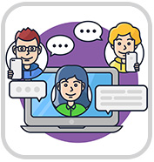
Etiquette
- Good practice is to turn off your video and microphone while someone is speaking.
- More than one speaker at a time can be difficult to understand.
- Set your microphone and speaker settings to appropriate levels.
- Come prepared and on time.

Chat
- The sidebar chat tools should be used only for classroom discussion.
- Language used in the chat should be safe and respectful to others.
- Use proper sentences and avoid ‘texting’ or ‘social media’ style chat.

