How to repair/upgrade Office 365, April 22, 2020
This process should fix problems with office Apps, update O365 to our latest available version and install Teams (if it was missing). Click on start button, go to settings, apps, apps and features.
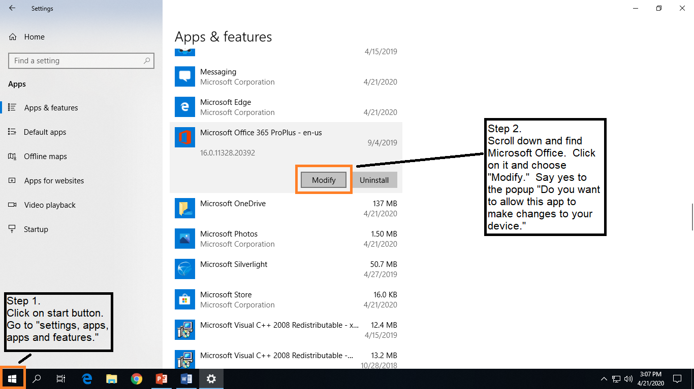
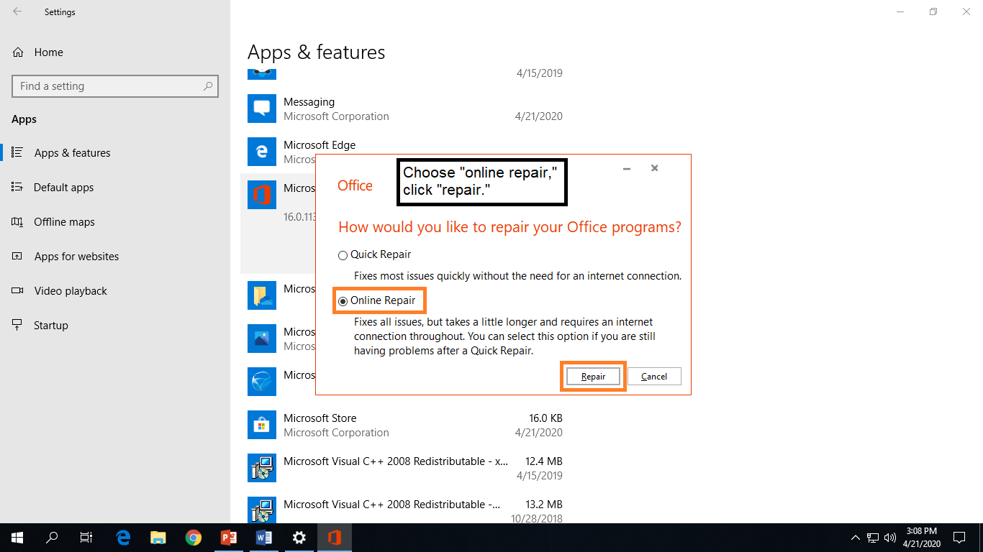
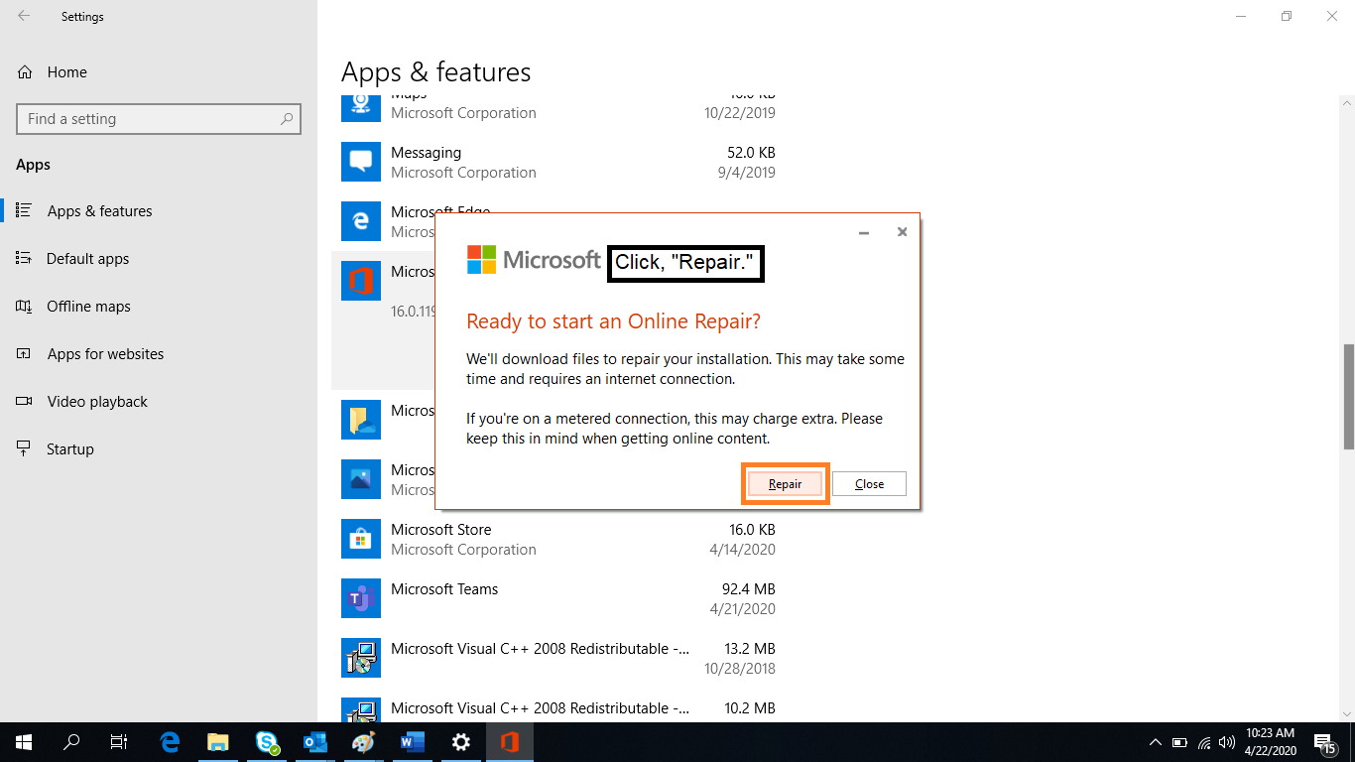

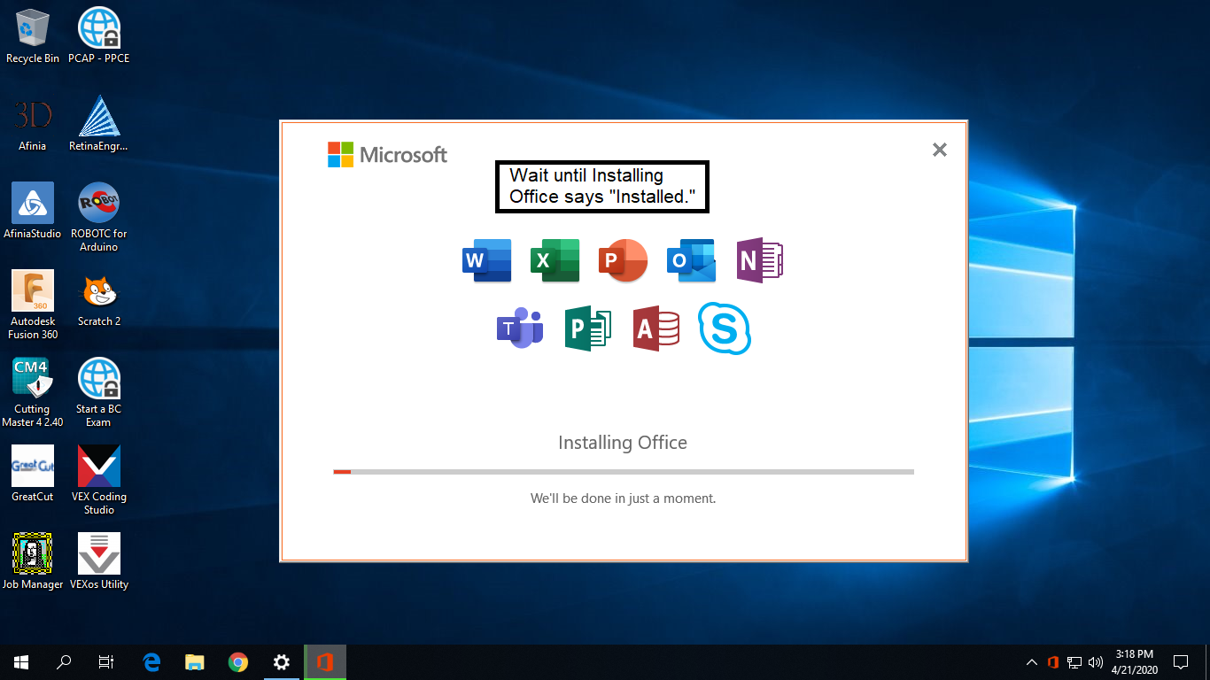
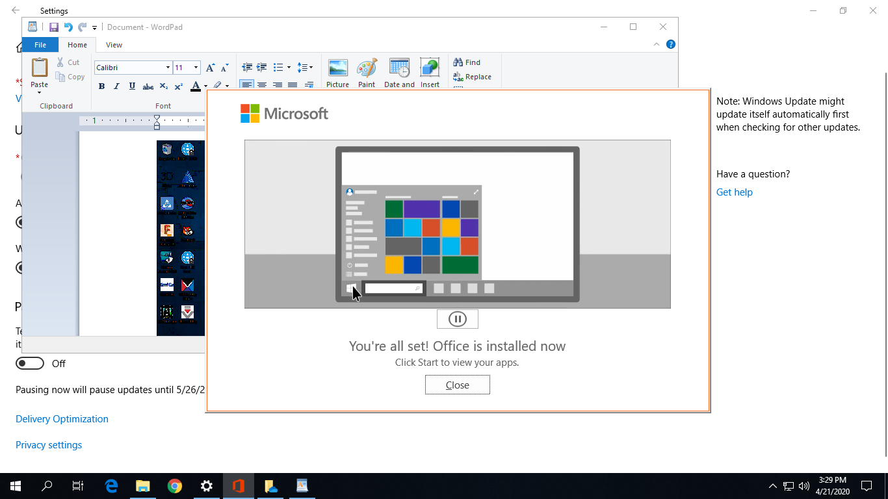
JA, April, 2020.

