Biology Inquiry Poster Including Infographic (v.17.1)
A Personal Interest Project
Overview
Poster presentations are a common and professionally accepted method to present initiatives and findings. Your poster project is an opportunity to think deeply about a topic you are interested in and develop expertise on a topic related to biology. It will be displayed publicly in the form of a polished poster.
You may work individually or with a partner, but make sure you choose an equal partner.

Steps of the Project and Timeline
STEPS 1, 2 AND 3 REQUIRE DOCUMENTATION:
- LOG EVERYTHING AND PROVIDE EVIDENCE. THIS WILL ACCOUNT FOR 20 MARKS.

Step 1: Brainstorm – Find your interest.
- Early research.
- Do some reading. Read a variety of articles related to current events in biology.
- Watch good documentaries like The Nature of Things, listen to a radio program like Quirks and Quarks
- Read articles from Ms. P’s World of Science, Current Events.
- Write about it in your notebook.

DEADLINE: ______________

Step 2: Narrow it down.
- Commit to a topic.
  - Select a topic with sufficient depth.
  - MAKE SURE IT IS OF INTEREST TO YOU.
- Nail down a specific topic.
  - Too broad: Climate change
  - Narrower: What effect will climate change have on the lower mainland?
  - Specific: How will a 2 degree Celcius increase in temperature affect local plants / farming?
- Come up with a THICK QUESTION. This may evolve as you do more research.
  - Examples of THICK QUESTION starters: What are some ways . . . , What if . . . . If . . . then, How might . . .
- Get feedback from peers.
- Write about it in your notebook.
- EARLY GALLERY WALK OF IDEAS WITH PEERS.

DATE: _________

Step 3: Research – Dig deeper.
- Analzye your topic. Go beyond the text.
- Speculate, hypothesize, or make inferences. Analyze, critically examine, and appraise the information presented by recognizing what is missing or only implied.
- Use at least ONE Tier 1 resources. (see below) and no Tier 4 resources.
- Write about your findings in your notebook. Notes are fine at this point.
- Begin a “Works Cited” Word document using EasyBib for the correct formatting. This will later be pruned as you eliminate sources not actually used in your final product.

ONGOING

Step 4: Synthesis – Put it all together.
- Consider what your poster will look like. Keep in mind who your target audience will be and the goal of your presentation.
- Draft your text (kept to a minimum) and infographic. This will be handed in and should appear on your poster.
  - NEW THIS YEAR. Include an ORIGINAL infographic as part of your poster.

WRITTEN WORK AND VISUALS DUE DATE: _________

Step 5: Create Your Poster and Supplementary Material
- Format your poster in Powerpoint or Word with the following dimensions:
  - WIDTH = 61 cm, HEIGHT = 91 cm. This will allow printing at the School District print shop.
  - Font should be readable from 1 metre away. Test this by setting your poster size to 100%, step back, and see if you can read it.
  - Try to use the 40/20/40 rule: 40% graphics, 20% text, 40% blank space.
- Save as a PDF.
- Bring your PDF to class on a memory stick. The PDF will be transferred and your memory stick returned. There is a $3 charge for printing at the time you hand in your PDF.
- Supplementary material is material that does not fit on your poster. It is available for reference during your presentation. It should be formally written and presented.
- Create the final version of your “Works Cited” by pruning unused references.

Step 6: Presentation Days
- You will present your poster to multiple audiences which may include: your peers, other teachers, ELL classes, elementary students, parents, district guests, your teacher.
  - You will need to tailor your presentation to fit the audience.
- Presentations should be approximately 3 minutes long, reference your visuals be engaging.
  - Watch “Giving an Effective Poster Presentation”
https://www.youtube.com/watch?v=vMSaFUrk-FA.

POSTER CONFERENCE DATES: _________ _________ _________

Step 7: Submit Journey, References, Supplemental Materials, and Self-Evaluation
- Submit your notebook, documenting your journey throughout the project.
- Submit your “Works Cited” in APA or MLA format. (Use EasyBib.)
  - AN ASSIGNMENT SUBMITTED WITHOUT REFERENCES WILL NOT BE MARKED.
  - BEWARE OF COPYRIGHT AND PLAGIARISM. CREDIT ALL IMAGES USED. DOCUMENT ALL SOURCES.
- Submit a self-evaluation, thoughtfully completed.
  - This self evaluation will be deeply considered in your final grade for this project.

NOTEBOOK, REFERENCES, SELF-EVALUATION PACKAGE DUE DATE: _________

- Your finished work must be original, based on your thinking, research, analysis and unique insights. You cannot just regurgitate information. This would be too easy for you and would not challenge your mind. Use higher order thinking skills. Analyze, synthesize, evaluate, and create!
- Present relevant information that supports the answer to your question.

Finding Suitable References
Tier 1 - Primary Sources
- Scholarly sources.
- Published summary of the original research.
- Includes academic papers written by the researcher that appear in a professional peer reviewed journal. Example:
- To find primary sources use Google Scholar or other such search engines.
- May also include an interview with an expert.
- Primary sources enable you to work with the raw material and to draw your own conclusions.
- Author is an expert in the area.
- Article is current.
- Solid CRAAP TEST score.
Tier 2 – Secondary Sources A
- Reputable sources: academic (university) or government (ex. Centres for Disease Control, Statistics Canada, World-O-Meters)
- Published on a university website with the URL ending “.edu” or “.gov”, NOT “.org” or “.com”.
- Author is an authority in the area.
- Article is current.
- Solid CRAAP TEST score.

Tier 3 – Secondary Sources B
- Reputable authoritative sources.
- Created for the interested masses.
- Examples:
  - Science Magazines: Scientific American, New Scientist, Discover, National Geographic;
  - WebMD – author specialist;
  - Newspaper if written by a specialist.
  - You Tube videos or TED Talks by authoritative sources.
  - Wikipedia article, if substantiated by Tier 1 or Tier 2 references. Check the author’s authority.
- Author is an authority in the area.
- Solid CRAAP TEST score.
- Beware: Secondary sources are further removed from the research and may reflect the author’s biases or a hidden agenda.
Tier 4 – Secondary (or Tertiary Sources) C
- Blog with no author or written by a non-expert.
  - YouTube videos from sources with no authority or pseudo-authority.
- Newspaper article, if not written by a specialist.
- Reason not to use them: Too much opportunity for bias or misinterpretation of primary or good secondary sources.

Assessment Rubric 2017.1
EVIDENCE OF YOUR JOURNEY | Evidence and log are available showing the process that led to my final product. This includes  - An organized log and / or narrative showing sequence of your research process and synthesis of your product.  - May in include brainstorming, topic chooser, rough work; Research and note-taking  - Development of a “thick question”  - All deadlines met. | Comments:
 | Sophisticated (20) Acceptable (15) Very Basic (5) No Evidence (0)
RESEARCH QUALITY | - Excellent information selected  - Answers the thick question fully and supports your conclusion.  - Critical thinking evident  - Includes relevant background information. | Comments:
 | Sophisticated (25) Acceptable (15) Very Basic (5) No Evidence (0)
COMMUNICATION OF LEARNING  How well I shared what I found out. | Oral presentation quality  - Articulated clearly in your own words.  - Correct posture  - Clear speaking (not reading)  - Good volume.  - Adjusts to audience.  - Able to answer probing questions related to topic.  Visual work quality  - Written in your own words  - Neat, legible, attractive  - Correct spelling and grammar  - Poster is 40% graphics, 20% text, 40% blank space. | Comments:
 | Sophisticated (20) Acceptable (15) Very Basic (5) No Evidence (0)
DATA BASED INFOGRAPHIC | *Original infographic has a main idea.  *Data supports the main idea.  *Graphics enhance and support the data.  *Layout and design has a purpose; graphics and text effectively communicate your ideas.  *Source of Data cited right on the infographic. | Comments:
 | Sophisticated (20) Acceptable (15) Very Basic (5) No Evidence (0)
LAYOUT OF POSTER | - Sequence and layout add to the quality of the presentation.  - Effective use of headings/ subheadings / diagrams / colour /props / pictures / labels / extras  /10 | Comments:
 | Sophisticated (10) Acceptable (7) Very Basic (5) No Evidence (0)
QUALITY  OF RESOURCES* | - At least ONE Tier 1 reference.  - At least 8 references.  - All references are from quality sources and are CURRENT.  - All references pass the CRAAP test. | Comments:
 | Exceeds Expectations (20) Meets expectations (15) Very Basic (10) No references** (0)
WOW factor  (More likely ideas, not sparkles.) | - You’ve surprised observers by adding something extra that makes them go “WOW”.  - Extras that make the presentation richer are included | Comments:
 | Sophisticated (5) A bit of wow (3) No Extras (0)

Poster Format

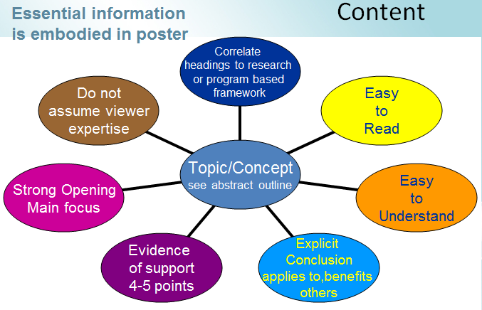

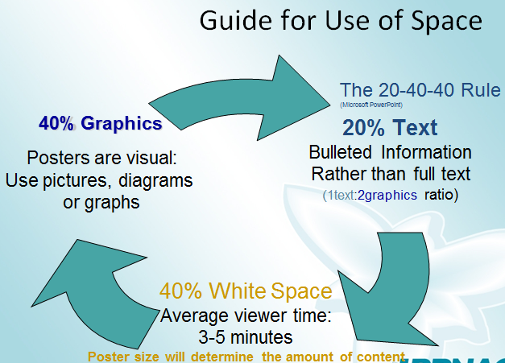
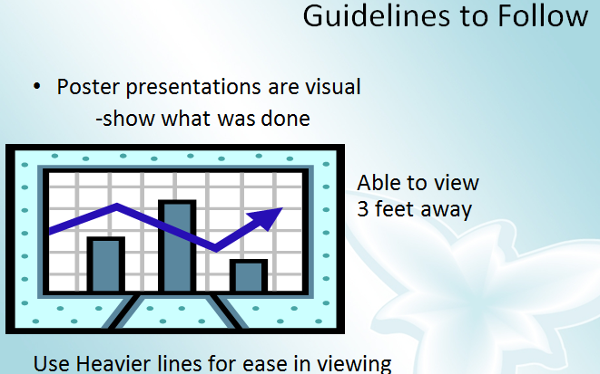

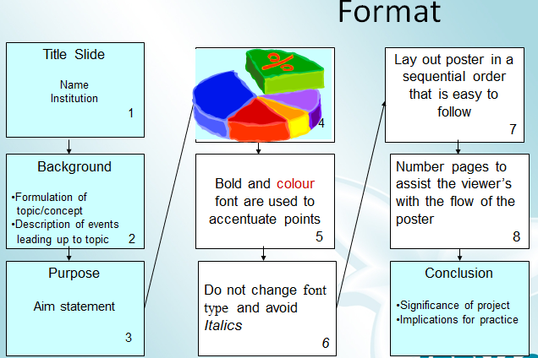

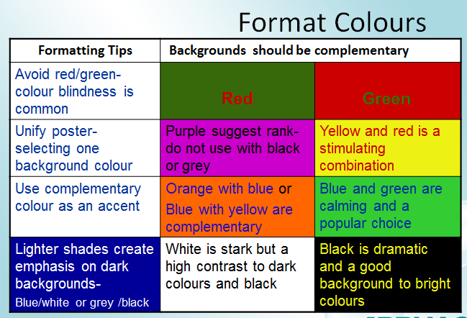

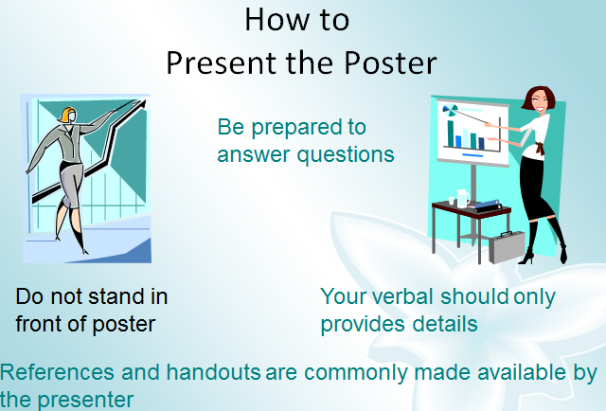
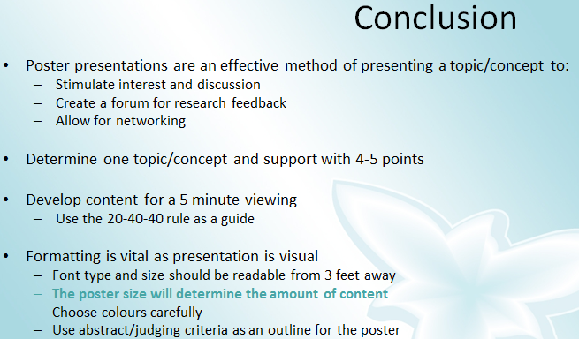
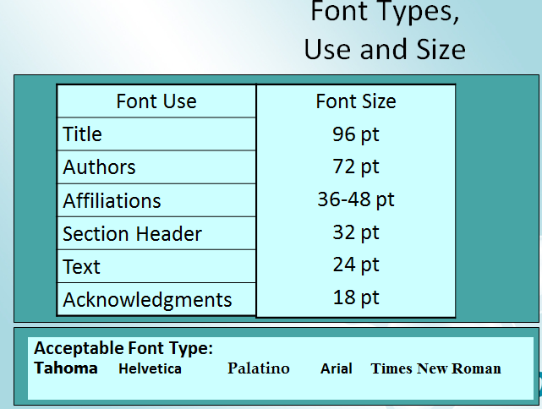

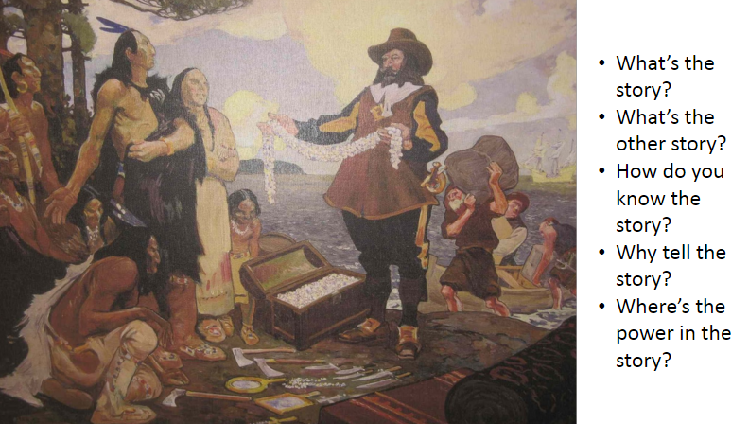

Review the criteria to include the required elements:
    - Content
    - Format
    - Presentation

Project Checklist (modify)

The professional development provider: | Observed?
 | Yes | No
Preparation
- Provides a description of the training with learning objectives prior to training
- Provides readings, activities, and/or questions to think about prior to the training
Introduction
- Provides an agenda before or at the beginning of the training
- Connects content to participants’ context (e.g., community, school, district)
- Includes the empirical research foundation of the content (e.g., citations, verbal references to research literature, key researchers)
- Engages the participant in a preview of the content (e.g., material, knowledge or practice)
- Builds on or relates to participants’ previous professional development
- Aligns with school/district/state standards or goals
- Emphasizes improving student learning outcomes
Demonstration
- Builds shared vocabulary required to implement and sustain the practice
- Provides examples, demonstrates, or otherwise illustrates the content/practice
- Illustrates the use or applicability of the material, knowledge or practice for the participant
Engagement
- Includes opportunities for participants to practice and/or rehearse new skills
- Includes opportunities for participants to express personal perspectives (e.g., experience, thoughts on concept)
- Includes opportunities for participants to interact with each other related to training content
- Adheres to agenda and time constraints
Evaluation
- Includes opportunities for participants to reflect on learning
- Includes discussion of specific indicators—related to the knowledge, material, or skills provided by the training—that would indicate a successful transfer to practice

Will Davis, Biology instructor and MESA Director: Change the World BIO 300 assignment
So, you learned something. Now what? For students in my Foundations of Biology class, hopefully the “now what” is they are going to change the world. Realistically, they can at least voice their opinion to someone who may make a change.
Throughout much of the semester, students individually investigate a biological topic of interest to them, and then apply their knowledge by writing a convincing and knowledgeable letter to a decision maker. Who receives the letter depends upon the issue, but common choices are local or regional elected officials, government agency representatives, an advocacy organization such as the American Cancer Society or Sierra Club, or a private organization such a Procter and Gamble or Exxon Oil Co.
The assignment has three parts. First they gather the information and compile it into a draft report that addresses the biological topic only and does not include personal opinion or recommendations for action. As a class we attend a library orientation in which the reference librarian focuses specifically on this project, so they have knowledge of the library and its resources. They receive feedback from fellow students and from me on their report draft, then they revise the draft to produce a final report. Finally, based on the expertise developed while producing the report, they craft a persuasive letter. The letter provides a reasoned and accurate explanation of the biology involved and includes their personal position and specific recommendation(s) for action. A response to their letter is requested.
When students turn in a copy for me to grade, they also turn in a signed original in an addressed envelope. I tell them that it will be mailed, but when I return the graded letter, I leave the stack of envelopes on my desk and announce that if they do not want it mailed, just take back their letter. Seldom do students not want their letter mailed.
Many students have reported to me about a received response. Most are simple acknowledgement letters, but there have been a good number of students who have contacted me, amazed that they received substantive responses. One student was invited to attend a conference, another promised a copy of a soon to be issued report, and several have been told their comments would be considered in the development of future reports.
The November/December issue of the Journal of College Science Teaching landed in my mail this morning, and it includes an article titled “Civic Engagement in the Science Classroom”. Letter writing, voting, and volunteering with civic organizations are identified as ways students can engage. Margaret Mead is quoted as saying “Never doubt that a small group of thoughtful, committed citizens can change the world; indeed it is the only thing that ever has.” Too many student assignments eventually end up in the student’s trash can. Why not have them end up as a letter in someone else’s trash can? Or, just maybe, they end up changing the world.

With your teacher you will develop a plan using the planning document sheets.
You will develop a program that clearly shows what you will learn and do and the steps you will take throughout the process.
You will outline how you will learn and ultimately how you will know you have achieved success.

Assessment

Next Your project will be assessed by a number of people.
Assessment is an opportunity to get feedback and to reflect on your learning. It is an opportunity for growth.
With this in mind you will be given the opportunity to reflect formally on your own work, you will provide your peers with feedback and your teacher will also assess your work. STICKY NOTES DURING GALLERY WALK.
There will also be an opportunity for you to get feedback from our gallery walk visitors.

Timeline:

Your project must be completed before lunch time on Friday the 23rd of November.
The gallery walk is on Friday the 30th of November. You will have time in the week prior to the gallery walk to work on creating an amazing display for your work but all projects MUST BE COMPLETE by the 23rd.
This means you have 7 weeks. You have about 5 hours a week to work on your project but plan for about 3.5 - 4hours a week to allow for time if you get sick or things go wrong.
REMEMBER: It is called a Personal PASSION Project because you should be passionate about it. Make sure you pick a topic that will sustain your interest for 7 weeks.
Important Dates What is it? Some Ideas: What would Ansel Adams do with a digital camera? William Shakespeare meets the iPhone;
telling stories in a digital age. My great story. A tale of two cities and vampires. Indigenous Pop Art Why fads fail or what happened to my YoYo Reinventing the... Toy trends throughout time and into the future. A plan for the city of the tomorrow. How to turn waste to wonderful What ads say about us.

Who is on your biology dream team?
Darwin meets Mendel at a dinner party.
What would Rachel Carson say at the Paris climate conference?
What would Rachel Carson say to Al Gore
What would Darwin say about climate change?
Why go to Mars?
A sustainable plan for the city of the future.
What will the world be like without fossil fuels?
What if biological organisms weren’t patentable?
Is therapeutic fecal matter a drug or a tissue?
Who should own your body fluids?
What are some other ways . . .
What if you . . .
Can you imagine . . .
If . . . , then . . .
How might . . .

What are the steps to improving the climate?
What are the barriers to climate improvement?

Another time (lots of marking):

