Why do leaves change color?

-because it’s fall (Jaycee)
-sun (Mei)
-the sun shines through the trees and changes their colors (Max)
-the sun hits them and they get all crumbly (Georgia)
-because they fall down (Miliana)
-because it’s fall (Kais)
--it’s fall and the sunshine goes on the leaves and it crumbles and they fall off (Jaycee)
-sunlight hits in the fall (Megan)
-cause it’s too much cold outside and the wind blows the color away and then a new color comes (Arnav)
-the sun shines to the leaves cause the sunlight gives the leaves orange (Russell)
-the leaves slowly changes color because when it’s cold (Sahara)
-maybe the leaves change color that makes them warm (Arnav)
-because it turns dirty (Niko)

Our Experiment
Step 1: Put the leaves in the beakers.

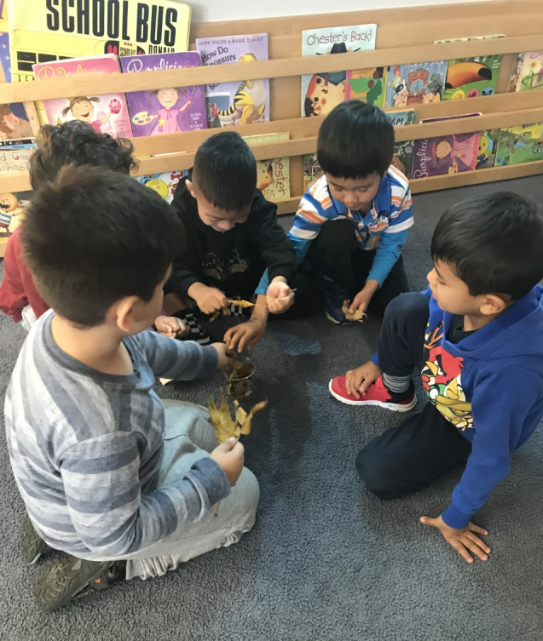

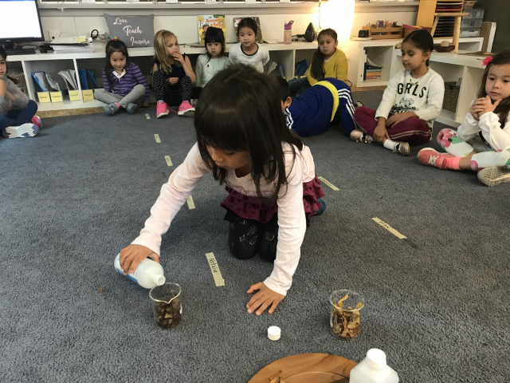
Step 2: Add the rubbing alcohol.

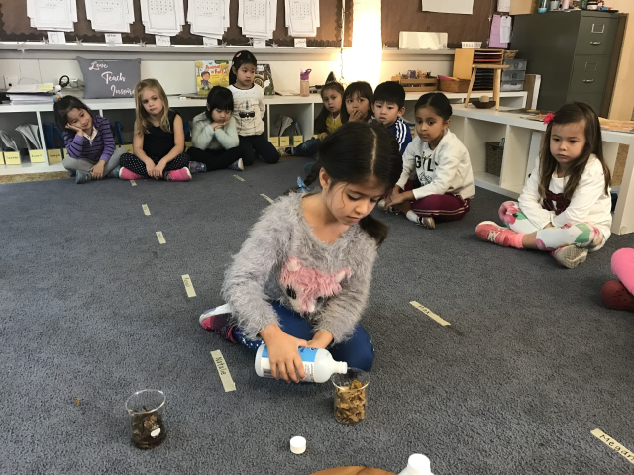
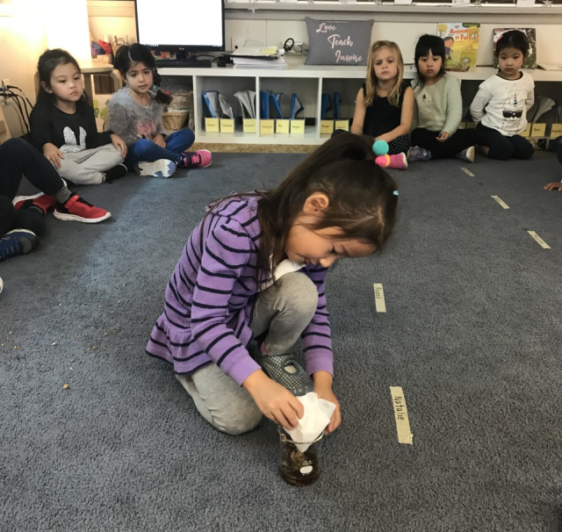
Step 3: Add the coffee filter and wait.
