English
Hello

French
Bonjour

Arabic
marḥabanمرحبا

Tagalog
Musta?
Kurdish
Sillaw

Hindi namaste
नमस्ते
Punjabi
sat srī akāl
ਸਤਿ ਸ੍ਰੀ ਅਕਾਲ।
ست سِر اَکال

Croatian
Bok
Spanish
¡Hola!

Mandarin Chinese
nǐ hǎo
你好
Tibetan
tashi delek
བཀྲ་ཤིས་བདེ་ལེགས།

Japanese konnichiwa
今日は
Turkish
Merhaba

Greek
Ya
Γειά!

Dari
As-salâmo 'alaykom
ااسال م عليكم

Cantonese
néih hóu
你好
Korean annyeonghaseyo
안녕하세요

Portuguese
Olá

Vietnamese
Chào anh

Albanian
Ç'kemi

Indonesian
Apa kabar?

Swahili
Habari

Russian Zdravstvujte!
Здра́вствуйте!

Ukranian
Vitayu
Вітаю
Serbian
Zdravo
Здраво

Cree
Tanisi
ᑕᓂᓯ
Squamish

Nú, chexw men wa ha7lh?

Nú (to close friends)

Halkomelem
spoken by Musqueam and Tsleil-Waututh people

kwéleches

Farsi
Salam
سلام

Did you know that there are about 7,000 languages in the world?

Source: Ethnologue – SIL International
https://www.ethnologue.com/
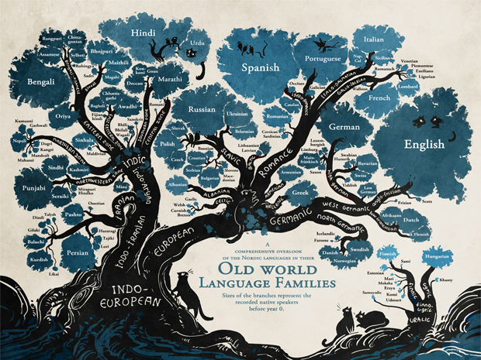
Many can be grouped into families of languages.

Source: Linguistic Society of America
https://www.linguisticsociety.org

