Orange Shirt Day Vocabulary
Group 1 | Group 2 | Group 3
angry  care  Canada  English  goodbye  heart  hurt  Indian  matters  orange  sad  school  shirt  sick  sorry  study  take off  to be taken away  wear | Aboriginal  apology  culture  experience  First Nations  government  healing  heritage  history  honour  identity  important  Indigenous  language  memories  remember  residential schools  tradition  understand | 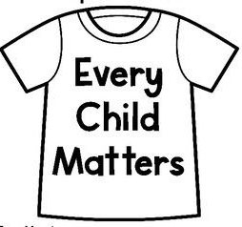  advocacy  assimilation  conformity  forced labour  humiliation  intergeneration  justice  reconciliation  shame  truth

