Phylogenetic Tree: a branching diagram that represents the evolutionary history of a group of organisms.
Bio12 AP Phylogeny and the Tree of Life Name: ______________
Chap 26 Bozeman Phylogenetics- https://www.youtube.com/watch?v=fQwI90bkJl4 Date: ___________
pg 538- & Cladograms https://www.youtube.com/watch?v=ouZ9zEkxGWg Block: ___
-each branch point or “clade” represents a divergence from a common evolutionary ancestor-branch lengths can be proportional to the amount of evolutionary change or to the amount of time.
-Phylogenies are inferred from homologies body structures, genetic, biochemical, and/or early embryological similarities due to common ancestry.
Cladograms do the same thing but with less “bells & whistles” and do not show time in proportion to clade length.
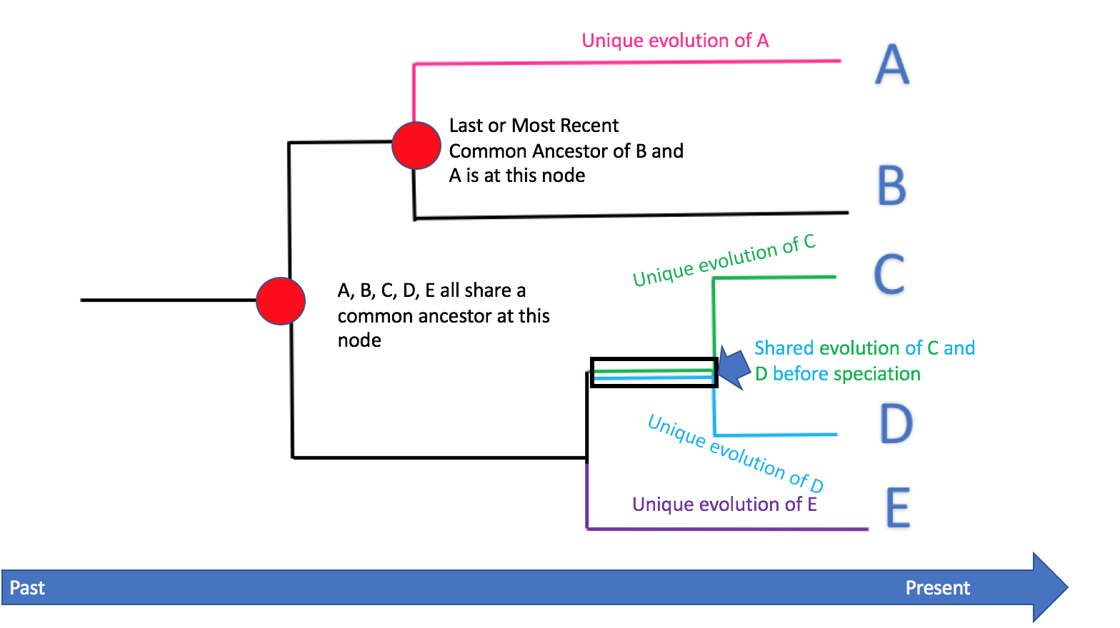

Molecular systematics- the discipline that uses data from DNA and other molecules to determine evolutionary relationships has transformed phylogeny!
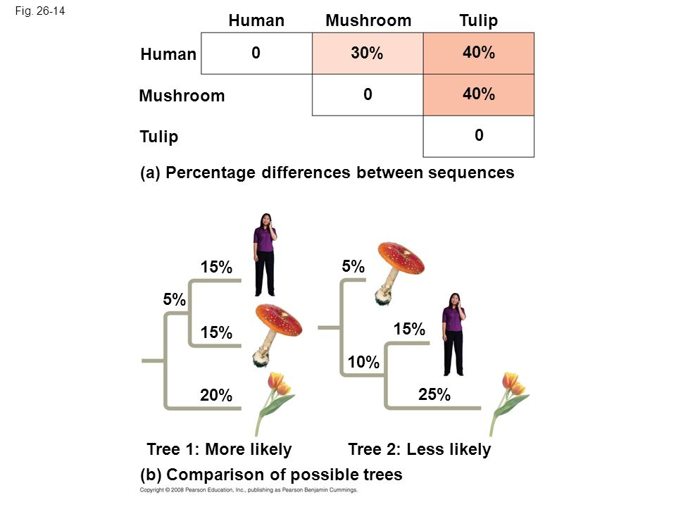

Principle of Maximum Parsimony
Identify the hypothesis/ tree that requires the fewest evolutionary events (molecular changes) to have occurred
this is the most parsimonious

Principle of Maximum Likelihood
Apply probability rules to DNA changes to find a most likely tree
