In all organisms, certain genes are expressed at any given time while other genes are not. Both prokaryotes and eukaryotes regulate gene expression at the______________________ stage. However, the greater _________________ of eukaryotic cells makes it possible for gene expression to be regulated at many other stages as well.
Bio12AP Regulation of Gene Expression in Eukaryotes Name: _____________
Sec 18.2 pg 356 Date: _____________

There are multiple points where a Eukaryotic gene expression can be regulated
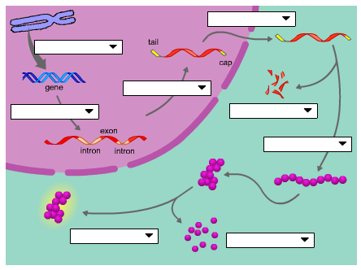
Let’s talk about a couple of them…
- Regulation of Chromatin Structure
The packaging of DNA:
Histones
- a small protein with an overall __________charge that bind __________DNA in the chromatin structure

Nucleosomes
- a bead like unit of DNA, consists of DNA wrapped around ___________.

DNA methylation
The addition of ____________groups to DNA which causes DNA to be more _______________ and reduces gene expression
Histone Acetylation
Acetyl groups are added to amino acids of __________________and makes the chromatin less tightly packed and ____________________transcription.

2. Regulation of Transcription Initiation

DNA control elements that bind transcription factors are involved in regulation. (page 359 Campbell)
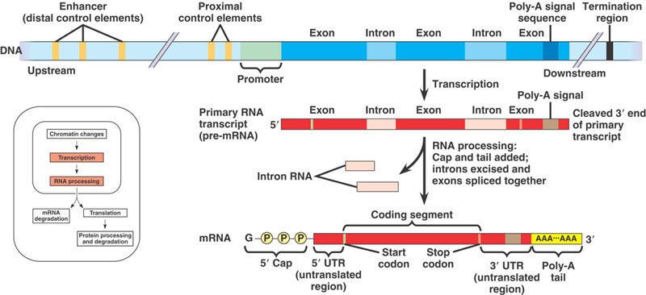
Transcription Factors:
- a regulatory proteins that bind to__________ and affects transcription
Transcription Initiation Complex:
- the completed assembly of _________________and ________________bound to a promoter
Enhancer Regions:
- DNA sequence__________ from the gene, contains control elements
Activators:
- bind to certain ________________and __________________to form initiation complex
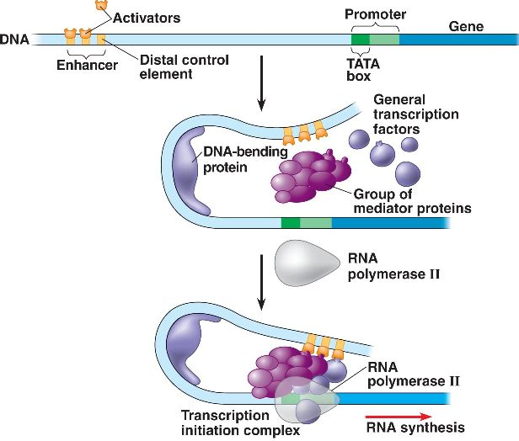
3. Post Transcriptional Regulation
Occurs after transcription and just after translation, when proteins are processed.
example: micro RNA (miRNA) and small interfering RNA (siRNA) can bind to _________and degrade the mRNA or bind to mRNA and block its ___________
Protein Degradation
A___________________, an enormous protein complex shaped like a trash can, chops up unneeded proteins.

Epigenetic inheritance
These chromatin modifications do not entail a change in the DNA ___________ however, they may be _________________in future generations of cells. This is called epigenetic inheritance. The DNA sequence is not changed, just its ____________________.

