Biology 12AP : Fruit Fly Genetics Lab
Name: _____________
Date: _____________
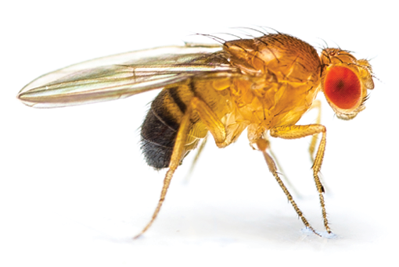
Adapted from: https://cb.collegeboard.org/ap-course-audit/courses/pdfs/cb-biology-lab-manual-1-24-12.pdf

Background Information: Drosophila melanogaster is a fruit fly, a little insect about 3mm long, of the kind that accumulates around spoiled fruit. It is also one of the most valuable of organisms in biological research, particularly in genetics and developmental biology. Drosophila has been used as a model organism for research for almost a century, mainly because it is practical: it’s a small animal, with a short life cycle of just two weeks, and is cheap and easy to keep in large numbers. Wild Type refers to flies that have the ‘normal’ characteristics, red eyes, normal length wing and brown bodies shown as w+. Mutant flies are those with defects in any of several thousand genes are available, and the entire genome has been sequenced. Mutant flies refers to any variation from the wild type (w). Mutant alleles can be carried on autosomes or sex chromosomes.

Reminder: For genetic problems, your null hypothesis is that there will be no difference between the predicted phenotype ratio that is found with a Punnett square and the actual phenotypes seen in experimental data.
Your Mission: Follow the instructions in this handout and prepare a separate Lab Report
You will be assessed on your data tables, observations & analysis (application of Chi Square) and 3 written discussion questions. On a separate sheet of paper your lab report should include the following:
Title, Purpose, Procedure & Materials- (write refer to handout) Data & Observations (follow the lab instructions for parts A, B, and C and create clearly numbered and titled data tables & observations wherever the lab instructs you to) Record any written question answers for part A, B, C under clearly labeled headings in this section too. Discussion: record your answers for part E and the written discussion questions in this section
Procedure
Part A: Sexing Fruit Flies: https://www.biologycorner.com/fruitflygenetics/sex.html
- Anesthetize and then click on the flies to see the gender. Look at their stripes. Describe the differences between male fruit flies and female fruit flies. Record the male and female numbers in a data table you create under Data & Observations

Part B: Cross 1
Wild Type Female x Vestigial Winged Male: https://www.biologycorner.com/fruitflygenetics/flash1.html
- a) Describe the difference in the dominant wild type and recessive vestigial wings.

b) Cross the parent generation and then cross the F1 generation. Record the results of your F2 Generation in a table you create under Data & Observations

- How are vestigial wings inherited (autosomal or sex linked)? Why do you think so? Record your answer under Data & Observations

- Prove your prediction using a Chi Square Analysis. Use the numbers from Cross 1 and show the following under Data & Observations: a)Write a null and an alternate hypothesis, show all of your work in a table format, include a final statement whether you should reject or accept your null hypothesis.

Part C. Cross 2 White Eye Female x Wild Type Male: https://www.biologycorner.com/fruitflygenetics/flash2.html
- Notice the difference in eye colour. Mate the parent generation. Then mate the F1 generation. What are your expected results (include a Punnett square)? What are your experimental results? Record this in a data table.

- What is the genotype of the F1 generation? How do you think that eye colour is inherited (autosomal, sex linked or something else)? Record your answers under data and observations

- Prove your prediction using a Chi Square Analysis. Use the numbers from Cross 2 and show the following under Data & Observations: Include a null and an alternate hypothesis, show all of your work in a table format, and include a final statement whether you should reject or accept your null hypothesis.
Part D. Cross 3
Wild Type Female x Vestigial Winged Aristapedia Male: https://www.biologycorner.com/fruitflygenetics/flash3.html
- Note what the parent flies look like (difference in wings and antennae). Mate the 2 parent flies. Notice that the F1 generation all look alike, showing only the dominant trait. Then mate the F1 generation and record the observed F2 results in a table you create.

- What is the genotype of the F1 generation parents and how is aristapedia and vestigial wings inherited (autosomal or sex linked or….)?

- Prove your prediction using a Chi Square Analysis. Use the numbers from Cross 3. Include a null and an alternate hypothesis, show all of your work in a table format, and include a final statement whether you should reject or accept your null hypothesis.
Part E: Complete the Lab Bench Activity: Genetics of Organisms online practice with answers provided http://www.phschool.com/science/biology_place/labbench/lab7/intro.html
The multiple choice questions on the online lab are included below. Please record your answers on your lab report under Discussion Part E as well. At the end correct your work and show your corrections. You will not be penalized for making any mistakes so don’t avoid showing where your corrections were made. Don’t forget to answer the three final discussion questions in full sentences.

- Is fly “A” male or female? 2. Is fly “B” male or female? 3. Is fly “C” male or female?
4. Is fly “D” male or female? 5.Is fly “E” male or female?
Case 1
- Base on the data obtained, is this cross a monohybrid or a dihybrid?
- Is the cross sex-linked or autosomal?
Case 2
- Based on the data obtained, which is the most likely mode of inheritance in Case 2? Autosomal or Sex-linked?
- From the data presented, determine the genotype of the parental generation + = wild type (red eyes) W = white eyes
- X⁺X⁺ × X⁺Y
- X⁺X^{w} × X⁺Y
- X⁺X⁺ × X^{w}Y
- X^{w}X^{w} × X^{w}Y

Lab Quiz Qs
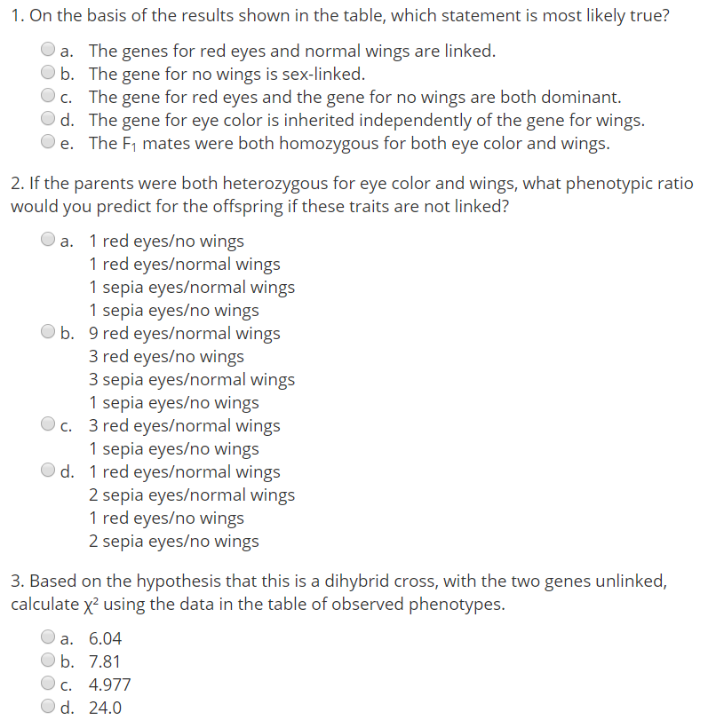
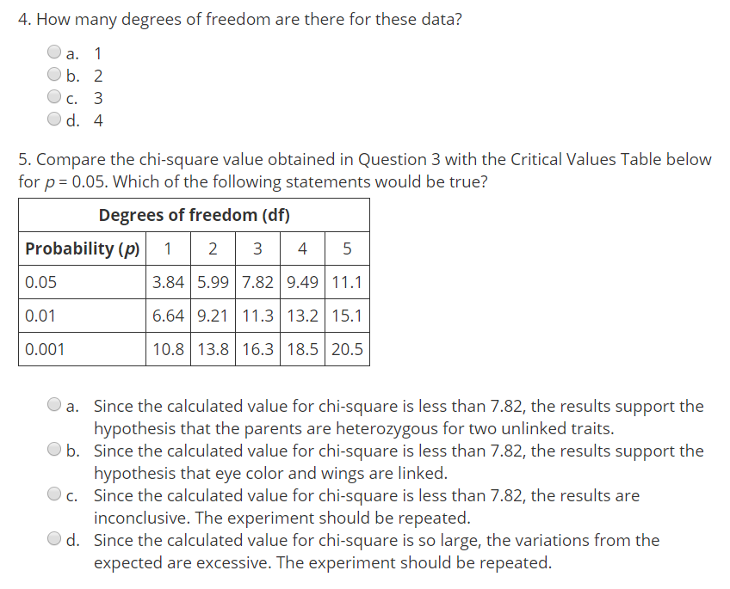
Written Discussion Questions: Record your answers under Discussion on your Lab
- Why are fruit flies a good subject for genetic studies? Why did we not use them here then?

- Why is Mendel’s law of Independent Assortment not always valid for two or more phenotypical traits?

- Describe how crossing over results in genetic recombination and infers in the relative position of a set of linked alleles based on recombination frequency.
 | Emerging | Developing | Proficient | Extending
Data Observations & Analysis | - Major gaps in data tables  - calculation work is missing  - Improper units  - Difficult to follow/work not shown | - Most data tables included but missing some data  -Tables lack numbers & titles  -Some minor calculations missing  - Some minor errors in units  -Missing some Qs | -All tables completed with titles  - Calculations complete with proper units  -observation & analysis questions completed | - Data tables are very well ordered and easy to follow with numbers and titles  -all calculations, complete & accurate with proper units  -observation & analysis questions completed with strong reasoning
Discussion | - Point form  - Answers are incorrect or incomplete | - Poor sentence structure(fragments)  - All answers demonstrate a minimal understanding of concepts | - Full sentences  - All answers demonstrate a complete understanding of concepts  -Details included | - Clear communication through structured sentences that connect one idea to the next  - All answers demonstrate a thorough, in depth understanding of concepts  -Strong reasoning and supporting details used to enhance answers

