Bio12AP- Alterations of Chromosome Number or Structure Name: _____________
Sec 15.4 Cause Some Genetic Disorders Date: ______________
Pg 297 Block: ___

Genetics Concept # 4
Learning Goal: I can apply the theory of chromosomal inheritance to analyze changes in chromosome number and structure
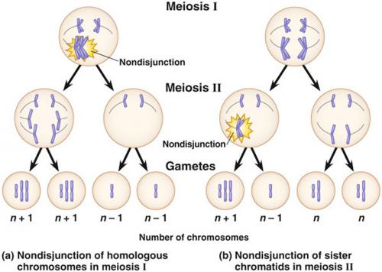
I. Alteration of Chromosome Number

________________________
- Occurs when homologous chromosomes do not separate properly during meiosis II.

Result? _________________________
- Incorrect number of a chromosome
  - Trisomic: three copies of the chromosome
  - Monosomic: one copy of the chromosome

___________________
- More than two complete sets of chromosomes

Other ways chromosome abnormalities happen…
Mitosis: problems with cell division
Maternal Age: Women are born with all the eggs they will ever have. Errors may crop up in the eggs' genetic material with age. Because men produce new sperm throughout their lives, paternal age does not increase risk of chromosome abnormalities.
Environment: No conclusive evidence however it is still possible that the environment may play a role in the occurrence of genetic errors.

Most common non disjunctions in humans:

Trisomy 21:

Trisomy 18:

Trisomy 13:

Sex Chromosome Aneuploidy

XXY-

XYY-

XXX-

II. Alteration of Chromosome Structure pg 300
Portions of a chromosomes may be ______or _______________ during crossing over

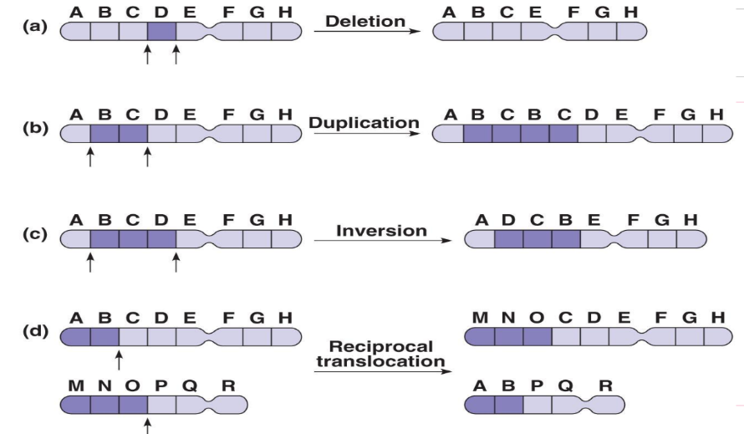

a) Deletion: Fragment is lost. Missing ____________.
Example: Cri du Chat syndrome- deletion in chromosome 5 in humans,
Symptoms: small head, cry sounds cat like, death in infancy

b) Duplication: Extra fragment. ___________ genes.

c) Inversion: a chromosomal fragment reattaches in ___________ _________________

d) Translocation: when a fragment of a chromosome becomes attached to a _____________________ _______________________

Example: Chronic Myelogenous leukemia (CML) &
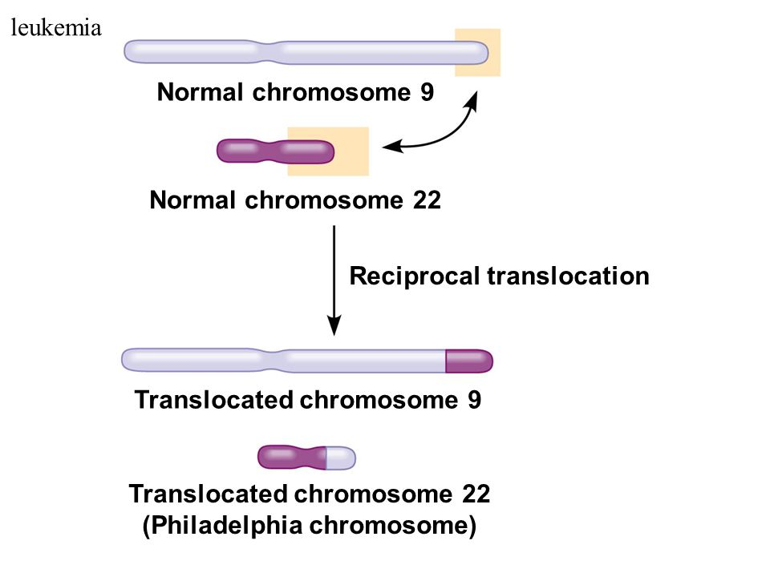
the Philadelphia chromosome
Karyotypes:
-are images that show the number, size & types of chromosomes
-used to diagnose some
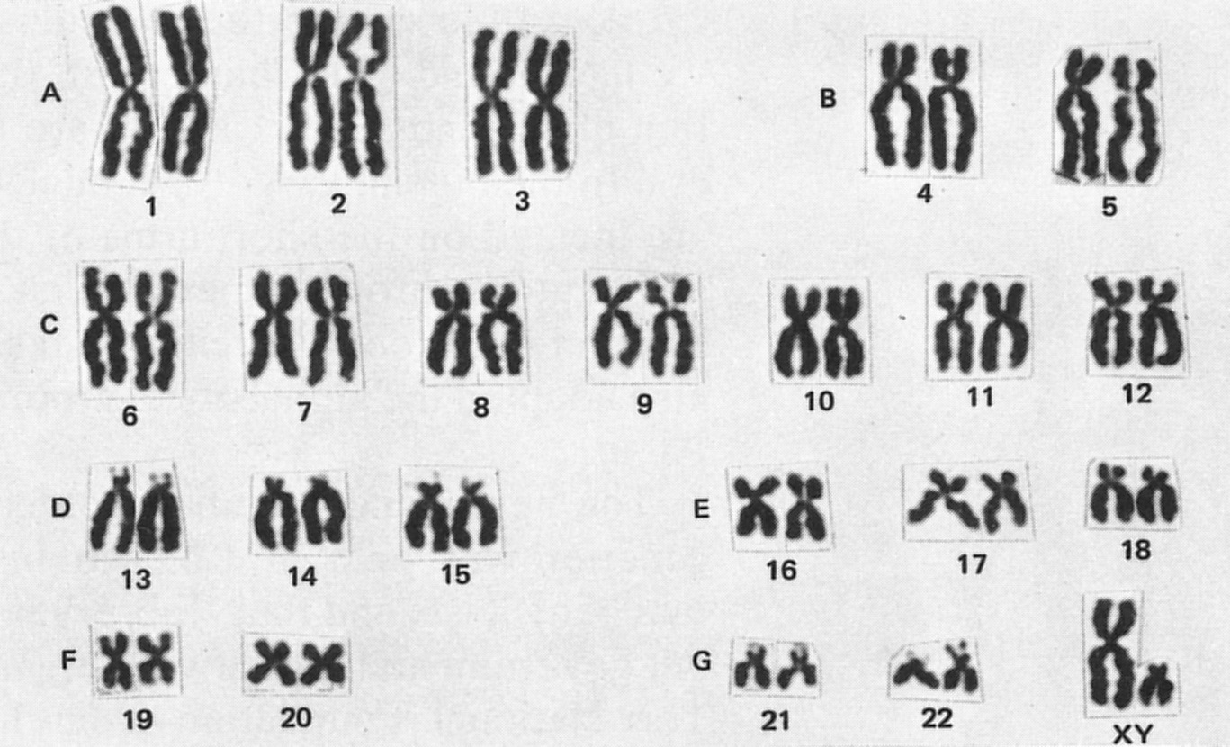
genetic disorders
Karyotyping activity online at: http://www.biology.arizona.edu/human_bio/activities/karyotyping/karyotyping.html

