Genetic Disorder | What I understand about the genetic disorder before the reading | What I now understand about the genetic disorder after the reading | Questions I still have about the genetic disorder
Cystic Fibrosis
Tay-Sachs disease
Sickle-cell anemia
Huntington’s disease
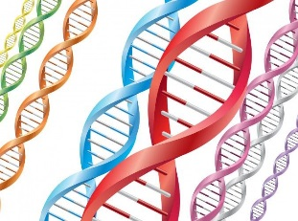
Connections: Any personal, social media, or community connections to any of these genetic disorders?
______________________________________________________________________________________________________________________________________
Please read the section on technology and genetic testing and counseling.

Write down five points from this reading that you found interesting and important to share with someone else. Please include at least one point from each section (Tests for Identifying Carriers, Fetal testing, newborn screening)

- _________________________________________________________________________
- _________________________________________________________________________
- _________________________________________________________________________
- _________________________________________________________________________
- _________________________________________________________________________
Evolution Connection Q:
1. Over the past half century, there has been a trend in the United States and other developed countries for people to marry and start families later in life than did their parents and grandparents. What effects might this trend have on the frequency of late-acting dominant lethal alleles in the population?

Science, Technology and Society Q:
2. Imagine that one of your parents has Huntington’s disease. What is the probability that you, too will someday manifest the disease? There is no cure for Huntington’s. Would you want to be tested for the Huntington’s allele? Why or why not?

