**Learning Goals for Enzymes & Metabolic Reactions**

Bio12 AP  **Enzymes & Metabolic Reactions** Name: ______________

Sec 8.4 & 8.5 pg 152-160 Date: _______________

Block: _____

* Define key terms- enzymes, activation energy, active site, substrate, transition state,
* Describe how enzymes catalyze reactions
* Describe the structure of an enzyme, how it can be altered, and how pH and temperature affect enzyme function.
* Relate the enzyme activity to competitive inhibition, noncompetitive inhibition and cooperativity
* Analyze and apply the implications of allosteric regulation of metabolic pathways

**ENZYMES**

Background:

A **catalyst** is a chemical agent that speeds up a reaction **without being consumed by the reaction**.

Proteins have many functions in the human body, including to act as catalysts🡪 enzymes!

An **enzyme** is a **_______________________** that acts as a _________________

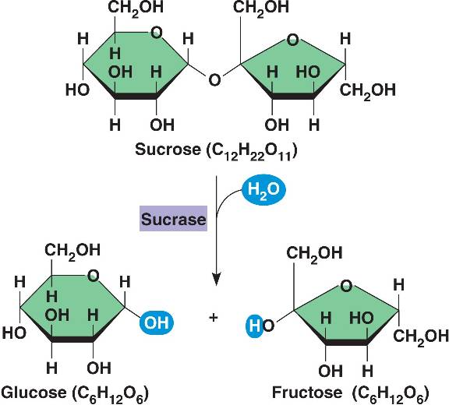

* Hydrolysis of sucrose by the **enzyme sucrase**

is an example of an enzyme-catalyzed reaction

Even though the reaction is “spontaneous”/exergonic/releases free energy, it would happen WAY too slow (years) without help from the enzyme due to its very high energy of activation.  With the enzyme, the reaction takes seconds!

**THE ACTIVATION ENERGY BARRIER**

Every chemical reaction between molecules involves bond breaking and bond forming

The initial energy needed to start a chemical reaction is called the **free energy of activation**, or **_______________________** **Ea**(to contort the bonds)

Activation energy is often supplied in the form of ___________ _________ (heat)from the surroundings.

Absorbing heat accelerates the reactant molecules so they collide more often and forcefully, making the breakage of _________more likely.

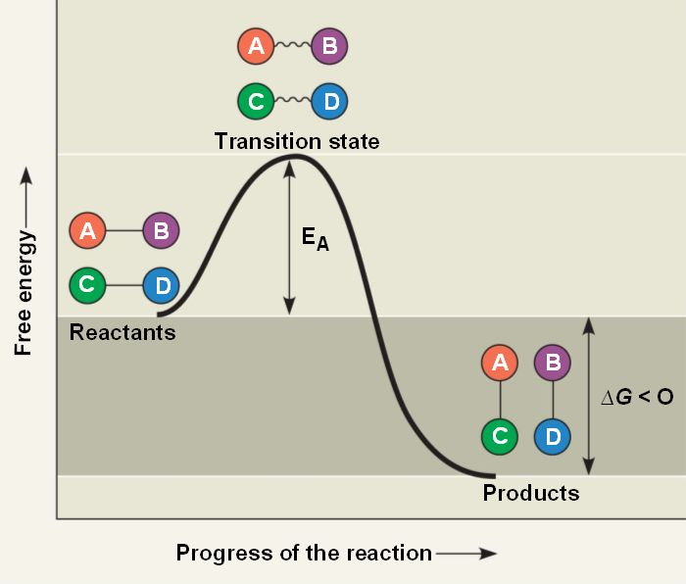

***Let’s look at a hypothetical exergonic reaction:***

When an energy equivalent to the **Ea** has been absorbed,

an unstable ___________ state is reached by the reactants

and their bonds can be broken.

As the atoms settle into their new, more ________

bonding arrangements, energy will now be _____________

into the surroundings

***HOW DO ENZYMES LOWER THE EA BARRIER?***

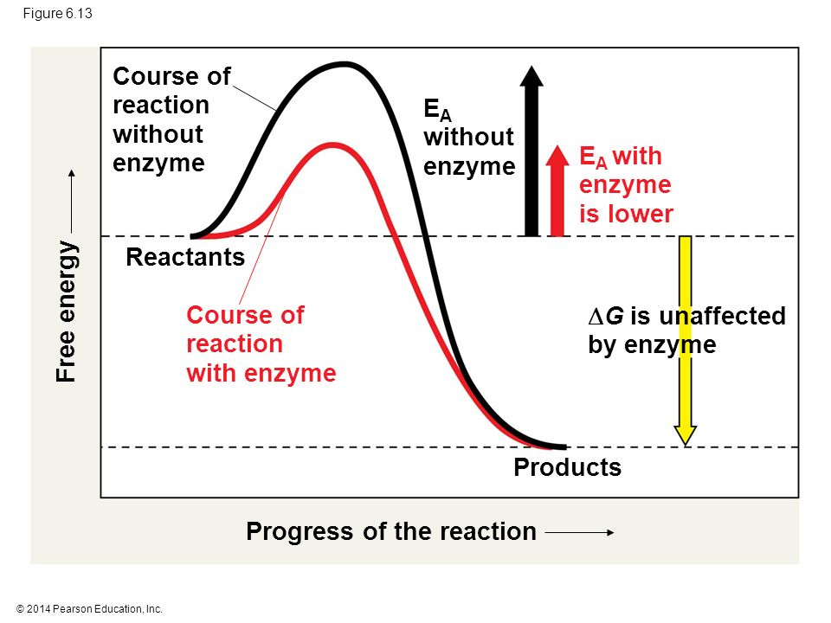

The laws of thermodynamics favor the break down of proteins, DNA and other complex molecules (they are rich in free energy!)

However, these molecules persist because at temperatures typical for cells, few molecules can make it over the hump of activation energy.

Heat can speed up reactions BUT it denatures proteins and kills cells.

An enzyme catalyzes a reaction by _________________ the energy of activation barrier.

Enzymes CANNOT change the G for a reaction but they can hasten reactions that would eventually occur anyways!

***SUBSTRATE SPECIFICITY OF ENZYMES***

The reactant that an enzyme acts on is called the enzyme’s _____________

The enzyme binds to its substrate, forming an_____________- ______________ complex

The **____________ _____________**is the region on the enzyme where the substrate binds.

An enzyme is not a stiff structure locked into a given shape. Recent work has shown that enzymes seem to “__________” between subtly ___________ _________. The shape that best fits the substrate isn’t necessarily the one with the lowest energy but the one where the active site can best bind the substrate.

**___________ ______** of a substrate brings ___________ groups of the active site into positions that enhance their ability to catalyze the reaction. Most enzymes are capable of 1000 substrate actions per second!

***CATALYSIS IN THE ENZYME’S ACTIVE SITE***

In an enzymatic reaction, the substrate binds to the active site of the enzyme by weak interactions such as _____ bonds and _________ bonds.

***Think* of four mechanisms which allow the active site to lower an EA barrier…**

1. Orienting substrates correctly – providing a place for _____________ to find each other
2. Straining substrate bonds – _________________reactants towards transition state through weak H and ionic interactions from the R groups in the protein
3. Providing a favorable microenvironment – ex) acidic conditions via acidic R-groups
4. Covalently bonding to the substrate – this covalent bonding is temporary… it is released in subsequent reactions

**EFFECTS OF LOCAL CONDITIONS ON ENZYME ACTIVITY**

An enzyme’s activity can be affected by:

* Substrate concentration activity increases with increasing substrate concentration until the _________________point is reached (where all active sites are occupied)

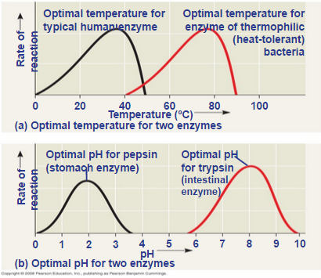

* General environmental factors, such as_________________
* Chemicals that specifically influence the enzyme.

**EFFECTS OF TEMPERATURE AND PH**

* Each enzyme has an optimal temperature in which it can function.
* Each enzyme has an optimal pH in which it can function.

**COFACTORS**

* Cofactors are ____________enzyme helpers
* Cofactors may be inorganic (such as a metal in ionic form) or organic
* An organic cofactor is called a _____________
* Coenzymes include ___________

**ENZYME INHIBITORS**

**Competitive inhibitors** bind to the _________ _______ of an enzyme.

Substrates are __________ from entering active sites. This type of competition can be overcome by increasing

_______________ ________________

**Noncompetitive inhibitors** bind to another part of an enzyme, causing the enzyme to change it’s __________ and making the active site less effective.

Toxins and poisons are often ______________ inhibitors. For example, ________ a nerve gas inhibits an important enzyme in the ____________ ___________. Pesticides and antibiotics are also inhibitors.

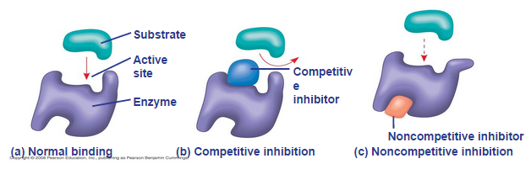

**However, not all enzyme inhibition is harmful. Many metabolic pathways are regulated by naturally occurring molecules acting as selective inhibitors.**

**Sec.8.5 pg 158- REGULATION OF ENZYME ACTIVITY HELPS CONTROL METABOLISM**

Chemical chaos would result if a cell’s metabolic pathways were not tightly ________________.

A cell does this by switching on or off the ____________ that encode specific enzymes or by regulating the activity of enzymes.

**ALLOSTERIC REGULATION OF ENZYMES**

Allosteric regulation occurs when a **regulatory molecule binds to a protein at one site and affects the protein’s function at another site Allosteric regulation** may either _____________ or _______________ an enzyme’s activity

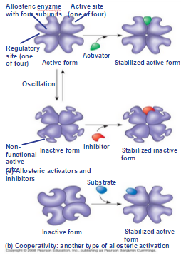

***ALLOSTERIC ACTIVATION AND INHIBITION***

Most allosterically regulated enzymes are made from polypeptide subunits.

Each enzyme has ____________ and ____________ forms.

The binding of an activator _____________the active form of the enzyme.

The binding of an inhibitor stabilizes the inactive

form of the enzyme.

**Cooperativity** is a form of allosteric regulation that can ____________ catalytic activity at the active sites

In cooperativity, binding by a substrate to one active site stabilizes favorable conformational changes at all other subunits.

Allosteric regulators are attractive drug candidates for enzyme regulation because they exhibit ___________ specificity for particular enzymes than do inhibitors that bind to the active site.

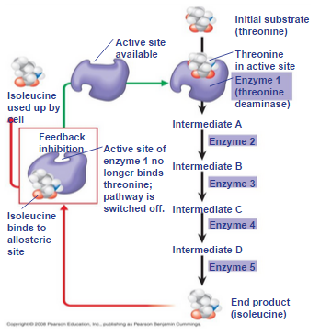

Inhibition of protein- digesting (proteolytic) enzymes called _____________

may help management of inappropriate inflammatory responses.

In **feedback inhibition**, the end product of a metabolic pathway _________

_____________ the pathway.Feedback inhibition prevents a cell from wasting chemical resources by synthesizing more product than is needed.

**SPECIFIC LOCALIZATION OF ENZYMES WITHIN THE CELL**

Structures within the cell help bring order to metabolic pathways.

Some enzymes act as structural components of membranes.

In eukaryotic cells, some enzymes _______________specific organelles;

for example, enzymes for cellular respiration are located in mitochondria.

Bio 12AP **Enzymes & Metabolism Practice Qs** Name: _______________

Sec 8.4 -8.5 Date: ________________

p152-160 Block: ____

1. Identify and label the parts on the diagram.

2. Describe the ***transition state*** that occurs during a chemical reaction

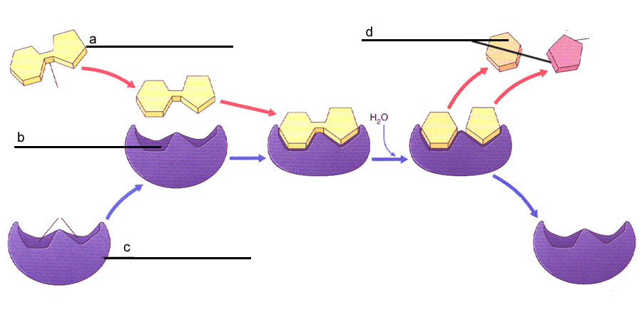

____________________________________________________________________________________________________________________________________________________________

3.a) Label all missing parts on the graphs below. b) **Highlight the energy of activation** on both graphs. c) Assuming the graphs represent the same reactants, which one shows a catalyzed reaction? Explain how you know

______________________________________________________________________________________________________________________________________________________

Bx

A

4. In a metabolic pathway which of the following is correct:

a) the product of one reaction becomes the substrate of the next reaction

b) the same enzyme is used for all reactions

c) the end product is always pyruvic acid

d) ATP is used up all the time

e) all of these

5. Which graph below best represents a graph of the Enzyme activity vs pH?



6. Why do you think each enzyme has its own preferred pH at which it operates?

7a. What is the effect of lowering the temperature on enzyme activity compared to raising the temperature? **Draw and label a graph** to show these relationships.

***II. Try the multiple choice Graphing Qs below:*** 9.

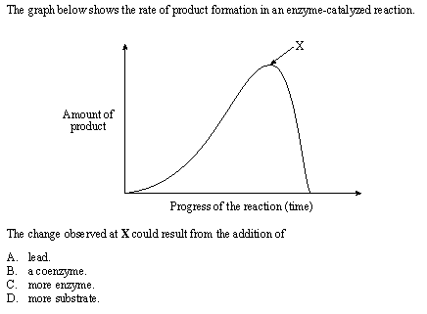

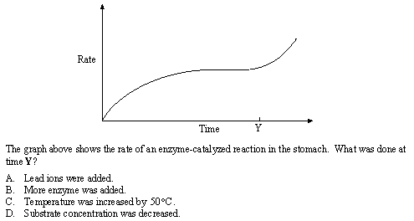

8.

**III. Critical thinking Qs…. Answer on a separate page.**

10. What **advantages** can you see in having **complex metabolic pathways** within body cells to produce various substances, such as amino acids and ATP?

11. Explain, using diagrams, how **competitive inhibitors** differ from **non-competitive** inhibitors in the way they act on enzymes. Is enzyme inhibition considered a good or bad thing? Explain using examples.

12. Explain why a genetic defect that affects only one enzyme in a metabolic pathway can have serious consequences.

13. What is the relationship between vitamins and cofactors? How may vitamin deficiencies affect metabolism?

14. Hemoglobin is not an enzyme yet it demonstrates the principles of cooperativity. Explain.