Although allosteric regulation is probably widespread, relatively few of the many known metabolic enzymes have been proven to be regulated in this way. Allosteric regulatory molecules are hard to characterize in part because they are hard to isolate given that they bind to the enzyme at low affinity. However, recently, pharmaceutical companies have “zoomed in” on allosteric regulators as attractive drug candidates for enzyme regulation due to the fact that they show even higher specificity for their particular enzymes than inhibitors that bind the active site.
Bio12AP Metabolic Control via Enzymes Inquiry Name: ______________
Inquiry Q: Are there allosteric inhibitors of caspase enzymes? Date: ______________
Block: ___
Caspases are protein-digesting (proteolytic) enzymes that play an active role in inflammation and cell death. By specifically regulating these enzymes we may be able to better manage inappropriate inflammatory responses such as those commonly seen in vascular and neurodegenerative diseases.
Sunesis Pharmaceuticals and researchers at the University of California at San Francisco have recently collaborated to determine if there are allosteric regulators of caspases. Use the study summary below (and the scientific paper by J.A Scheer et al 2006) to complete the rest of this activity.
Experiment: In an effort to identify allosteric inhibitors of caspases, Justin Scheer and co-workers screened close to 8,000 compounds for their ability to bind a possible allosteric binding site in caspase and inhibit the enzyme’s activity.
Each compound was designed to form a disulfide bond with a cysteine near the site in order to stabilize the low affinity interaction that is expected of an allosteric inhibitor. As the caspases are known to exist in both active and inactive forms, the researchers decided to look more deeply at this bond.
Hypothesis:
The allosteric inhibitor locks the caspase enzyme into it’s inactive form.
Method:
X-ray diffraction was used to determine the structure of caspase 1 when bound to an inhibitor and to compare this to the caspase 1’s inactive and active forms
Results:
Fourteen compounds were identified that could bind to the proposed allosteric site of the caspase 1 and block enzymatic activity. The enzymes shape when one such inhibitor was bound most closely resembled the enzyme’s inactive form rather than it’s active form.

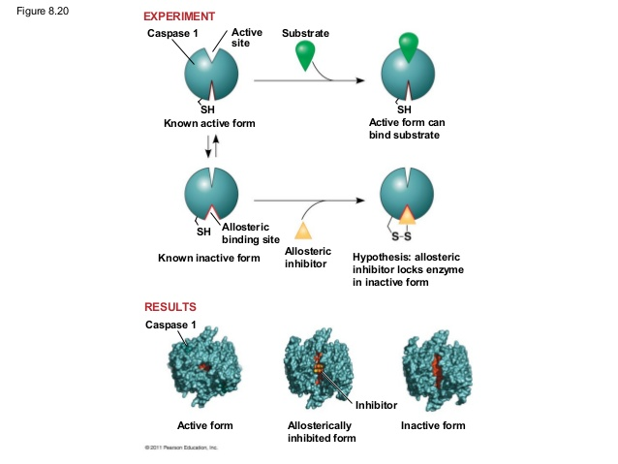

Analysis Qs Name:__________________
1. Does the data support or refute the existence of an allosteric inhibitory site on caspase 1? Explain.

2. As a control, the researchers broke the disulfide linkage between one of the inhibitors and the caspase. Assuming that the experimental solution contains no other inhibitors, how would you expect the caspase 1 activity to be affected?

3. Imagine you are a pharmalogical researcher who wants to design a drug that inhibits a particular enzyme. Upon reviewing current scientific studies, you find that the enzyme’s active site is similar to that of several other enzymes. What might be a good approach to developing your inhibitor drug?

4. What is the link between this enzyme and health? Explain a specific connection.

5. In your opinion, should cooperativity be investigated further for this same health issue? Explain.

