The image below shows many details about how DNA makes copies of itself. Look closely at all parts of the image. Discuss and jot down your ideas below
Bio 12 DNA Replication- In Depth Name: ___________________
Ch. 25 Date: ____________________
p506-509 1. Visual Thinking Strategy warm up your brain! Block: _____
Looking at this image…
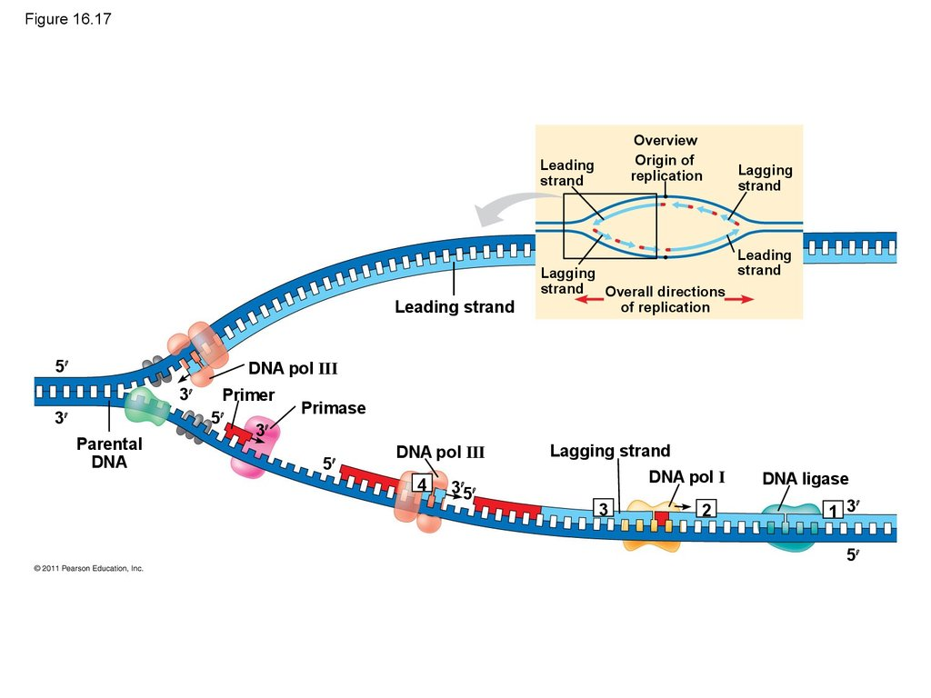

What I already know is that: | What I can infer is that: | I am still wondering is:
-

2. Why do Okazaki fragments occur? Label them on the diagram above (from Q 1)

3. Why are proteins a key part of DNA replication? Describe 3 specific reasons.

4. Use the diagram below to answer the questions
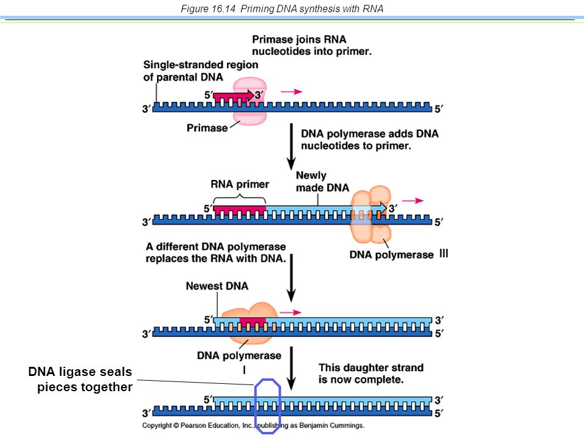

a) Why is an RNA primer required?

b) What would happened if primase was missing?

c) Do RNA primers exist in the new daughter strand of DNA?

5.a) What are telomeres?

b) Why are telomeres needed?
c) What evidence suggests telomeres may be a limiting factor in the life span of some tissues and even whole organisms?

