A solution is a solute (dissolved substances, including charged particles) suspended in a solvent (which in livings systems is water). When two solutions of different solute concentration are separated by a selectively permeable membrane, such as a cell membrane, the natural tendency would be for these two solutions to reach a concentration equilibrium, that is, an isotonic state. The might be accomplished by the movement of molecules through the membrane in both directions until a concentration equilibrium was reached between the two solutions. However, it depends a variety of factors that can affect the rate of diffusion such as: the size of the molecules, temperature, charge of the particles, size of pores etc.
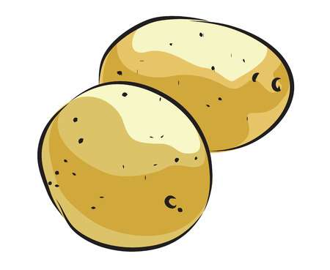
Osmosis & Tonicity Name: _____________
Sec 4.3 A Sweet Potato Lab Date: _____________
74-75 Block: _____
P7

It is known that living cell membranes can and do restrict the passage of many types of molecules. For example, water molecules, because of their small size, and abundance in intracellular and extracellular fluids, tend to pass through cell membranes much faster than do other molecules or ions. This movement of water molecules through membranes is called osmosis. Furthermore, water diffuses very rapidly down its concentration gradient from a more dilute (hypotonic) solution, to a less dilute (hypertonic) solution.
Osmotic pressure is the pressure associated with osmosis and can be simply considered as a measure of a solution’s tendency to draw water into it. The osmotic pressure is proportional to the total number of solute particles dissolved in it. Therefore, a hypertonic solution will draw more water into it, from a hypotonic solution, because it has higher osmotic pressure. An equilibrium may be reached in which the number of water molecules moving into the solution will equal the number of water molecules moving out. Solutions which have the same osmotic pressure are said to be iso-osmotic, and would be considered to be an isotonic state.
Purpose: To determine the concentration of solute in potatoes and to develop a stronger understanding of water movement in different solute concentration environments.
Hypotheses: On a separate page please write hypotheses for how the potato’s mass will be changed by each of the following solutions. Use if… then...because statements. a) Ex: If the potato is in an isotonic solution then…because…
b) hypotonic solution c) hypertonic solution
Procedure: Part One
- Using a cork borer, cut six pieces of potato of approximate equal size.
- Label six beakers: distilled water, 0.2M, 0.4M, 0.6M, 0.8M, and 1.0M
- Weigh the initial mass of each of the potato pieces and record their mass in the table provided
- Place one potato piece into each of the labeled beakers
- Place 15mL of each of the solution into the labeled beakers
- Make predictions and record these predictions in the table. Indicate a + or – (gain or loss mass), as well as a number indicating how much the mass has changed
- Place all of the beakers on a piece of paper towel on the back bench
Procedure: Part Two
change in mass x 100 = % Change
initial mass Mass

- Carefully remove each potato piece, dab off any extra solution.
- Weigh each potato piece, one at a time, and record the final mass in grams
- Calculate the change in mass and record the values (final-initial)
- Calculate the percent change in mass and record the values
- Collect the class data and record the values
- Calculate the average percent mass change according to our class’ data
- Graph Both your individual group data, as well as the class data
- Draw a best fit line that connects the data points
- Create a legend on the side of the graph that indicates which line is your group compared to the class data
Table One: Potato Pieces (Individual Data)
Contents in Beaker | Initial Mass | Final Mass | Predicted Mass Difference | Calculated Mass Difference | Percent Change in Mass
water
0.2M sucrose
0.4M sucrose
0.6M sucrose
0.8M sucrose
1.0M sucrose
Table Two: Potato Pieces (Class Data)
Contents | G1 | G2 | G3 | G4 | G5 | G6 | G7 | Total | Average
water
0.2M sucrose
0.4M sucrose
0.6M sucrose
0.8M sucrose
1.0M sucrose

Be sure to include the following in your graph:
- A descriptive title
- Labels for all axis
- A best fit line for group and class data with legend
- All units
- Data recorded in pencil
Name: ___________________

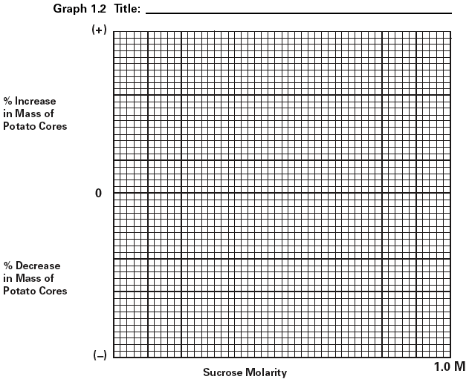
Discussion Questions: Name: ______________
1. What was done to try and ensure that this was a controlled experiment? _______________________________________________________________________ _______________________________________________________________________

2. What were some variables that were difficult to control. Explain the significance of this. ____________________________________________________________________________________________________________________________________________________________
3. What was the independent variable? Dependent variable in this lab? Remember the x-axis on the graph is the independent and the y-axis is the dependent variable. ____________________________________________________________________________________________________________________________________________________________
4. In terms of tonicity, explain why some potato sections increased in mass, why some decreased in mass, and why some changed very little. ________________________________________________________________________________________________________________________________________________________________________________________________________________________________________________________________________________________________________________________
5. At what concentration point is the potato and the sucrose solution isotonic? Explain. What can you conclude about the solute concentration of the potato? ____________________________________________________________________________________________________________________________________________________________
6. If potato cells were suspended in 1.0M of sodium chloride solution instead of sucrose, what would you expect to happen to the mass of the potato cells? Explain. __________________________________________________________________________________________________________________________________________________________________________________________________________________________________________
7. CRITICAL THINKING Q: Explain how salt can be used as a slug killer. __________________________________________________________________________________________________________________________________________________________________________________________________________________________________________Conclusion: On a separate piece of paper, please use the criteria outlined below:
- Write in a neutral/passive tone (avoid all subject pronouns- no “I”, no “We” etc)
- Begin by re-stating the purpose & hypothesis What was investigated & predicted?
- Summarize results…what did the results / data show? Did this prove / disprove hypothesis?
- Make Connections
  - Are there any “big ideas” or known background information that can be applied to explain why the results occurred? Do the results match known theories/models etc
- Identify possible sources of scientific error
  - Were there any variables that were impossible or difficult to control?
  - What could account for any unexpected results?
- Suggest scientific solutions to avoid or minimize error and/or to expand the experiment
- End with a concluding sentence that re-iterates key findings / big ideas

