**Osmosis:**

Biology 12 Name: _________________

Sec 4.3 **Osmosis& Tonicity** Date: __________________

Pg 74-75 Block: ____

Passage of water across the membrane is believed to require special                        proteins called __________.

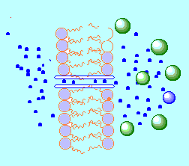

**Label the following on the diagram:**

- phospholipid bilayer -water molecules

- channel protein -direction of osmosis

-solvent molecules -direction of osmosis.

**Tonicity:**

**Isotonic-**

**Hypotonic-**

**Hypertonic-**

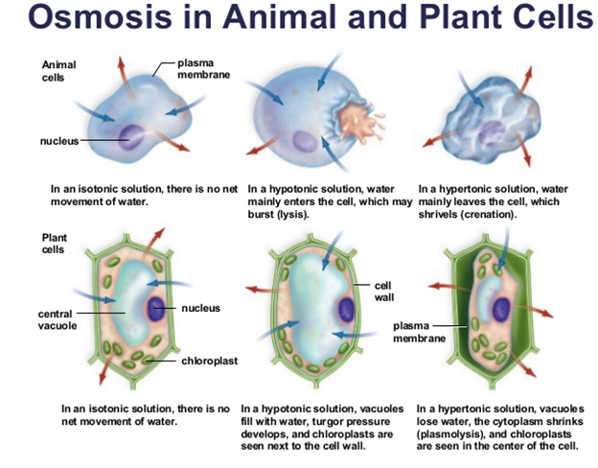

|  |  |  |  |
| --- | --- | --- | --- |
| **Term** | **What is it?** | **Why does it happen?** | **Where does it happen? (plant or animal cells)** |
| **Lysis** |  |  |  |
| **Crenation** |  |  |  |
| **Turgor pressure** |  |  |  |
| **Plasmolysis** |  |  |  |

**Use pg 74-75 to complete the table**

**PRACTICE QUESTIONS**

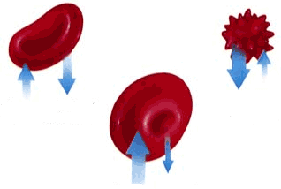

1. Label the following red blood cells as:

i) being in an isotonic, hypotonic or hypertonic environment.

ii) as undergoing crenation or hemolysis.

iii) what do the arrows represent?

2. Which of the following moves material against a concentration gradient?

a. active transport b. diffusion c. osmosis d. facilitated transport

3.Red blood cells are isotonic to 0.9% NaCl. In which type of solution will crenation occur?

a. 0.1% NaCl b. 0.9% NaCl c. 0.5% NaCl d. 1.2% NaCl

4. According to the diagram to the below, which of the following conditions would cause the change in the fluid levels as shown after 10 minutes? (Solution in Side A; Solution in Side B)

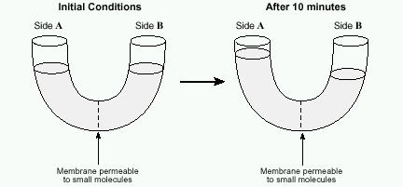

a. 5% protein; 2% protein c. 2% salt; 2% salt

b. distilled water; 5% salt d. 2% glucose; 5% glucose

5. The fact that lipid soluble molecules pass

through the cell membrane is due to:

a. their size c. their chemical composition

b. osmosis d. active transport