The Structures of DNA & RNA ***Label the nucleotide!***



Biology 12 DNA Replication Questions Name: ______________ Sec 25.1 p 506-509 Date: _______________

Block: _____

1. DNA & RNA are Linear Polymers of ____________

**Each nucleotide** is composed of:

a) a **pentose ___________**

b) a **_______________**

c) a **__________________ ____________**

d) **RNA nucleotides differ from DNA in that they have:**

**____________ sugar and the _____________ base**

|  |  |
| --- | --- |
| nucleotide: base = **A**denine | nucleotide: base = **G**uanine |

**2. There are 2 different** categories of **bases**:

i) **PURINES** - have a ***_____________ ring structure*** (adenine & guanine)

ii) **PYRIMIDINES** - have a ***_______ring structure*** (thymine, cytosine, uracil)

3a )List the key characteristics of DNA**:**

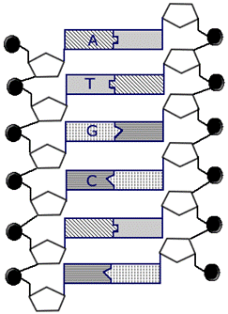

b) Label the first 4 missing bases to show you know the complementary pairs:

c) Circle a Nucleotide!

DNA Replication

**4. Use the diagram below. Add labels where needed and explain what is**

**happening in each of the 3 steps of DNA Replication. Include the enzymes**



5. Why is DNA Replication called “semi- conservative”

6. Why must DNA Replicate?

Sec 25.1 **The Steps in Replicating DNA**  Name : _______________

Pg 509 Date: ________________

Block: ____

|  |  |  |  |
| --- | --- | --- | --- |
| STEP | Visual | Description | Key Enzyme(s) |
| **1. Unwinding** |  |  |  |
| **2. Complementary**  **Base Pairing** |  |  |  |
| **3. Elongating- Joining of complementary base pairs** |  |  |  |
| **4. Proof reading** |  |  |  |