**Background:**

AP Bio12 **Investigating Diffusion and Osmosis** Name: _____________

Determining the Water Potential of Potato Cells Date: _____________

*Guiding Q: What causes plants to wilt if they are not watered?*  Block: _____

P7

Cells must move materials through membranes and throughout cytoplasm in order to maintain **homeostasis**. The movement is regulated because cellular membranes, including the plasma and organelle membranes, are **selectively permeable**. Membranes are **phospholipid bilayers** containing embedded proteins. The phospholipid fatty acids limit the movement of water because of their **hydrophobic** characteristics. Water may pass freely through the membrane by **osmosis** or through specialized protein channels called **aquaporins**. Most ions move through **protein channels,** while larger molecules, such as carbohydrates, are carried by **transport proteins**. The simplest form of movement is **diffusion,** in which **solutes move from an area of high concentration to an area of low concentration**; diffusion is directly related to **molecular kinetic energy**. Diffusion does not require energy input. In contrast, **the movement of a solute from an area of low concentration to an area of high concentration does require energy** input in the form of **ATP** and **protein carriers called pumps**.

Like solutes, **water moves down its concentration gradient** by diffusion in a process called osmosis. **Water moves from areas of high potential (high water concentration) and low solute concentration to areas of low potential (low water concentration) and high solute concentration**. In animal cells, the movement of water into and out of the cell is influenced by the relative concentrations of solute on either side of the membrane (hypertonic solutions, hypotonic solutions and isotonic solutions). **Animal cells cell may shrink , swell or even burst** depending on the direction of water flow.

I**n walled cells such as plant cells, osmosis is affected not only by the solute concentration but also by the resistance to water movement in the cell by the cell wall**. This resistance is called **turgor pressure**. In plant cells, the presence of a cell wall prevents the cells from bursting, but pressure does eventually build up inside the cell and affects the process of osmosis. For this reason, the concept of **water potential** is used to predict the direction in which water will diffuse through living plant tissues because eventually **the pressure inside the cell will become large enough so that no additional water can move into the cell even though the cell still has a higher solute concentration than pure water.** When this occurs, knowing the relative solute concentrations on either side of the cell wall cannot simply predict the movement of water and the concept of water potential is much more useful. The movement of solutes and water across cellular membranes is an overarching concept. **Cells must maintain their internal environments and control solute movement**.

**Understanding Water Potential** Water potential predicts which way water diffuses through plant tissues. It is abbreviated by the Greek letter psi (ψ) and expressed in bars, a metric unit of pressure equal to about 1 atm.

Water potential is the free energy per mole of water and is calculated from two major components:

**ψ = ψP + ψS**

(1) the solute potential (ψS ), *(also called osmotic potential)* which is dependent on solute concentration (2) the pressure potential (ψP ), which results from the exertion of pressure — either positive or negative (tension) — on a solution

**Water Potential = Pressure Potential + Solute Potential**

Water moves from an area of higher water potential or higher free energy to an area of lower water potential or lower free energy. Water potential measures the tendency of water to diffuse from one compartment to another compartment. **The water potential of pure water in an open beaker is zero (ψ = 0) because both the solute and pressure potentials are zero (ψS = 0; ψP = 0)**

**Examples**

When a cell’s cytoplasm is separated from pure water by a selectively permeable membrane, water moves from the surrounding area, where the water potential is higher (ψ = 0), into the cell, where water potential is lower because of solutes in the cytoplasm (ψ is negative). It is assumed that the solute is not diffusing (Figure 1a).

The movement of water into the cell causes the cell to swell, and the cell membrane pushes against the cell wall to produce an increase in pressure. This pressure, which counteracts the diffusion of water into the cell, is called turgor pressure. **Over time, enough positive turgor pressure builds up to oppose the more negative solute potential of the cell.**

Eventually, the water potential of the cell equals the water potential of the pure water outside the cell (ψ of cell = ψ of pure water = 0). At this point, **a dynamic equilibrium is reached** and net water movement ceases (Figure 1b).

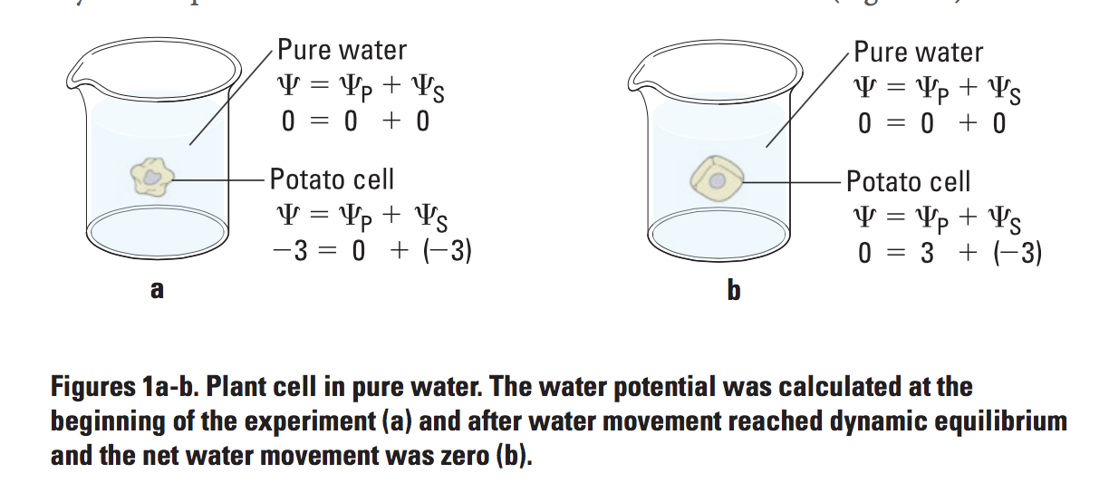

If solute is added to the water surrounding the plant cell, the water potential of the solution surrounding the cell decreases. If enough solute is added, the water potential outside the cell is then equal to the water potential inside the cell, and there will be no net movement of water. **However, the solute concentrations inside and outside the cell are not equal because the water potential inside the cell results from the combination of both the turgor pressure (ψP ) and the solute pressure (ψS ), as shown in Figure 2.**



If more solute is added to the water surrounding the cell, water will leave the cell, moving from an area of higher water potential to an area of lower water potential. **The water loss causes the cell to lose turgor**. A continued loss of water will cause the cell membrane to shrink away from the cell wall, and the cell will **plasmolyze.**

We will be using the following equation: **(ψS ) = – iCRT**

**Our Investigation**

To investigate the water potential of potato cells and to put the equation **ψ = ψP + ψS** to use, we will need to determine the molar concentration of sucrose (“C” ) in potato cores. This value can be found by finding the sucrose concentration in which the potato core is in an isotonic environment (no net gain or loss of water = no % change in mass). Creating a graph to find this value will then allow us to calculate **ψS.**

**i = the ionization constant (for sucrose this is 1 because sucrose does not ionize in water)**

**C = the molar concentration**

**R = the pressure constant (R = 0.0831 liter bars/mole-K)**

**T = the temperature in K (273 + °C).**

**Purpose:** To place potato cores in sucrose solutions of known concentrations in order to graph the % change in mass and to find the concentration of solute within the potato.

**Write a Null Hypothesis AND an Alternative Hypothesis:** -Please write these in the Data section of this lab. -Be sure to use an if… then… because statement for each.

**Procedure: Part One**

1. Using a cork borer, cut six pieces of potato of approximate equal size.
2. Label six beakers: distilled water, 0.2M, 0.4M, 0.6M, 0.8M, and 1.0M
3. Find the initial mass of each of the potato pieces and record their mass in the table
4. Place one potato piece into each of the labeled beakers
5. Place 15mL of each of the solution into the labeled beakers
6. Make predictions and record these predictions in the table. Indicate a + or – (gain or loss mass), as well as a number indicating how much the mass has changed
7. Place all of the beakers on a piece of paper towel on the back bench

**Procedure: Part Two**

1. Carefully remove each potato piece, dab off any extra solution.

change in mass x 100 = % Change  
 initial mass Mass

1. Weigh each potato piece, one at a time, and record the final mass
2. Calculate the change in mass and record the values (final-initial)
3. **Calculate the percent change in mass** and record the values
4. Collect the class data and record the values
5. **Calculate the average percent mass change** according to our class’ data for each soln.
6. Graph **Both** your individual group data, as well as the class data for % change in mass
7. Draw a smooth line that connects the data points
8. Create a legend on the side of the graph that indicates which line is your group compared to the class data. Include a descriptive title and be sure to label all axis.

Name: ___________________

**Table Two: Class Data for Potato Pieces % Change in mass**

**Table 1: Individual Group Data**

|  |  |  |  |  |  |
| --- | --- | --- | --- | --- | --- |
| Contents in Beaker | Initial Mass | Final Mass | Predicted Mass Difference | Calculated Mass Difference | Percent Change in Mass |
| water |  |  |  |  |  |
| 0.2M sucrose |  |  |  |  |  |
| 0.4M sucrose |  |  |  |  |  |
| 0.6M sucrose |  |  |  |  |  |
| 0.8M sucrose |  |  |  |  |  |
| 1.0M sucrose |  |  |  |  |  |

|  |  |  |  |  |  |  |  |  |  |
| --- | --- | --- | --- | --- | --- | --- | --- | --- | --- |
| Sucrose Conc | G1  % change | G2  % change | G3  % change | G4  % change | G5  % change | G6  % change | G7  % change | Total  % change | Mean |
| water |  |  |  |  |  |  |  |  |  |
| 0.2M |  |  |  |  |  |  |  |  |  |
| 0.4M |  |  |  |  |  |  |  |  |  |
| 0.6M |  |  |  |  |  |  |  |  |  |
| 0.8M |  |  |  |  |  |  |  |  |  |
| 1.0M |  |  |  |  |  |  |  |  |  |

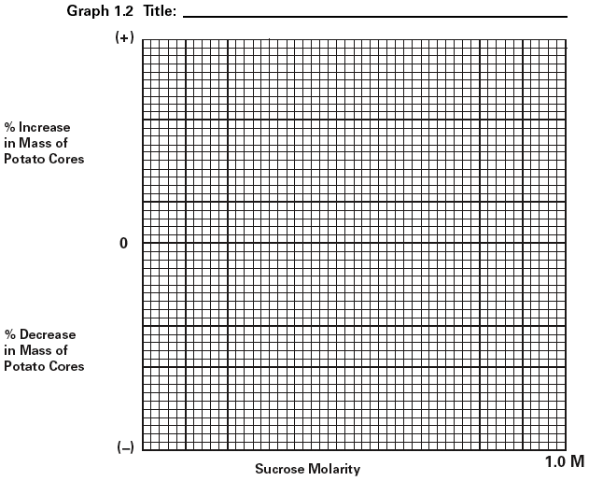

**Hypothesis:**

1. Null Hypothesis:

2 Alternative Hypothesis:

**Evaluation of Data:**

1. What is the molar concentration of sucrose in the potato core? How was this determined?

2. Is the 1.0M solution hypertonic or hypotonic to the potato cell? Explain using evidence from the lab

Name: ___________________

3. What was the independent variable in this experiment? b. What was the dependent variable?

4. a) List 3 variables that were controlled. b) Were there any variable that could not be controlled? Discuss.

5. Calculate the solute potential for the potato. Refer to lab handout for constants. Show all your work

Ψ**S = - iCRT**

**Critical Thinking- Analyze and Apply Questions**

1. If a potato core is allowed to dehydrate by sitting in the open air, would the water potential of the potato cells decrease or increase? Why? Explain.

____________________________________________________________________________________________________________________________________________________________________________________________________________________________________________________________________________________________________________________________________________________________

2a. If a plant cell has a lower water potential than its surrounding environment and if pressure is equal to zero, is the cell hypertonic or hypotonic to its environment? b. Will the cell gain or lose mass? Explain.

_____________________________________________________________________________________________________________________________________________________________________________________________________________________________________________________________________________________________________________________________________________________________

_________________________________________________________________________________________________________________________________________________________________________________________________________________________________________________________________

Name: ___________________

3. If the water potential for a sucrose solution in a dialysis bag is -6.25 bars and it is immersed in a cup of sucrose solution having a water potential of -3.25 bars, will the bag gain or lose mass? Explain.

4a. Calculate the solute potential of a 0.1M NaCl solution at 25 degrees celsius. If the concentration of NaCl inside an onion cell is 0.15M, which way will the water diffuse if the onion cell is placed into the 0.1M NaCl solution? Explain.

5. You are in a hospital and need intravenous fluids. You read the label on the IV bag, which lists all the solutes in the IV fluid. a) Why is it important for an IV solution to have salts in it?

b. What would happen if you were given pure water in an IV?

|  |  |  |  |
| --- | --- | --- | --- |
|  | **Emerging** | **Developing** | **Proficient** |
| **Collecting & Representing Data** |  |  | Data tables are complete  Trends in data are accurate  Graph- clear, labeled, precise  Null & Alternate hypotheses  If ..then ..because…  Strong reasoning provided |
| **Evaluating Data** |  |  | Qs 1-5 fully completed  Own words are used  Relevant details/vocab used  Calculations show work/ units |
| **Analyze & Apply Qs** |  |  | Qs 1-5 fully completed  Relevant details/vocab used  Explanations- clear &accurate  Connections made & extend understanding |