Water-inorganic, polar  Biology 12 - Biologically Important Molecules!- KEY  this repeatedly this term to quiz yourself on biologically important molecules.  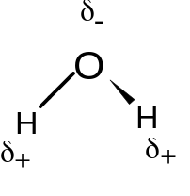 | Glucose- monosaccharide,monomer  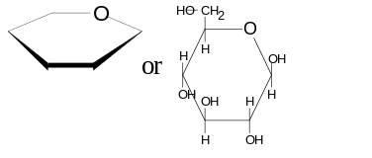 | Maltose- disaccharide  
Amino Acid- monomer  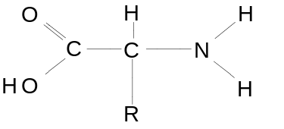 | Dipeptide-monomer  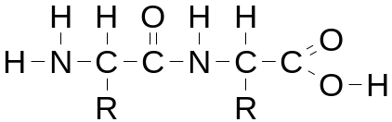 | Phospholipid- monomer  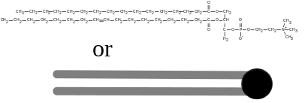
Unsaturated Fatty Acid-monomer  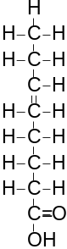 | Saturated Fatty Acid-monomer  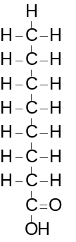 | Trigylceride    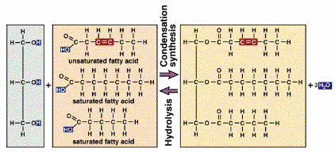
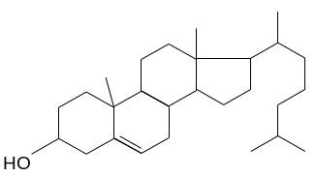  Cholesterol (steroid)-  lipid | 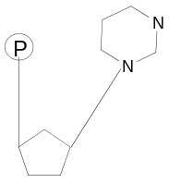  Nucleotide- Pyrimidine- 1N Base monomer | 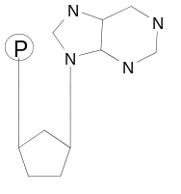  Nucelotide- Purine = 2 Nbases, monomer
_ATP- monomer  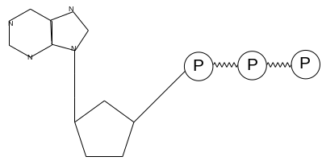 | DNA- polymer  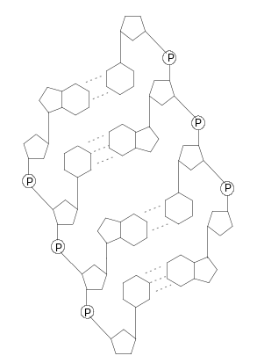 | Glycogen-polysaccharide, carbohydrate in animals  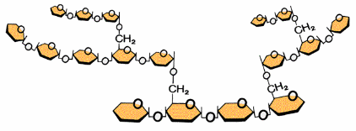  Cellulose- polysaccharide  -carbohydrate in plants    Starch- polysaccharide, plants  

