CLASSES OF ORGANIC MOLECULES
Biology 12
Sec. 2.8
Pg40-41
Name_______________
Date_______________
Block______
IV. NUCLEIC ACIDS
Nucleic Acids (DNA & RNA)
Function | Nucleic Acids help store, transmit and help express hereditary information  Deoxyribonucleic Acid: Ribonucleic Acid:
General structure of the monomer: |  | Types of Bases
Purines:

Pyrimidines:

Complementary base pairing occurs when purines form _________ bonds with pyrimidines
General structure of a polymer: |  | DNA Structure vs. RNA Structure
The phosphate group of one nucleotide joins the sugar of another nucleotide through ____________________ ______to form the sugar-phosphate backbone of the polymer
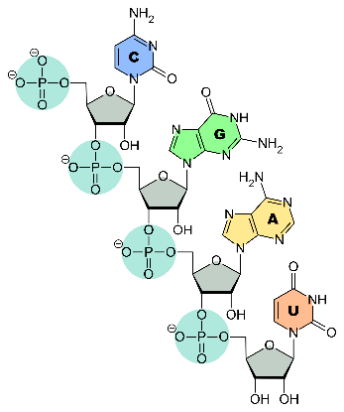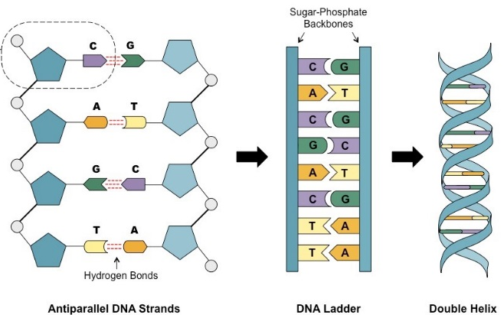
(*A single molecule of DNA can contain millions of base pairs.)
Adenosine Triphosphate (ATP) pg 41
Structure:  Adenosine = adenine + ribose (sugar)  ATP = Adenosine + 3 phosphates  (instead of 1 like in nucleotides)  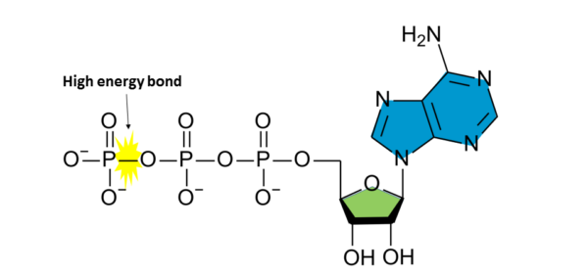  (ATP created from the breakdown of glucose in food) |  | Function:  Energy carrier in cells (supplies energy for chemical reactions in cells, ex. synthesis of macromolecules, contractions in muscle cells)  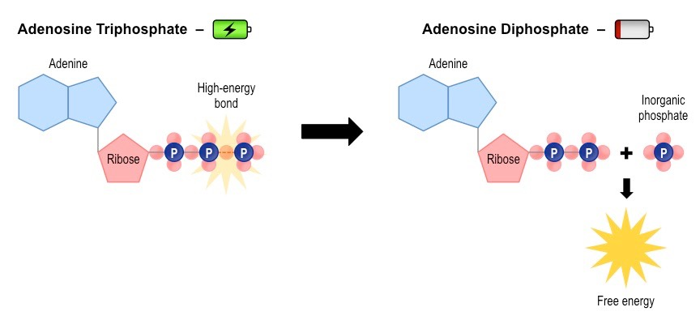  The bond between the last 2 phosphates is unstable and a high energy bond that is easily broken by _________ to release energy.

- What is the monomer of nucleic acids? _________________ What is it composed of? _________________________________
- Label the nucleobases in the diagram below as purines or pyrimidines. What type of bond allows for complementary base pairing? _______________ How does the pairing differ for each set of base pairs? _________________________________________

- Explain what is meant by the term antiparallel. ________________________________________________________________
- What type of bond joins nucleotides? Name and describe it. ______________________________________________________
- Compare and contrast the structure of DNA to RNA (# of strands, shape, sugars, and bases)

- Why is ATP called the “energy currency” of cells? (p.41) _________________________________________________________

