Bio 12 It’s a Cell-ebration! Name: ____________________
Date: ____________________
Time Magazine has decided time to run a feature all about cells. Block: _______
You’ve been asked to create a magazine cover & short article about some of the super cells that exist today.

Your Mission:
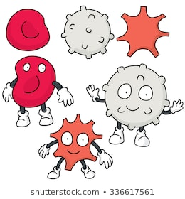
Begin your research, cite ALL sources & captivate you audience by designing an eye- catching and informative special feature article all about cells!

I. What types of cells do you already know of? List them here:

II. What type cells do you want to investigate? What are the “basics’?
The cell types I’ve chosen to research are: ______________ and ________________
Cite all sources and Complete the basic research below:
 | Cell Type 1: | Cell Type 2:
Size?
Shape?
Function?
Location in the body?
Unique organelles or features?

III. If you could interview these cells what questions would you ask?
What should your reader also know about these cell types? Health implications/diseases? Future research? Do these cells communicate with other cells etc?
Develop your own questions and list them here:

QUESTIONING:
Your work needs to demonstrate the following skills:
- Demonstrate a sustained intellectual curiosity about a scientific topic or problem
of personal, local, or global interest

- Make observations aimed at identifying your own questions

- Identify bias in primary and secondary sources, question the source of information

COMMUNICATING:
- Communicate scientific ideas and information for a specific purpose and audience

- Construct evidence-based arguments and using appropriate scientific language, conventions, and representations

Assessment:
Try This Next! | Criteria | You’re Rocking It!
I can…
- Brainstorm cell types

- Research basic questions

- Develop my own questions

- Answer my own questions with details, sci. vocab, connections

- Communicate ideas clearly, in own words

- Cite all sources in a bibliography

- Select strong scientific sources

- Create an eye catching design
-use of visuals and colour
Emerging | Developing | Proficient | Extending
8/20 10/20 | 12/20 14/20 | 16/20 18/20 | 20/20
I C- | C C+ | B A | A+

