Purpose
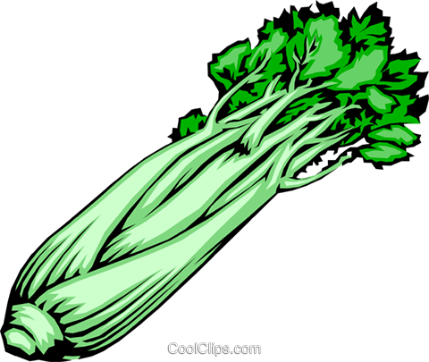
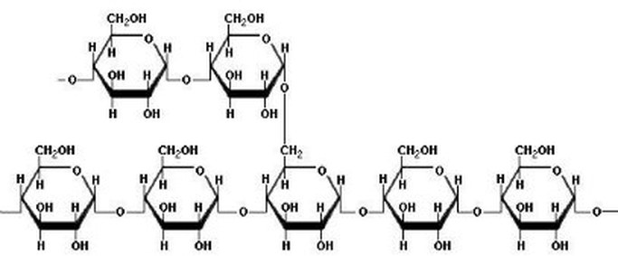
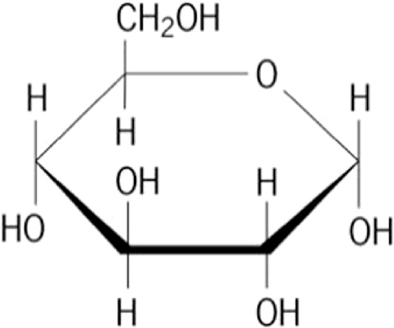
Biology 12 Name: _______________
Testing for Starch and Glucose Date: _______________
Block: _____

To investigate chemical reactions used to test for the presence of starch – a polysaccharide commonly used by plant cells to store glucose molecules. Many foods we eat are high in starches such as bread and some foods we may not even consider as “starchy” contain this polymer. This lab is designed to show students that polymers can be broken down into monomers, specifically in this lab that polysaccharides (starch) can be hydrolyzed/broken down into disaccharides (sucrose) and monosaccharides (glucose).

Background Information
Starch is a way that plants store energy and is an important food for people. It is found in the seeds and in the tuber (a root structure) of some plants, including yams, potatoes, and sweet potatoes. They are considered to be “energy foods” because the starch in them is chemically changed by our bodies to sugars for energy. This lab exercise will use a variety of foods to illustrate the conversion of one chemical substance (starch) to another (sugar).
Part One: Testing for Starch - Iodine is used to test for the presence of starch. If starch is present there should be a dark blue, black, purple colour change.
- In one of the spots on the spot plate place a drop of distilled water. This is the control because water is KNOWN to NOT contain any starch. Any future tests that show the same colour as water after you add iodine indicate a negative result for starch.
- Obtain five different food products and place a small amount of each one in 5 different (separate) parts of the spot plate.
- Before adding the iodine solution to any of the foods, make predictions in the table below. (Do you think starch is present in the food products chosen?)
- Place one to two drops of iodine on the water. Record the colour.
- Next, place 1-2 drops of iodine on each of the food products, one at a time.
- Record the colour change and the appropriate conclusion in the table.
Negative Test Result for Water | Colour Observed :
Positive Test Result for Starch | Colour Observed:

Results: Table 1: Testing known foods for starch
Spot Plate Number | Spot plate contents (name of food) | Predictions | Observation of  Colour | Conclusions  (presence of starch –y/n?)
1 | Distilled Water  (CONTROL)
2
3
4
5
6

Part Two: Hydrolyzing starch into sugars
-Breaking down polymers into monomers
-Breaking down polysaccharides into sucrose and glucose
If we are successful at breaking down starch into sugar a colour change should be visible:
Colour | Level of Glucose
Green | Low
Orange | Medium
Red | High
Brick Orange/Terra Cotta | High

Safety First!
- Be aware of hot surfaces; use test tube holders to remove test tubes from hot water bath.
- Wash hands after completing this laboratory activity.
Part 2 Procedure:

- Obtain four test tubes and label them 1-4. Using a ruler, mark each test tube at 1cm, 2cm, 3cm and 4cm.

2. Before starting PART 2, set up your test tubes #1-4 according to the conditions in the table. LABEL EACH TEST TUBE clearly with the wax pencil
READ PROCEDURE AND COMPLETE THE TABLE FIRST

3. Record a Hypothesis for each condition using an “if..then…because..” statement” to predict what colour change will occur.
Test tube # | Set Up the Condition of: | Record a Hypothesis  If.. then.. because…
1- Control | 1 cm water 1 cm Benedict Soln
2- Starch | 1cm Water, 1cm Benedict, 1cm Starch
3- Glucose | 1cm Water, 1cm Benedict, 1cm Glucose
4- Choice | 1cm water, 1 cm Benedict, 1 cm Choice
4. Place all of the test tubes, at the same time in a hot bath for 5-10 mins.
5. Observe for colour change and record results

Results: Table 2- Testing for Glucose (monosaccharide)
Test Tube # & Contents | Initial Colour Observations | Colour Change Observations | Significance of results:  Is level of glucose low, med or high?
1.

2.

3.

4.

- What is the purpose of a control test tube? Is there another control method that could’ve been used? Explain. ____________________________________________________________________________________________________________________________________________________________________________________________________________________________________________________________________
Discussion Questions

__________________________________________________________________

- What is the relationship between starch and sugar? Explain using your lab results. Please use the terms monomer, polymer, polysaccharide, monosaccharide, hydrolysis and glycosidic linkage in your explanation.
____________________________________________________________________________________________________________________________________________________________________________________________________________________________________________________________________________________________________________________________________________________________________________________________________________________________________________________________________________________________________________________________________________________________________________________________________________________________________
3. How does the excessive consumption of sugar lead to health problems? Give at least 2 specific examples and the issues associated with each health problem. _______________________________________________________________________________________________________________________________________________________________________________________________________________________________________________________________________________________________________________________________________________
Assessment:
 | Emerging | Developing | Proficient
Hypotheses |  |  | Student can demonstrate:  -Use of” if…then…because..”  -Strong reasoning
Results |  |  | Student can demonstrate:  - completion of all data tables  -accuracy -control of all variables  -precision
Discussion |  |  | Student can demonstrate:  -Understanding of “controls”  -Use of vocab with application & examples  -Critical thinking connections

