BIOLOGY 12 AP: LEARNING OUTCOMES
Name: _______________
Date: _______________
Block: _____
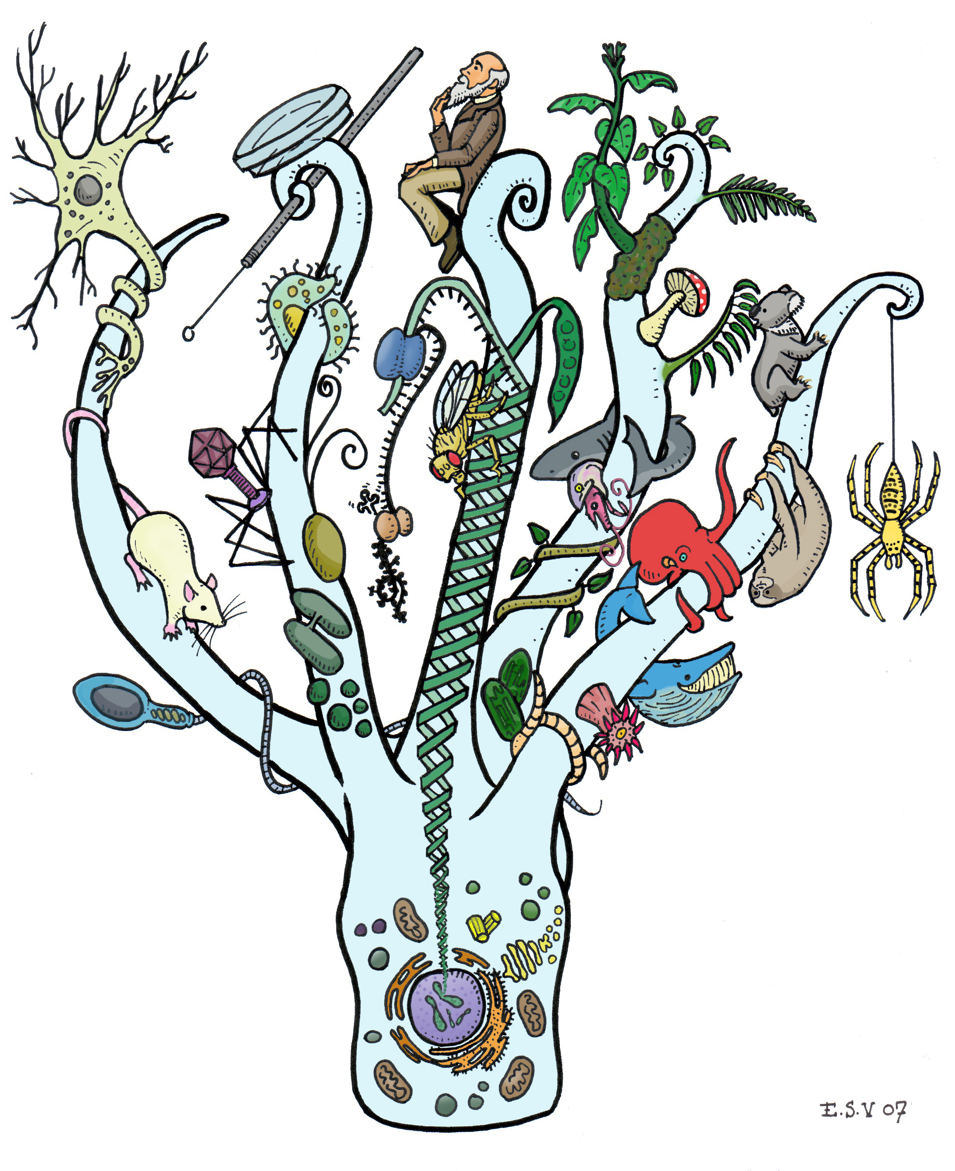
INTRO: Homeostasis- Chap 40 pg 860-867

- Explain the meaning of homeostasis & dynamic equilibrium
- Describe 4 examples of homeostasis in the human body
- Explain how organ systems use negative feedback to maintain homeostasis
- Apply and extend examples of homeostasis using graphs and diagrams
- Give an example of positive & negative feedback
- Use examples to explain the hormonal regulation of homeostasis

A. Chemistry of Life: Cell Compounds- Chap 3 pg 46-
- Draw and label two water molecules showing their polarity and where a hydrogen bond would form.
- Describe how the polarity of the water molecules results in hydrogen bonding.
- Describe how the polarity of water makes it a good solvent, temperature regulator, and lubricant.
- Distinguish among acids, bases, and buffers, and indicate importance of pH to biological systems.

B. Chemistry of Life: Biological Macromolecules- Chap 5 pg 68-
- Demonstrate knowledge of synthesis and hydrolysis as applied to organic polymers.
- Given diagrams, distinguish among carbohydrates, lipids, proteins, and nucleic acids with respect to chemical structure.
- List the main functions of carbohydrates
- Recognize the empirical formula of a carbohydrate.
5. Differentiate among monosaccharides, disaccharides, and polysaccharides.
6. Differentiate among starch, cellulose, and glycogen.
- List the main functions of lipids.
- Given a diagram, identify neutral fats, steroids, phospholipids, saturated and unsaturated fatty acids.
- Compare and contrast saturated and unsaturated fats in term of molecular structure, source and state at room temperature.
- List the major functions of proteins.
11. Draw a generalized amino acid and identify the amine, acid (carboxyl), and R groups.
12. Draw and label a di-peptide, showing the peptide bond and the formation of a water molecule.
13. Differentiate among the primary, secondary, tertiary and quaternary structure of proteins.
- List the major functions of nucleic acids including DNA, RNA and ATP.
- Label the components of a generalized nucleotide.
16. Relate the general structure of the ATP molecule to its role as the “energy currency” of cells.

C. Cell Biology: Cell Structure & Function Chap 6pg 94-
1. Describe the following cell structures and their functions: cell membrane, mitochondria, smooth and rough endoplasmic reticulum, ribosomes, Golgi bodies, vesicles, vacuoles, lysosomes, nuclear envelope, nucleus, nucleolus, chromosomes.
2. Identify the cell structures in a diagram and electron micrographs.

D. Cell Biology: Transport Across Cell Membrane Chap 7 pg 125-
1. Draw and label the fluid mosaic membrane model, giving the function of the components.
2. Explain why the cell membrane is described as “selectively permeable”.
3. Compare and contrast the following: diffusion, facilitated transport, osmosis, active transport.
4. Relate the structure of the membrane to the different methods molecules use to cross the membrane.
5. Explain factors that affect the rate of diffusion across the cell membrane.
6. Describe endocytosis, including phagocytosis and pinocytosis, and contrast it with exocytosis.
7. Define solute, solvent, solution, isotonic, hypertonic, hypotonic and concentration gradient.
8. Compare and contrast diffusion and osmosis.
9. Predict the effects of hypertonic, isotonic, and hypotonic environments on animal cells and plant cells.
10. Apply the concept of tonicity to osmoregulation in a variety of living organisms.
11. Use the equation Ψ ₌ Ψ_{P +} Ψ_{S} to calculate water potential
12. Demonstrate an understanding of the relationship and significance of surface area to volume, with reference to cell size.

E. Gene Expression & Regulation: DNA- Chap 16 pg 305-
- Name the four bases in DNA and describe the structure of DNA using the following terms: nucleotide (sugar, phosphate, base), complementary base pairing, double helix, hydrogen bonding, covalent bonding, antiparallel, 5→3.
- Differentiate between purines and pyrimadines, including differences in their size, number of bonds and explain why they bond complimentarily.
3. Describe DNA replication with reference to three basic steps: “unzipping”, complementary base pairing, joining of adjacent nucleotides.
4. Describe DNA replication in detail including the role of helicase, primase, DNA polymerase III, DNA Polymerase I and ligase.
5. Define recombinant DNA

F. Gene Expression & Regulation: Protein Synthesis- Chap 17 pg 325-
- Compare and contrast the general structural composition of DNA and RNA
2. Demonstrate a knowledge of the basic steps of protein synthesis, identifying the roles of DNA, mRNA, tRNA and ribosomes in the processes of transcription and translation, including initiation, elongation, translocation and termination.
3. Determine the sequence of amino acids coded for by a specific DNA sequence, given a table of mRNA codons.
4. Give examples of two environmental mutagens that can cause mutations in humans.
5. Use examples to explain how mutations in DNA affect protein synthesis and may lead to genetic disorders.
6. Investigate and discuss biotechnologies related to gene expression (cloning vectors, PCR, Gel Electrophoresis, Gene therapy…) Chap 20

G. Cellular Energetics: Enzymes & Metabolism- Chap 8 pg 142-
1. Demonstrate an understanding of the following terms: metabolism, enzyme, substrate, product, coenzyme, activation energy, active site, allosteric site, catabolic pathway, anabolic pathway
2. Use the free energy change of a reaction to classify it as endergonic or exergonic and whether it is spontaneous or not
3. Describe the role of ATP in energy coupling
4. Explain the “Lock & Key” and the “Induced Fit” models of enzymatic reactions
5. Identify the role of vitamins in biochemical reactions
6. Apply the knowledge of proteins to explain the effects on enzyme activity of pH, temperature, substrate concentration, enzyme concentration, competitive inhibitors, and heavy metals.
7. Explain how allosteric regulation works
8. Explain how feedback inhibition can be used to control the concentration of a product.
9. Outline the role of thyroxin in metabolism. Describe how thyroxin levels are controlled throughout the day and night.

H. Cellular Energetics: Cellular Respiration- Chap 9 pg 163-
1. Give the summary equation of cellular respiration.
2. Explain the importance of reduction & oxidation reactions
-explain the importance of electron carriers such as NAD+ and FADH
-identify oxidizing and reducing agents
3. Compare and contrast Glycolysis, Krebs Cycle & ETC/Chemiosmosis → compare what is used vs what is produced (NADH, FADH₂, CO₂, H₂O, ATP ) → the presence of oxygen? → location in the cell/ location within the mitochondria
4. I can explain the difference between substrate level and oxidative phosphorylation
5. I can explain how the proton motive force/gradient is produced & it’s significance in relation to chemiosmosis (ATP Synthase)
6. I can explain the importance of NADH and FADH in producing ATP during ETC
7. I can compare and contrast fermentation, anerobic respiration and aerobic respiration
→ apply vocab: obligate anaerobe, facultative anaerobe, pyruvate, presence of oxygen, final electron acceptor, glycolysis, prokaryotes, evolutionary significance, location in cell
8. I can explain the difference between alcohol fermentation and lactic acid fermentation using examples (yeast/ bacteria/ muscle cells)
9. I can analyze and interpret graphs based on cellular respiration
10. I can explain the importance of breathing in oxygen at a cellular level

I. Cellular Energetics: Photosynthesis- Chap 10 pg 184-
1. State the summary equation of photosynthesis including the source and fate of all reactants and products
2. Draw a diagram to show where in the leaf and in the chloroplast the photosynthesis reactions occur
3. Describe the events that occur during the light reactions (reactants, products)
4. Explain the differences between Photosystem ! and II
5. Describe linear electron flow vs cyclic electron flow
6. Explain how chemiosmosis generates ATP
7. Describe the 3 phases of the Calvin Cycle
8. Compare and contrast the Light Reactions and the Calvin Cycle
9. Compare and contrast chemiosmosis in choloroplasts and in mitochondria
10. Describe the photosynthetic adaptations of C₄ plants and CAM plants

J. Cell Communication and the Cell Cycle: Types of Communication- Chap 11 pg 206-
1. Describe & give examples of how cells may communication with direct contact, local signaling and long distance signaling.
2. Explain the 3 stages of cell signaling using key vocabulary
3. Describe the role of protein kinases in a phosphorylation cascade (in a signal transduction pathway)
4. Explain how cyclic AMP acts as a second messenger in signaling pathways
5. Explain how Calcium ions act as a second messenger in signaling pathways
6. Describe examples of nuclear and cytoplasmic responses
7. Explain the role of apoptotic pathways

I. Cell Communication and the Cell Cycle: The Cell Cycle- Chap 12 pg 228-
1.Describe the meaning of key vocabulary: chromosomes, chromatin, sister chromatids, centromere, kinetochore, somatic cells, gametes, mitosis, cytokinesis
2. Use a diagram to show the phases of the cell cycle (M phase, G₁ phase, S phase, G₂ phase, prophase, metaphase, anaphase, telophase)
3. Describe and identify what is occurring within the cell during PMAT and Cytokinesis
4. Describe the molecules of the cell cycle control system and checkpoints that regulate the cell cycle
(cyclins, cyclin dependent kinases, growth factor, MPF)
5. Explain how external signals regulate the cell cycle (density dependent inhibition, anchorage dependence)
6. Compare and contrast normal cells and cancer cells with regard to cell cycle control

J. Heredity: Meiosis -Chap 13 pg 248-
1. Describe the role of meiosis in creating genetic diversity
2. Demonstrate understanding of the key vocab: karyotype, homologous chromosomes, sex chromosomes, autosomes, diploid cell, haploid cell, zygote, fertilization
3. Describe the stages in meiosis (Meiosis I vs Meiosis II)
4. Compare and contrast Mitosis and Meiosis
5. Describe 3 mechanisms that contribute to genetic diversity (independent assortment of chromosomes, crossing over, random fertilization)

K. Heredity: Mendelian Genetics- Chap 14 pg 262-
1. Demonstrate understanding of key vocabulary: true breeding, hybridization, P generation, F₁ & F₂ generations, allele, dominant allele, recessive allele, genotype, phenotype, homozygous, heterozygous, testcross, monohybrid cross, dihybrid cross, complete dominance, incomplete dominance, codominance, pleiotropy, epistasis, pedigree carrier
2. Use a Punnet’s square to predict the offspring that will result from monhybrid and dihybrid crosses
3. Apply the multiplication rule / the addition rule / probability rules to Mendelian inheritance problems.
4. Solve genetics problems that do not follow simple Mendelian patterns (incomplete/codominance, multiple alleles, pleiotropy, epistasis)
5. Discuss the inheritance/ significance of Huntington’s, Tay-Sachs, Cystic Fibrosis, Sickle-Cell Anemia, blood types , genetic testing, etc
6. Give examples of environmental effects on phenotype

L. Heredity: Chromosomal Inheritance- Chap 15 pg 286-
1. Describe the chomosomal theory of inheritance
2. Demonstrate the chromosomal basis for determining sex ( X vs Y chromosomes?)
3. Explain the difference between autosomal genes and sex linked genes inheritance patterns
4. Explain the meaning of “linkage” and “crossing over”
5. Construct a linkage map using observed recombination frequencies.

M. Human Biology: Nervous System- Neuron, Impulse, Generation & Reflex Arc Chap- 48-49
1. Identify and give functions for each of the following: dendrite, cell body, axon
2. Distinguish among sensory, motor and interneurons with respect to structure and function
3. Explain the transmission of a nerve impulse through a neuron using the following terms: resting and action potentials, depolarization and repolarization, sodium and potassium gates, sodium-potassium pump, recovery period, threshold (“all-or-none”)
4. Relate the structure of a myelinated nerve fibre to the speed of impulse conduction
5. Identify the major components of a synapse
6. Explain the process by which impulses travel across a synapse
7. Demonstrate knowledge of how neurotransmitters are broken down in the synaptic cleft
8. Explain the effect of THC, alcohol and cocaine on neurotransmitter function in the brain.

N. Human Biology: Divisions of the Nervous System and the Brain-Chap 48-49 pg 1045-
- Contrast the locations and functions of the central and peripheral nervous systems
- Relate the structure of a reflex arc to how it functions
3. Differentiate between the functions of the sympathetic and parasympathetic divisions of the autonomic nervous system
4. Identify the source gland for epinephrine and explain its role in the “fight or flight” response
5. Identify and give functions for each of the following: medulla oblongata, cerebrum, thalamus, cerebellum, hypothalamus, corpus callosum
6. Explain how the hypothalamus and pituitary gland interact as the neuroendocrine control centre

O. Human Biology: Endocrine System- Chap 45 pg 974-
1. Describe how hormones bind to target receptors and trigger specific pathways
2. List the secretion, target, action and regulation of at least two hormones
3. Draw an illustration of both positive and negative feedback in the regulation of homeostasis by hormones

P. Ecology: Ecology and the Biosphere- Chap 52 pg 1144-
1. Describe and give examples of abiotic and biotic factors
2.Describe how both abiotic/biotic factors affect the formation & distribution of biomes

Q. Ecology: Population Ecology- Chap 53 pg 1170-
1. Define and use graphs/diagrams to show types of density, dispersion and demography.
2. Draw a graph to show exponential and logistic models of population growth
3. How can density dependent and density independent factors affect population growth?
4. What is meant by “carrying capacity”?

R. Ecology: Community Ecology- Chap 54 pg 1194
1. Explain the difference between a fundamental niche and a realized niche.
2. What is the competitive exclusion principle?
3. Describe and give examples of the symbiotic relationships of parasitism, mutualism and commensalism.
4. Define keystone species. Draw a graph to show the impact of a keystone predator on species diversity within a tidal pool community.
5. Compare and contrast primary and Secondary Succession

S. Ecology: Energy Flow Through Ecosystems- Chap 55 pg 128-
1. Define key vocabL ecosystem, autotrophs, primary producers, heterotrophs, primary consumers, secondary consumers, tertiary consumers, detrivores/decomposers
2. Differentiate between gross primary productivity and net primary productivity
3. Draw and label a diagram to show the carbon cycle
4. Draw and label diagram to show the nitrogen cycle
5. Describe the role of bacteria in nitrogen fixation

T. Ecology: Biodiversity and Disruptions to Ecosystems- Chap 56 pg 1238
1. Why is biodiversity important?
2. What are 4 major threats to biodiversity
3. How does agriculture affect nutrient cycling?
4. What are the effects of biomagnification in a marine food chain. Specifically how may the Orcas of British Columbia be impacted?
5. What factors may contribute to ocean acidification? What are the side effects of this?
6. What is climate change? What evidence supports it? What should be done to stop climate change and why?

U. Mechanisms of Evolution: Natural Selection- Chap 22,23,24,2 5pg 453-536

1. Describe how Lamarck’s view of the mechanism of evolution differed from Darwin’s
2. List examples of evidence for evolution
3. Explain the difference between homologous and analogous structures and how this relates to evolution.
4. Define natural selection, genetic drift, founder effect, Bottleneck effect, Gene flow, Fitness, Directional Selection, Disruptive selection, Stabilizing selection, sexual selection, allopatric speciation. sympatric speciation, adaptive radiation
5. Give a scientific hypothesis about the origin of life on Earth
6. Give evidence for endosymbiosis
7. How did Miller and Urey test the Oparin-Haldane Hypothesis and what did they learn?
8. Shared characteristics are used to make phylogenetic trees. Make a cladogram for 6 organisms of your choice.
9. List the conditions needed for Hardy Weinberg Equilibrium (for evolution to Not be occurring)
10. Apply the Hardy Weinberg Equation: p² + 2pq + q² = 1



