Bio 12AP Sparking the Ingredients for Life Name:________________
See pg 59, Fig 4.2 Date: ________________

Source: https://study.com/academy/lesson/stanley-miller-theory-experiment-apparatus.html
Stanley Miller was an American chemist who conducted one of the most exciting experiments in modern science. It sought to answer the question, How did life on Earth begin? It's a complex question, and one that has still not been fully answered and may never be. Miller's famous experiment, though, gave us an idea of how life could have developed out of non-living matter, a process called abiogenesis.

The Miller-Urey Experiment

Miller's experimental interests at the University of Chicago were in the field of astrobiology, which is the study of life in the universe, including its origins and evolution on Earth, as well as, potentially, elsewhere. The famous experiment Miller conducted in 1953 was based on a hypothesis that stated life could have originated from basic molecules present on the early Earth. The idea was that gases present in the atmosphere and in the seas of the primitive, pre-life Earth could have been stimulated by lightning to react and produce the chemicals necessary for living cells to arise. Stanley Miller, under the guidance of Professor Harold Urey, set up the Miller-Urey Experiment to test this hypothesis.

He included basic chemicals that were present on Earth before life began: water, methane, ammonia, and hydrogen. These molecules contain the most abundant elements in living cells, which are carbon, hydrogen, oxygen, and nitrogen.

Miller connected two sterile, glass flasks by a series of glass tubes. One flask contained water and the dissolved molecules. This flask was heated, and the water vapor and gases released into the tubing. They could freely move into the second flask, which was sparked by electrodes to simulate lightning strikes. The gases were then condensed into a liquid that was carried back to the original flask. The cycle went on continuously for two weeks.
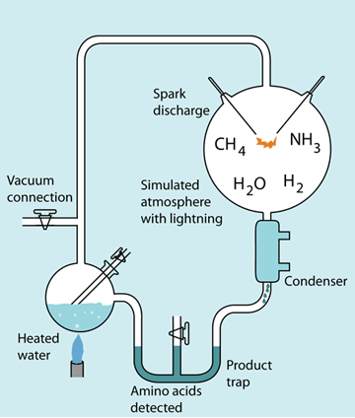

Within one day the solution in the flask had developed a pinkish hue. By the end of the experiment, Miller and Urey identified many new compounds that formed in the apparatus. These included several different types of amino acids, the small molecules that make up proteins, as well as simple carbohydrates.

The Implications and Continuing Work

The results of the Miller-Urey experiment were thrilling for scientists, and the implications were important. Miller proved that under the conditions present on the early Earth (as far as were known at the time), the building block molecules of life could form. Furthermore, we now know that early Earth's atmosphere contained a few more simple compounds that Miller didn't include in his original experiment. These additional molecules would lead to a greater diversity of amino acids and other chemicals found in living cells.

Inorganic molecules constitute nonliving matter, but even so inorganic molecules like salts (eg; NaCl) and water play important roles in living things.
Bio12AP An Introduction to Organic Molecules
Chap 5 pg 68-69
The molecules of life are organic molecules. Organic molecules always contain carbon (C) and hydrogen (H). The chemistry of carbon accounts for the formation of the very large variety of organic molecules found in living things.
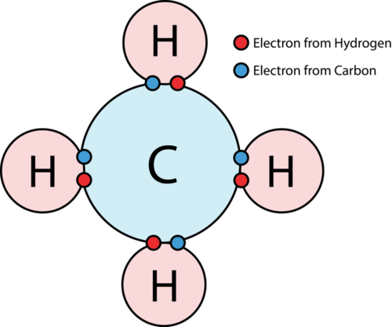

A carbon has four electrons in the outer shell. In order to achieve eight electrons in the outer shell, a carbon atom shares electrons covalently with as many as 4 other atoms.
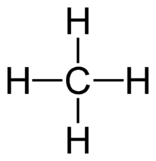

Methane is a molecule in which a carbon atom shares electrons with four hydrogen atoms.

A carbon atom can share electrons with another carbon, and in doing so can form a long hydrocarbon chain (a). A hydrocarbon chain can also turn back on itself to form a ring compound (b).
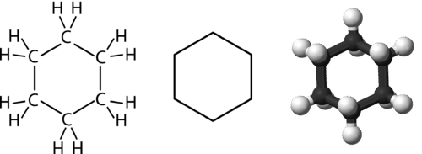
a)
b)
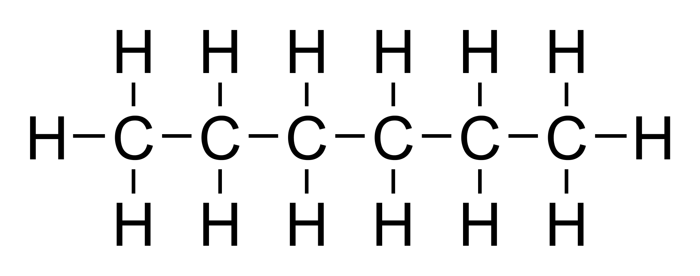

Functional groups can also be attached to carbon chains. A functional group is a particular cluster of atoms that always behaves a certain way. One functional group of interest is the acidic carboxyl group –COOH because it can give up a hydrogen (H+) and ionize to –COO -

While a hydrocarbon chain is hydrophic (not attracted to water) because it is nonpolar, a hydrocarbon chain with an attached ionized group is hydrophilic (is attracted to water) because it is polar.

The molecules of life are divided into four classes: i) carbohydrates, ii) lipids, iii) proteins and iv) nucleic acids. Many molecules of life are macromolecules. Just as atoms can join to form a molecule, so can molecules to form a macromolecule. The smaller molecules are called monomers and the macromolecule is called a polymer. A polymer is a chain of monomers.
Your Mission:
Read Section 5.1 on pg 68-69 in your text. Complete the Sec 5.1 Instant Practice Qs & Correct

