Carbon is the backbone of life on Earth. We are made of carbon, we eat carbon, and our civilizations—our economies, our homes, our means of transport—are built on carbon.
Bio 12AP Carbon and the Molecular Diversity of Life Name: ______________
Chap 4 pg 58 Adapted from: https://earthobservatory.nasa.gov/features/CarbonCycle Date: _______________
Block: ____
Hydrogen (H), Oxygen (O), Nitrogen (N), Sulfur (S) and Phosphorus (P) are the other common ingredients in living things, but it is the element Carbon that accounts for the enormous variety of biological molecules.
Forged in the heart of aging stars, carbon is the fourth most abundant element in the Universe. Most of Earth’s carbon—about 65,500 billion metric tons—is stored in rocks. The rest is in the ocean, atmosphere, plants, soil, and fossil fuels.
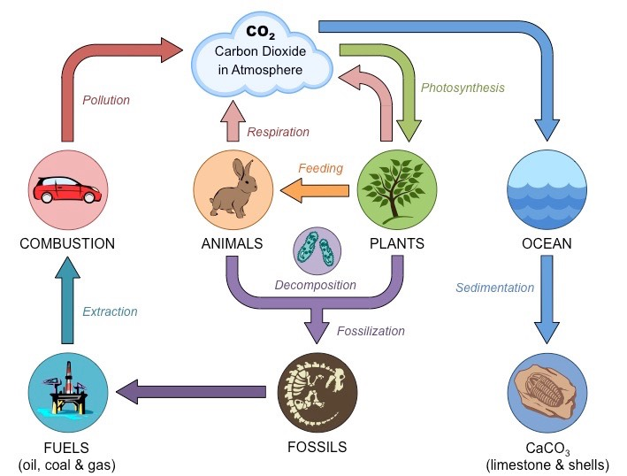

Carbon flows between each reservoir in an exchange called the carbon cycle, which has slow and fast components. Any change in the cycle that shifts carbon out of one reservoir puts more carbon in the other reservoirs. Changes that put carbon gases into the atmosphere result in warmer temperatures on Earth.

We need carbon, but that need is also entwined with one of the most serious problems facing us today: global climate change.
Q: Have you watched any of Greta Thunberg’s speeches at the United Nations Climate Summit? What is your opinion on this topic? Check it out at : https://www.theguardian.com/environment/video/2019/sep/23/greta-thunberg-to-world-leaders-how-dare-you-you-have-stolen-my-dreams-and-my-childhood-video
This thermostat works over a few hundred thousand years, as part of the slow carbon cycle. This means that for shorter time periods—tens to a hundred thousand years—the temperature of Earth can vary. And, in fact, Earth swings between ice ages and warmer interglacial periods on these time scales. Parts of the carbon cycle may even amplify these short-term temperature changes.
Over the long term, the carbon cycle seems to maintain a balance that prevents all of Earth’s carbon from entering the atmosphere (as is the case on Venus) or from being stored entirely in rocks. This balance helps keep Earth’s temperature relatively stable, like a thermostat.

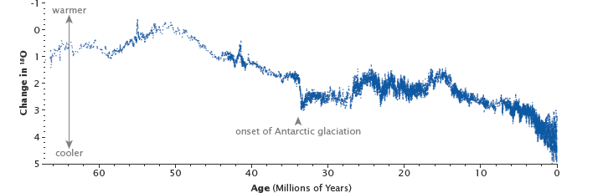

The uplift of the Himalaya, beginning 50 million years ago, reset Earth’s thermostat by providing a large source of fresh rock to pull more carbon into the slow carbon cycle through chemical weathering. The resulting drop in temperatures and the formation of ice sheets changed the ratio between heavy and light oxygen in the deep ocean, as shown in this graph. (Graph based on data from Zachos at al., 2001.)

The Slow Carbon Cycle
Through a series of chemical reactions and tectonic activity, carbon takes between 100-200 million years to move between rocks, soil, ocean, and atmosphere in the slow carbon cycle.
On average, 10¹³ to 10¹⁴ grams (10–100 million metric tons) of carbon move through the slow carbon cycle every year. In comparison, human emissions of carbon to the atmosphere are on the order of 10¹⁵ grams. The movement of carbon from the atmosphere to the lithosphere (rocks) begins with rain. Atmospheric carbon combines with water to form a weak acid—carbonic acid—that falls to the surface in rain. The acid dissolves rocks—a process called chemical weathering—and releases calcium, magnesium, potassium, or sodium ions. Rivers carry the ions to the ocean. The slow cycle returns carbon to the atmosphere through volcanoes.
The Fast Carbon Cycle
The fast carbon cycle moves 10¹⁶ to 10¹⁷ grams of carbon per year. Plants and phytoplankton are the main components of the fast carbon cycle. Phytoplankton (microscopic organisms in the ocean) and plants take carbon dioxide from the atmosphere by absorbing it into their cells. Using energy from the Sun, both plants and plankton combine carbon dioxide (CO₂) and water to form sugar (CH₂O) and oxygen. The chemical reaction looks like this: CO₂ + H₂O + energy = CH₂O + O₂
Changes in the Carbon Cycle
Left unperturbed, the fast and slow carbon cycles maintain a relatively steady concentration of carbon in the atmosphere, land, plants, and ocean. But when anything changes the amount of carbon in one reservoir, the effect ripples through the others. In Earth’s past, the carbon cycle has changed in response to climate change. Variations in Earth’s orbit alter the amount of energy Earth receives from the Sun and leads to a cycle of ice ages and warm periods like Earth’s current climate. Today, changes in the carbon cycle are happening because of people. We perturb the carbon cycle by burning fossil fuels and clearing land.
When we clear forests, we remove a dense growth of plants that had stored carbon in wood, stems, and leaves—biomass. By removing a forest, we eliminate plants that would otherwise take carbon out of the atmosphere as they grow. We tend to replace the dense growth with crops or pasture, which store less carbon. We also expose soil that vents carbon from decayed plant matter into the atmosphere. Humans are currently emitting just under a billion tons of carbon into the atmosphere per year through land use changes.

