Learning Goals
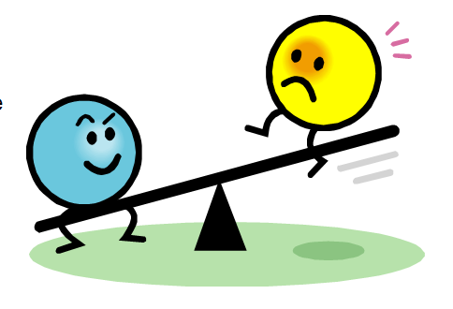
Bio 12 REVIEW: Homeostasis, Water, Acids/Bases, Buffers Name: ___________________
Sec 11.5 pg 208-209 Date: _____________________
Ch. 2 Block: ________
Homeostasis Intro
- 1. I can explain the meaning of homeostasis & dynamic equilibrium
- 2. I can describe 4 examples of homeostasis in the human body
- 3.I can explain how organ systems use negative feedback to maintain homeostasis
- 4. I can apply and extend examples of homeostasis using graphs and diagrams

Water
- 5.I can describe the polarity of water using key vocab
  - Covalent bond, negative end, positive end, polar, hydrophobic, hydrophilic, hydrogen bonds
- 6. I can use examples to explain the properties of water needed for life (polarity, cohesion, temperature regulator, universal solvent) & the significance of water in the human body ( Solvent , temperature regulator, lubricant)

Acids / Bases /Buffers
- 7. I can identify, give examples & describe the differences between:
- an acid, base, buffer, inorganic molecule, organic molecules
- 8. I can use the pH scale to indicate acidity or basicity & use examples to describe the importance of pH in the human body
- 9.I can explain the significance of carbonic acid in maintaining homeostasis

PRACTICE
-Identify the following as True or False.
-If true, explain & extend to show what this means. If false, correct the statement.

1. T F | The diagram below shows that water is in organic and non-polar
2. T F | Water does not form Hydrogen bonds easily

3. Using the graph shown above which animals do you predict
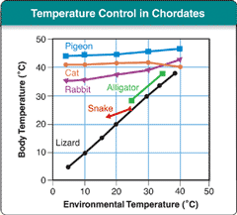
are thermoregulators (aka utilize homeostasis to maintain
body temp.?)

4. Why is blood sugar level constant between 21:00-7:00?
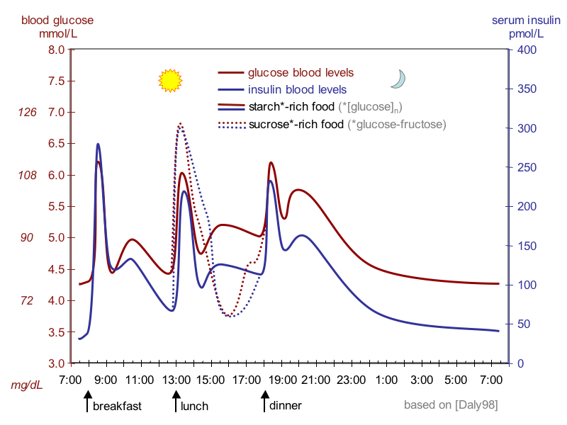

b. Write a hypothesis in an “if…then..
because...” statement to predict what will occurring during the next breakfast

5. Compare and contrast positive feedback and negative feedback in the human body.
POSITIVE FEEDBACK Similarities NEGATIVE FEEDBACK

6. Why is homeostasis a dynamic equilibrium?

