b)

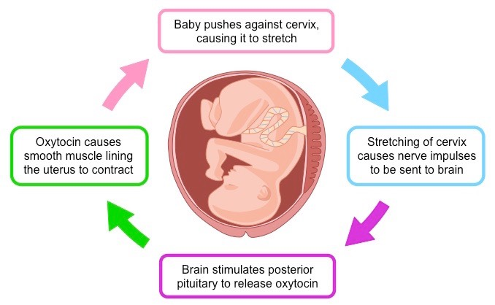

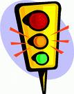

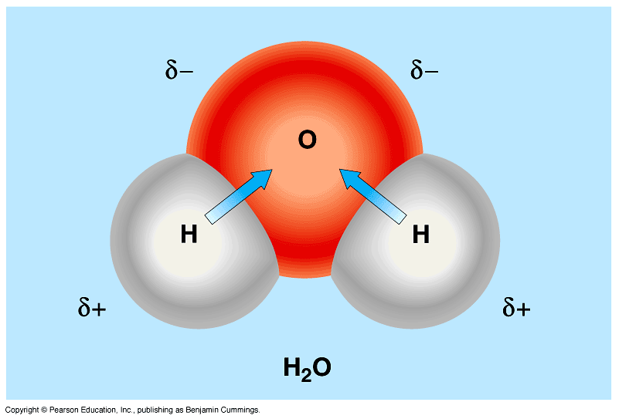



Biology 12 CHECKPOINT- **Homeostasis, Water, Acids/Bases/pH Buffer** Name(s): _______________

Date: _________________Block: ____

**a) What do the following diagrams show? Add key vocab/details/ examples to show your understanding**

Biology 12 CHECKPOINT- **Homeostasis** Name(s): ______________________

Date: _________________Block: ____

**a) What do the following diagrams show? Add key vocab/details/examples to show your understanding**

b)



 





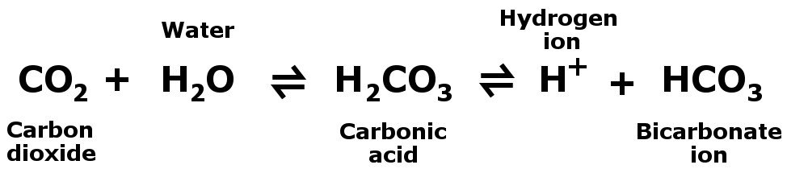

c)



d) The pH of the blood changes from 7.4 to 5.4. How much more acidic is the blood now?

c)





d) The pH of the blood changes from 7.4 to 5.4. How much more acidic is the blood now?