**Biology 12 is an intensive yet rewarding course that provides an in depth look at the molecular, cellular & systems levels of the human body.** The main themes of Biology 12 can be divided into:

**Biology 12- Anatomy & Physiology**

Ms. V. Norris @adventuresinbio

vanessa.norris@burnabyschools.ca

http://sd41blogs.ca/norrisv/

1. **Homeostasis-** **the body strives to maintain the internal environment relatively constant within a normal range.**

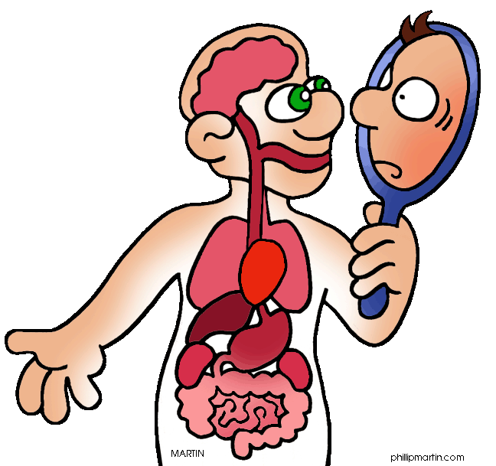

[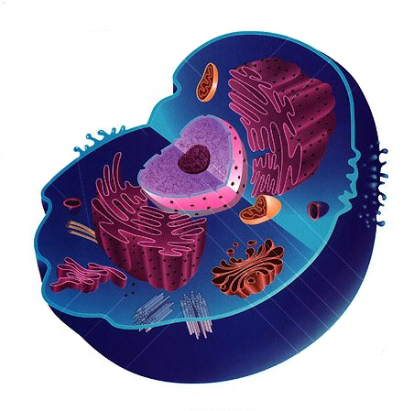](http://www.clipartbest.com/clipart-acqeegKcM)

1. **Gene Expression -cell structure & transport, organic molecules, DNA replication & protein synthesis, enzymes & rxns**
2. **Systems & Organization- body systems have complex interrelationships to maintain homeostasis (***digestive,**circulatory, respiratory, nervous, urinary & reproductive)*

**Course Objectives:**

* To build a culture of learning that is fun, positive, collaborative & challenging ☺
* To gain appreciation & enthusiasm for the human body (from cells to systems)
* To develop the ability to question, predict, conduct, plan, process, analyze & evaluate data & information at a higher level

**Classroom Expectations:**

***I. RESPONSIBILITY:***

* ***Bring your materials & work, bring a positive attitude, participate, ask q’s & ask for help!***
* **Check the website for missed work** <http://sd41blogs.ca/norrisv/> or @adventuresinbio
* **Missed classes are missed opportunities to show your learning & may negatively affect your work habit. You may be asked to complete any missed test as an interview instead**

***II. RESPECT:*** *Each other and the learning environment!*

MC900089060[1]

**Work Ethic:** ***Regular attendance, active engagement &***

|  |  |  |
| --- | --- | --- |
| **Good** | **Satisfactory** | **Needs Improvement** |
| * On time for class, with all materials * Actively involved in learning; asks Qs, participates respectfully, works well with all students & in groups, shows initiative * Completes all work to the best of ability * Uses class time wisely * Responsible use of equipment & clean up * Uses personal technologies responsibly | * Usually on time for class, with materials * Usually actively involved in class, participates respectfully, works w/others * Completes most work to the best of ability * Usually uses class time wisely * Sometimes needs reminders to use personal technologies responsibly | * Often late for class, missing materials / in excused absences * Needs support to become involved in class activities/participate/ to work with others * Work is incomplete, lacks effort or copied * Struggles to use class time wisely * Personal technologies interfere with learning |

***good work habits are essential for success!***

Daily review of the learning goals covered in class is highly recommended **as assessment will emphasize making connections, extending and applying ideas.**

**Assessment:**

|  |  |  |  |
| --- | --- | --- | --- |
| **Emerging** | **Developing** | **Proficient** | **Extending** |
| * Difficulty demonstrating basic understanding of concepts. * Needs support to explain & show knowledge using key terms, details, images& examples. * Struggles to relate & apply knowledge to other concepts | * Demonstrates a basic   understanding of concepts.   * Needs to improve use and connection of key terms, details, images and examples. * Partially relates and applies knowledge to other concepts | * Demonstrates a solid   understanding of concepts.   * Able to connect most key terms, images and examples using details * Moderately extends knowledge through connections & applications to other contexts. | * Demonstrates deep understanding & mastery of key concepts * Can connect key terms, images & examples with details * Thoroughly extends, relates and applies knowledge to a variety of contexts & concepts |

Term grades will depict a snapshot of the student’s learning and may involve student-teacher interviews along with portfolio assessments of the most pertinent learning activities. This course will require at least 1 mini & 1 major inquiry project.

|  |  |  |  |  |  |  |  |  |  |  |  |  |
| --- | --- | --- | --- | --- | --- | --- | --- | --- | --- | --- | --- | --- |
| **LEVEL** | **Emerging** | | | **Developing** | | | **Proficient** | | | **Extending** | | |
| **LETTER GRADE (L.G)** | I / C- | | | C / C+ | | | B / A | | | A+ | | |
| **PERCENTAGE (%)** | 0 | 40 | 50 | 60 | 65 | 70 | 75 | 80 | 86 | 90 | 95 | 100 |

***“Think about your hero.***

***Do you think of this person as someone with extraordinary abilities who achieved with little effort?***

***Now go find out the truth.***

***Find out the tremendous effort that went into their accomplishment- and admire them more.”***

***(Dweck, 2008)***

