|  |  |  |  |
| --- | --- | --- | --- |
|  | **Carbohydrates** | | |
| **General Function** |  | | |
| **Key Characteristics:**  **-molecules involved:**  **-ratio of molecules:**  **-general molecular formula:**  **-general structure:** |  | | |
| **Simple Carbohydrates**  **Examples**  **&**  **Structural Diagrams** | i) Glucose: monosaccharide  **Found in:**  **Used for:**  **Diagram:** | ii) Fructose: monosaccharide  **Found in:**  **Used for:**  **Diagram:** | iii) Maltose: disaccharide  **Found in:**  **Used for:**  **Diagram:** |
| **Example of polymers**  **&**  **Structural Diagrams** | i) Starch  **Found in:**  **Used for:**  **Diagram:** | ii) Glycogen  **Found in:**  **Used for:**  **Diagram:** | Cellulose  **Found in:**  **Used for:**  **Diagram:** |



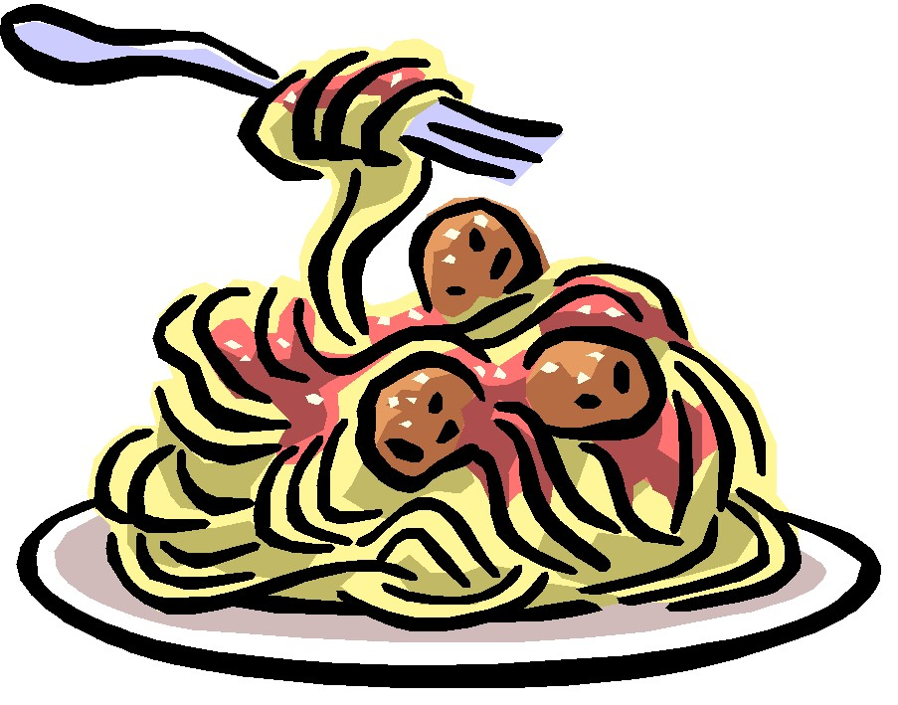

Biology 12 Name: _______________

Sec 2.5 **CLASSES OF ORGANIC MOLECULES** Date: _______________

Pg32-33 I. CARBOHYDRATES Block: _____

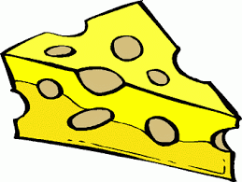

|  |  |  |  |
| --- | --- | --- | --- |
|  | **Lipids** | | |
| **a)What key characteristic do ALL lipids have in common?**  **b) List 3 examples of lipids** |  | | |
| **List 3 Functions Lipids have in the body:** |  | | |
| **Draw a diagram to show the synthesis & hydrolysis of a fat. (See Fig 2.22)** |  | | |
| **Notes on Lipids**  *Read the text and make your own notes for each heading*  **Structural Diagrams**  *Be sure to highlight/note key differences on the diagrams* | i) Saturated Fatty Acids | ii) Unsaturated Fatty Acid | iii) Triglyceride |
| iv) Phospholipid | v) Steroids |  |

Biology 12 Name: _______________

Sec 2.6 **CLASSES OF ORGANIC MOLECULES** Date: _______________

Pg34-35 II. LIPIDS Block: _____

