Welcome to Bio 12 AP! Ever wonder how our cells communicate to each other, how hormones and proteins are created, how genetic differences arise, or how our bodies create energy? We will explore all of this and more in Biology 12 AP!
Biology 12 Advanced Placement
Ms. V. Norris @adventuresinbio
vanessa.norris@burnabyschools.ca
http://sd41blogs.ca/norrisv/

Course Content:
Biology 12 AP includes content enriched from Anatomy & Physiology 12 with the addition of Advanced Placement (AP) Biology topics that are generally covered in first/second year college level courses. Together we will explore subject matter emphasizing Homeostasis, Cell and Molecular Biochemistry, Energetics & Metabolism, Genetics, Human Biology, Ecology & Evolution. Those students who wish to prepare for the AP Biology exam in May will have access to further resources and materials, as necessary.
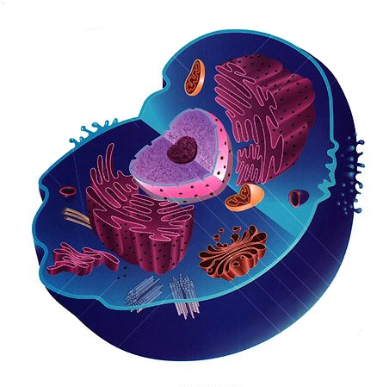

Goals:
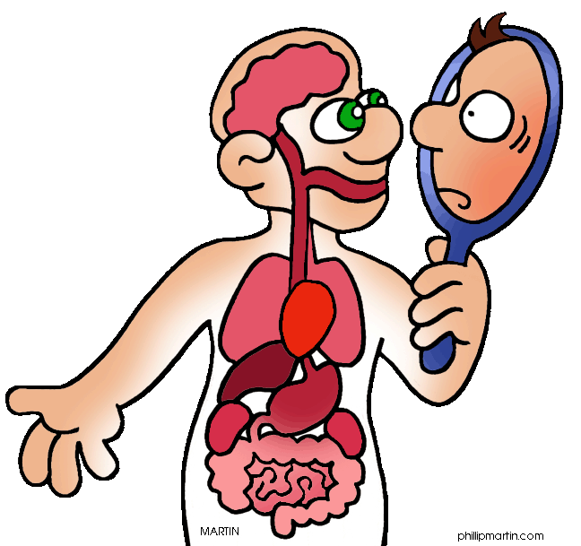
- Be a good human. Be kind to yourself and to others so that we can learn together.
- To become better critical and creative thinkers
- To develop and to explore complex questions
- To effectively communicate ideas using scientific language and a variety of forms
- To analyze and interpret information to form new questions
- To connect what we are learning in our class to other contexts and to investigate how these ideas are useful/apply to “real life.”
- To gain more of an appreciation and enthusiasm for Biology
Classroom Guidelines:
- Respect (yourself, others, the classroom, and the learning community)
- If you decide to snack on food please put all garbage away
- Please bring your binder/notebook/textbook and a pen/pencil and calculator to class

Homework and Assignment Policies:
- Students are expected to keep up to date with all work, to maintain a study guide and a lab book.
- If you are away or miss any part of a class please check the class’ homework website located on the school’s homepage: http://sd41blogs.ca/norrisv/

Marks and Evaluation:
The year is divided into three terms, and our scores will be recorded cumulatively. There will be a term test each. The date will be provided at least two weeks prior to the test. A final inquiry / research paper will be assigned.
5 Big Ideas of AP Biology:

Emerging |  | Developing |  |  |  | Proficient |  |  |  | Extending
Does not yet demonstrate a basic understanding of concept. Struggles to use key vocabulary or ideas accurately. Substantial errors, needs more practice. |  | Basic understanding of concepts shown. Can show meaning of some key ideas & vocab. Errors / inconsistency show some missing elements, review recommended. |  |  |  | Solid understanding of concepts shown. Can apply & use examples for key vocab. Few errors. Sophisticated connections can be made & explained with details. |  |  |  | Deep understanding & mastery shown. Strong application of terms, images & examples with details  Thoroughly extends, relates and applies knowledge to a variety of contexts & concepts
I | C- | C |  | C+ |  | B |  | A |  | A+
40% | 50% | 60% | 65% |  | 70 | 75 | 80 |  | 86 | 90 | 95 | 100

- The process of evolution drives the diversity and unity of life.
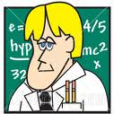
The 5 Big Ideas of AP Biology:
-Darwin’s theory of natural selection is evolution’s major driving mechanism.
-Phylogenetic trees and cladograms graphically represent evolutionary history.
-The genetic code is universal because all living things descend from a common ancestor & evolutionary theory is supported with evidence from many scientific disciples.

- Biological systems utilize free energy and molecular building blocks to grow, to reproduce and to maintain dynamic homeostasis.
-Reciprocal processes of cellular respiration and photosynthesis cycle H₂0, O₂ & CO_{2.}
-Surface to volume ratios affect the capacity to obtain resources and eliminate wastes.
-Selectively permeable plasma membranes regulate the movement of molecules across them.
-Negative and positive feedback mechanisms maintain dynamic homeostasis.

- Molecules, cells and organs coordinate activities for the fitness of the organism as a whole
-Cells communicate by generating, transmitting and receiving signals.
-Signal transduction pathways link signal reception with cellular response.
-Animals have nervous systems that sense transmit and integrate information.
-Different regions of the brain have different functions.
-Cells of the immune system interact in complex ways.

- Living systems store, retrieve, transmit and respond to information essential to life processes.
-Genetic info. is passed from parent to offspring via DNA with accuracy though some mutations can occur.
-DNA directs the production of polypeptides at the ribosome with an elaborate process
-The cell cycle is complex with highly regulated checkpoints
-Most traits derive from gene interactions more complex than what Mendel described
-The expression of genes is controlled by cell signaling, transcription factors, alternate splicing of pre-RNA, and environmental factors.

- Biological systems interact, and these systems and their interactions possess complex properties
-Populations, communities and ecosystems interact and respond to changes in the environment.
-Mathematic operations can be used to quantify interactions among living things
-Interactions between living organisms and their environments results in the recycling of matter and the movement of energy through food chains.
The 3 Big Ideas of Anatomy & Physiology 12 Biology:

- Homeostasis- the body strives to maintain the internal environment relatively constant within a normal range.
- Gene Expression -cell structure & transport, organic & biochemistry, DNA replication & protein synthesis, enzymes & rxns
- Systems & Organization- body systems have complex interrelationships to maintain homeostasis (digestive, circulatory, respiratory, nervous, urinary & reproductive, lymphatic)
What is important is to keep learning, enjoy challenge and accept ambiguity.
-Martina Horner

AP Science Practices
When AP questions are written they link specifically to a learning objective and apply one or more of the AP Science Practices. Building these AP skills is essential to your growth as a Scientist!

Science Practice 1: The student can use representations and models to communicate scientific phenomena and solve scientific problems. (create /describe/refine/re-express)

Science Practice 2: The student can use mathematics appropriately.
(justify/apply/estimate)

Science Practice 3: The student can engage in scientific questioning to extend thinking or to guide investigations within the context of the AP course. (pose/refine/evaluate)

Science Practice 4: The student can plan and implement data collection strategies in relation to a scientific question (justify/design/collect data/ evaluate sources of data)

Science Practice 5: The student can perform data analysis and evaluation of evidence (analyze, refine observations & measurements)

Science Practice 6: The student can work with scientific explanations and theories (justify/construct/articulate/make claims/ evaluate)

Science Practice 7: The student is able to connect and relate knowledge across various scales, concepts, and representations in and across domains. (connect / extrapolate)
Final Notes:
- The AP Biology course has changed in the last few years and focuses more on inquiry, exploration and ability to interpret, analyze and apply data, graphs and lab scenarios AND less on content and memorization. The exam can include Biology 11 content, Biology 12 content, and Biology 12 AP content.
- LAB work is an essential component of the AP program and skill development
- AP exams are subject to fee (~$120) and are written in May.
- The exam is scored out of FIVE. Scores of FOUR or FIVE will make you eligible to bypass first-year biology courses at most post-secondary institutions (some will accept scores of THREE as well).
- Last years’ students did very well and credit the course’s preparation, but more importantly worked hard to achieve their desired goals.
A Note on Labs:
This science course will provide students with the opportunity to perform laboratory dissections involving preserved specimens. Students always have the choice to opt out of such activities, but you may be required to complete an alternative learning activity (virtual lab, watch a video, or an alternate task). Although, I want to emphasize the value of the hands-on experience, I completely respect the right for students to choose and you will not be penalized for choosing the alternative activity.

Believe it or not, lack of excellence has nothing to do with talent, personality, conditions, or luck. Excellence is a choice. Quality is not an accident; it is always the result of high intention sincere effort, intelligent direct and skilful execution. It represents the wise choice of many alternatives.
-Willa A. Foster

*Additional Chapter References for AP Exam Review
Topic | Chapter from Campbell Textbook
The Cell  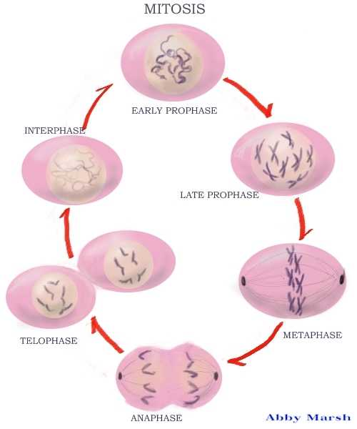  -Cellular Respiration  -Photosynthesis  -Cell Communication  -The Cell Cycle (Mitosis) | Chapter 9  Chapter 10  Chapter 11  Chapter 12
Genetics  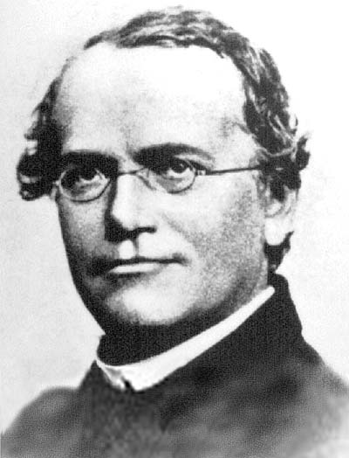  -Meiosis and Sexual Life Cycles  -Mendel and the Gene Idea  -The Chromosomal Basis of Inheritance  -**The Molecular Basis of Inheritance  -**From Gene to Protein | Chapter 13  Chapter 14  Chapter 15  Chapter 16  Chapter 17
Mechanisms of Evolution  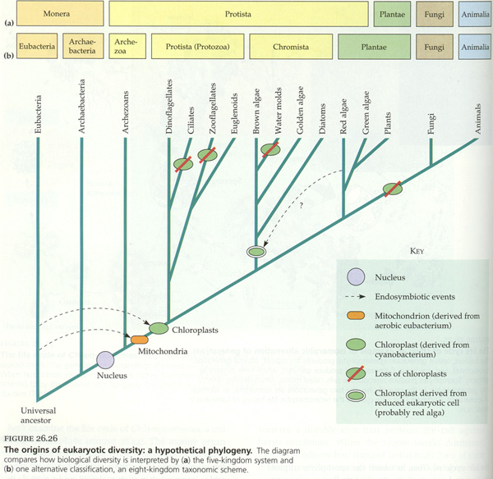  -Descent with Modification  -The Evolution of Populations  -The Origin of Species  -Tracing Phylogeny | Chapter 22  Chapter 23  Chapter 24  Chapter 25
Ecology  -An Introduction to Ecology  and the Biosphere  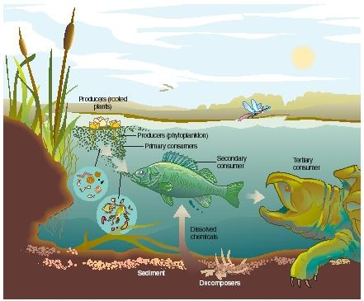  -Population Ecology  -Community Ecology  -Ecosystems  -Conservation Biology | Chapter 50  Chapter 52  Chapter 53  Chapter 54  Chapter 55
Wishing you an AMAZING year of Biology!

