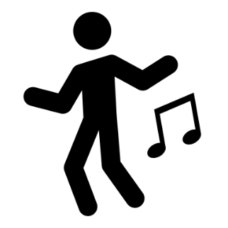
My Music Quarantine Capsule
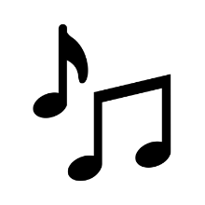

Name ___________________________________________________________________
Date ___________________________________________________________________
My Band Instrument ___________________________________________________________________

How am I feeling today?
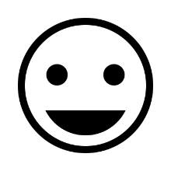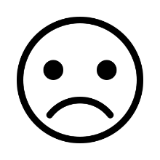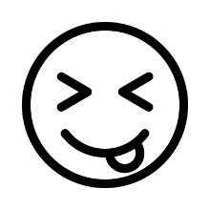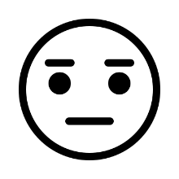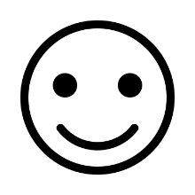

What music did I listen to today?
______________________________________________________________________________

I am able to practice my instrument at home: (circle or highlight)

YES NO

What are 3 things I’m grateful for?
- _______________________________________________________________________
- _______________________________________________________________________
- ________________________________________________________________________

What are 3 goals for the week?
- _______________________________________________________________________
- _______________________________________________________________________
- ________________________________________________________________________

What is something I have learned about myself?
____________________________________________________________________________________________________________________________________________________________

Something I would like you (Ms. Nastalski) to know is:
____________________________________________________________________________________________________________________________________________________________

