Your Hero’s Journey
A Graphic Monomyth
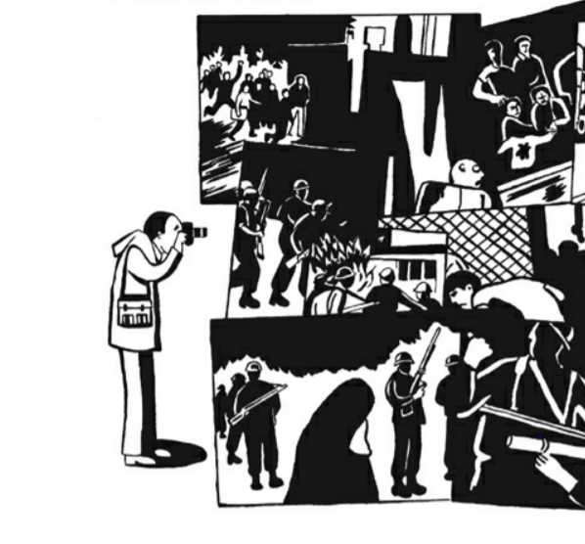
Over the last few classes, you have mused upon mythology, honed your understanding of heroes, and talked of tales of tricksters. You learned how the stories of your favourite characters fit a story-skeleton called the monomyth. Finally, you learned how graphic novels bring a vibrant and dynamic take on narrative. Now, you’re going to make your own six-panel comic of a hero’s journey.

In this assignment, you must:
- Choose one fictional character, or create one yourself.
- Choose either:
  - Six stages of the monomyth that summarize key moments for your character
  - One stage of the monomyth that shows one key scene in detail.
- Create a six-panel comic that illustrates 2a. or 2b.
- Show your understanding of the conventions of graphic novel by using speech bubbles, captions, sound effects, and panel layout. You may also consider what your hero looks like, what they wear, and what tools they might use.
- Directions to the illustrator option: If you do not wish to illustrate a comic yourself, you can also choose to describe your comic in written form, as if you were giving directions to an illustrator. If you choose this option, you need to describe everything that you would want to see in every panel of the comic. Look at 4 for more details.
- Comics expo: show off your work, give and get constructive feedback, and make finishing touches before handing your work in to Mr. Cherrille.

