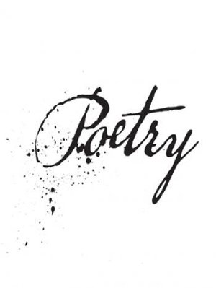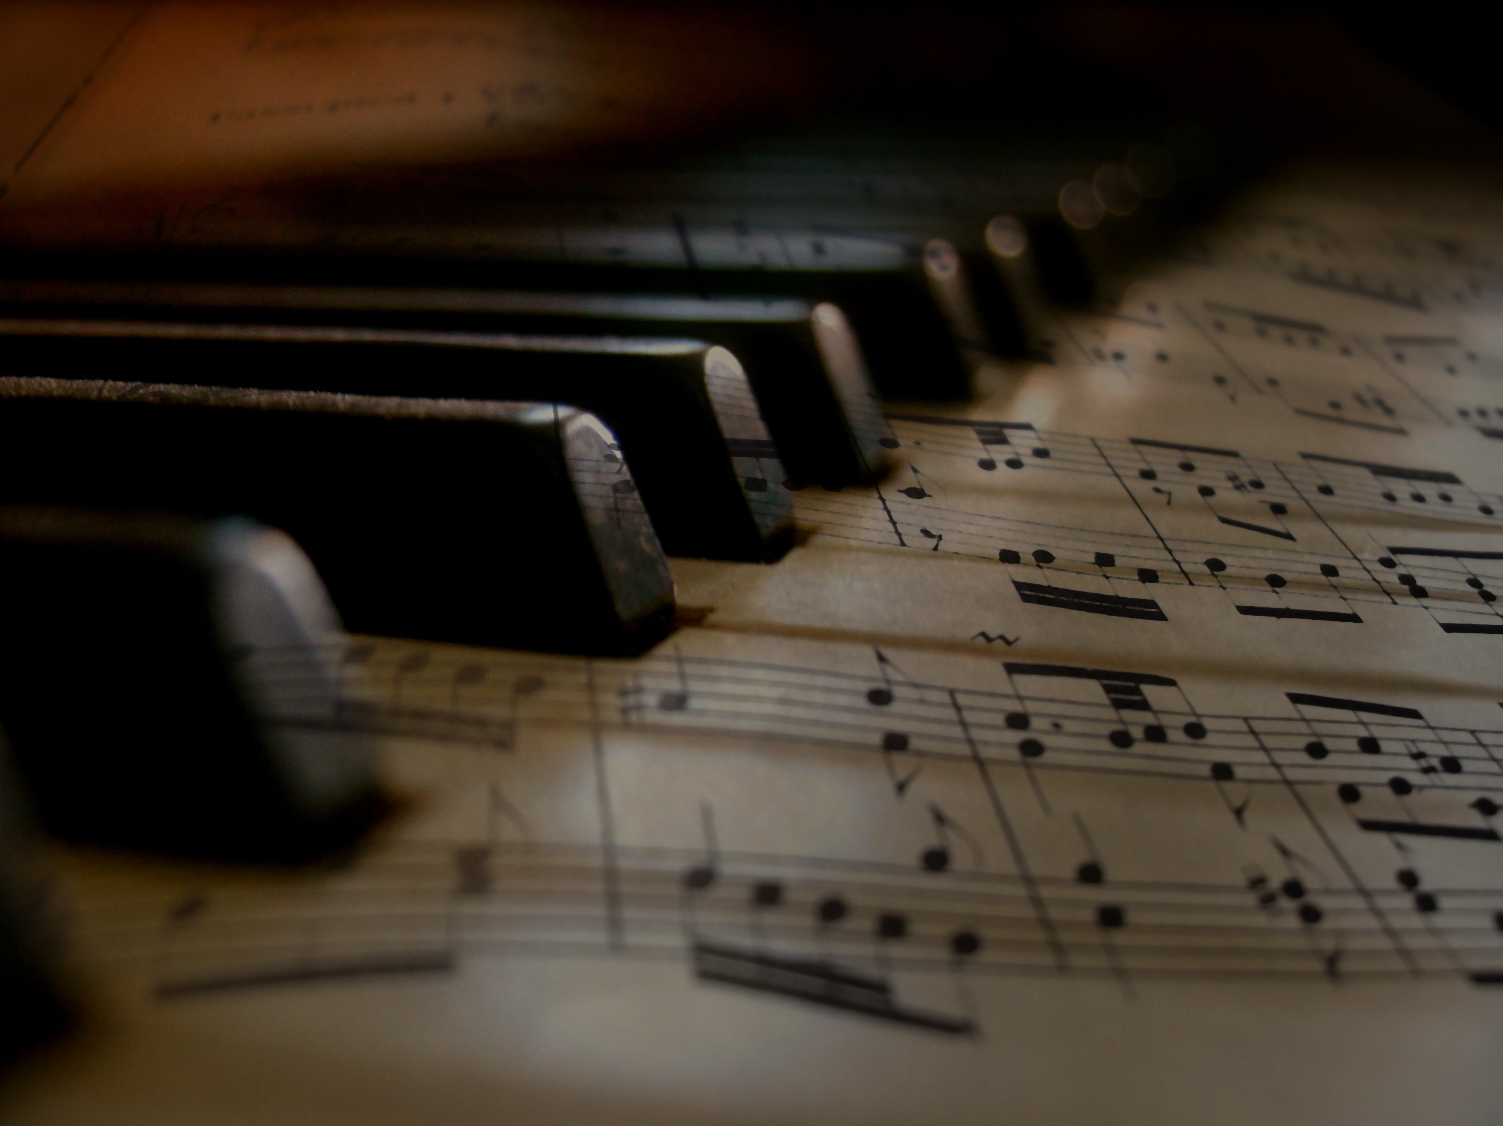  This Photo by Unknown Author is licensed under CC BY-SA-NC |  |  |  | Music & Poetry:  A Symbiotic Relationship
Goal:
To explore the relationship between poetry and music using poems/songs from the past and present. We will utilize the poetry in voice senior choices to explore these concepts. This is in line with the BIG IDEA category : Looking at how language shapes ideas and influences others.

Task:

To find a poem from the” Poetry in Voice Senior Selection Category” on the website provide and then you will find a song that shares a similar theme in order to create a comparison. Themes can range anywhere from race, love, hardship, hope, etc.
Once you have chosen your poem (at least 25 lines from the website) you will then chose a song that holds the same or similar theme. A word to the wise, choose a song with substance. This will allow you the ability to fully demonstrate your understanding of concepts and make inference on if your song is a viable piece of literature.
The overall task involves analyzing both the poem and the song to locate the following:
Literary devices, rhyme, images, greater historical reference, quality of language.
You will then be comparing the themes represented in both works. Finally, you will end with stating why you believe the song is a viable (worthy) piece of literature (or not). Be persuasive and provide proof for your analysis. I have provided a list of 50 literary devices and their definitions down below for you.

Assessment: Rubric online.
 |  | https://www.poetryinvoice.com/poems/senior
 |  | Sd41blogs.ca/murrays

50 LITERARY DEVICES (DEFINITIONS) – BC ENGLISH 12
Alliteration- the repetition of the initial consonant sound in words
Assonance- the repetition of vowel sounds
Consonance- the repetition of consonant sounds in the middle or at the end of words
Enjambment- when the writer uses line breaks meaningfully and abruptly to either emphasize a point or to create dual meanings
Imagery- when the writer or speaker uses their descriptions to access the senses of the reader of listener
Repetition- when the writer or speaker knowingly repeats a word or group of words for effect
Rhyme- when the end or final sound of two or more words are identical
Rhythm- when the arrangement of words creates an audible pattern or beat when read out loud
Onomatopoeia- when the words sound like what they mean
Idiom- an accepted phrase or expression having a meaning different from the literal
Simile- a figure of speech that expresses a resemblance between things of different kinds (usually formed with ‘like’ or ‘as’)
Metaphor- a comparison between two unlike things
Hyperbole- a figure of speech that uses exaggeration to express strong emotion, make a point, or evoke humor
Personification- representing an abstract quality or idea as a person or creature
Meter- a pattern of stressed/unstressed syllables in poetry
End rhyme- rhyme that occurs at the end of two or more lines of poetry
Allegory- a story, play, or picture in which characters or settings are used as symbols or abstract ideas
Allusion- a reference to something literary, mythological, or historical that the author assumes the reader will recognize
Slant rhyme- two words that have some sound in common but do not rhyme exactly
Tone- the attitude a writer takes towards a subject, character, or the reader
Internal rhyme- rhyme that occurs within a line, rather than at the end
Diction- a writer’s or speaker’s choice of words
Oxymoron- an expression in which two words that contradict each other are joined
Cacophony- loud, harsh, or disagreeable sounds
Blank verse- poetic form written in unrhymed iambic pentameter
Free verse- poetic form that does not have a regular meter or rhyme scheme
Ballad- a type of poem that is meant to be sung and is both lyric and narrative in nature
Colloquial language- informal language; language that is “conversational”
Euphemism- an indirect, less offensive way of saying something that is considered unpleasant
Elegy- A sad or mournful poem, especially one mourning the dead
Irony- a contrast between what is expected and what actually exists or happens
Foil- two characters that highlight each other by their differences
Foreshadowing- the use of hints and clues to suggest what will happen later in a plot
Juxtaposition- placing two elements side by side to present a comparison or contrast
Lyric- a short poem of songlike quality
Monologue- a speech made by one actor or speaker
Ode- a poem usually addressed to a particular person, object or event that has stimulated deep and noble feelings in the poet
Paradox- an apparently contradictory statement that actually contains some truth
Pun- a play on words, often achieved through the use of words with similar sounds but different meanings
Rhetorical question- a question asked for an effect, not actually requiring an answer
Sarcasm- harsh words intended to hurt someone
Satire- a literary work that ridicules or criticizes a human vice through humor or derision
Symbol- something that stands for or represents something else
Understatement- saying less than one means, for effect
Wit- intellectually amusing language that surprises and delights
Stream of consciousness- a style of writing in which the author tries to reproduce the random flow of thoughts in the human mind
Sonnet- Fourteen-line poem that is usually written in iambic pentameter and has one of several rhyme schemes.
Epiphany- a moment of sudden realization or insight
Epitaph- an inscription on a tombstone or monument in memory of the person buried there
Atmosphere-The emotional mood created by a literary work

