What Can I Buy?

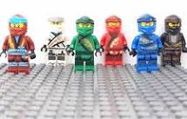  Ninjago Mini Figure Set $25 | 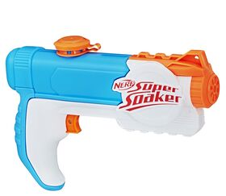  Super Soaker  $9 | 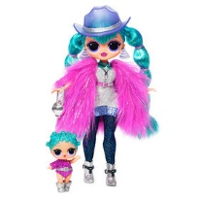  L.O.L Fashion Doll  $44 | 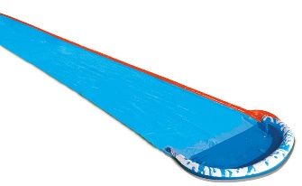  Speed Blaster Water Slide  $13
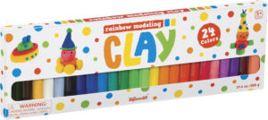  Rainbow Clay  $12 | 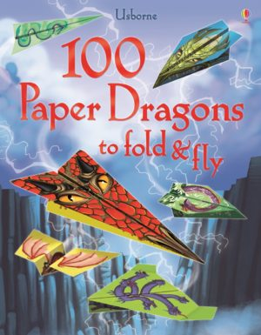  Paper Dragons Book  $10 | 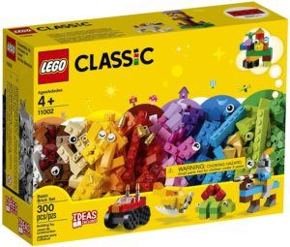  Lego Brick Set  $30 | 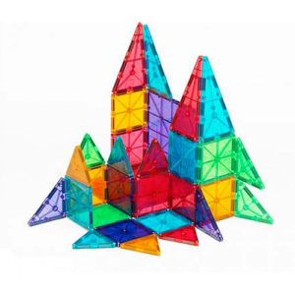  Magna Tiles  $58
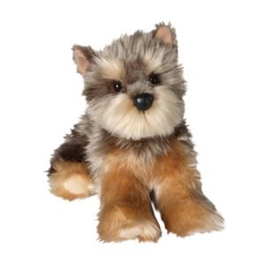  Dog Stuffie  $20 | 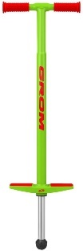  Pogo Stick  $76 | 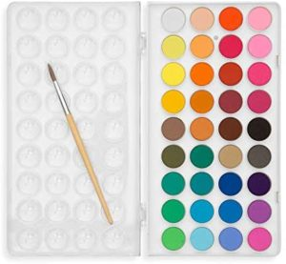  Watercolour Paint Set  $11 | 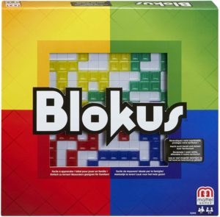  Blokus  $37

Pretend that you are going shopping in the store on the first page. There is no sales tax at this store.

Pick 2 items. What are they? How much will they cost in total?
Pick another 2 items. What are they? How much will they cost in total?
What is the most expensive item in the store?
What is the least expensive item in the store?
If you have $40, what could you buy? Could you buy more than one toy?
If you want to spend exactly $50, which items could you buy?

