Math – Lego Building Challenge – Buy Your Bricks

Let’s imagine that you don’t have any lego. If you want to build an interesting sculpture, you would have to buy any bricks that you need. Which bricks would you buy? What could you build?

Here are the prices:
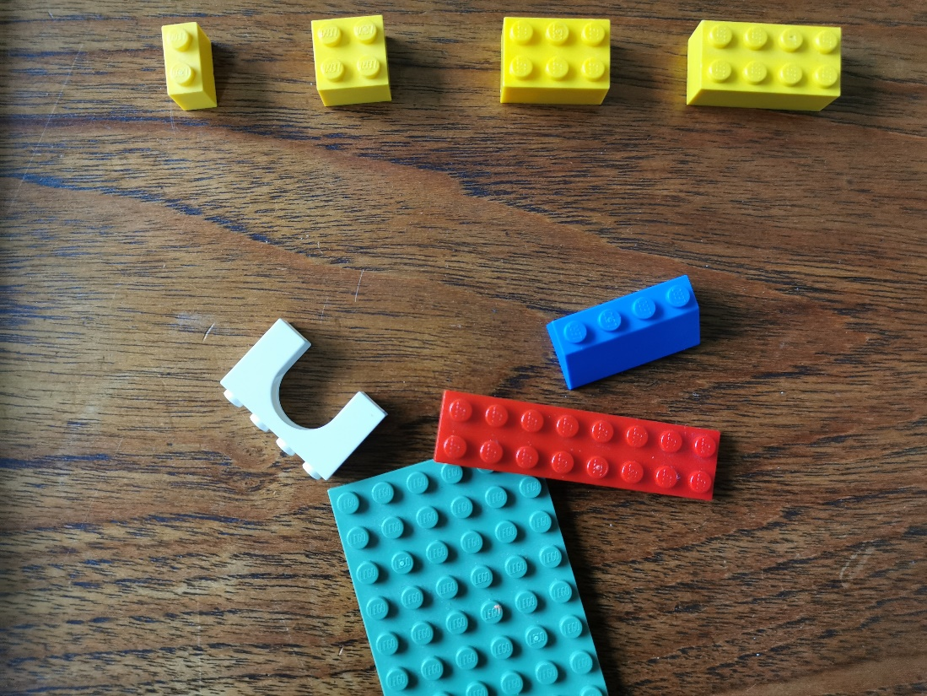

All other bricks
$6
Standard
4-stud brick
$2
Standard
2-stud brick
$1
Standard
6-stud brick
$3
Standard
8-stud brick
$4

What can you build if you have $20 to spend on bricks?
What can you build if you have $50 to spend on bricks?
What can you build if you have $100 to spend on bricks?

