Math – 100 Chart Coding

The goal of this task is to move from one point on the 100 chart to another by using coding. Remember, coding is specific step by step instructions.
Materials
- 10 playing cards (Ace to ten) or pieces of paper with the numbers 1 to 10 written on them
- a 100 chart – you can print one, use one that you made by yourself, or use one on your computer screen
- a game piece to move on your 100 chart (if you are using a paper 100 chart)

Step 1
To begin, you need to pick two cards. Take the numbers on your cards and make a 2-digit number. If you picked a 2 and 5, you could make 25 or 52. Choose one of those 2 digit numbers. This will be your starting number. Shuffle your cards, pick two cards again and make another number. This will be your ending number.
Example: My starting number will be 25 and my ending number will be 46.
Step 2
Put your game piece on the starting number. If you are doing this on the computer, you could put your mouse on the first number.
Step 3
Write the code to get your game piece from the starting number to the ending number but here are the rules: your game piece can only move one square at a time and can only understand the commands ‘add’ or ‘subtract’

Step 4
Get a family member to test your code. Did they get to the correct ending number?

Here is an example:
Starting number: 25
Ending number: 46

My Code
Add 10
Add 10
Add 1

Let’s test it.

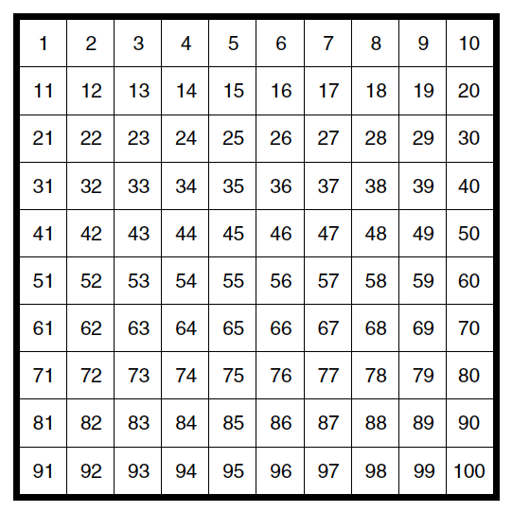

That one was pretty easy.
Try some numbers that are not quite so close together.
Try starting with a bigger number and ending with a smaller number.
Do this activity at least 5 times.

Next week, we are going to try doing this on a bigger game board and instead of using a game piece, you will use a human.

