Language Arts – Reader Response – Betty Bunny Wants Everything
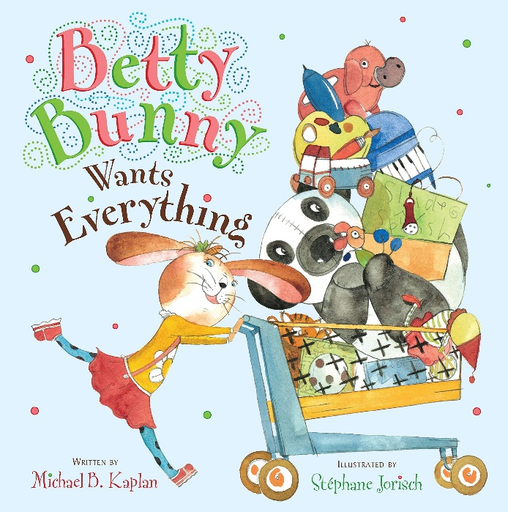

Please listen to the story, Betty Bunny Wants Everything, written by Michael Kaplan and illustrated by Stephanie Jorisch.

In the story, Betty Bunny goes to the toy store. She wants lots of toys but her mother tells her that she can’t have all of the toys that she wants. Can you make a connection to a time that you really wanted a toy or a treat but you were told that you couldn’t get it?

Draw a picture and describe what happened.

Tell someone in your family what you would have done if you were Betty Bunny’s parent in the story.

