**Core Competencies Self-Assessment**

Each year, students are asked to complete self-assessments of at least one core competency. In the classroom, we have conversations so that students understand the competency that they are assessing and we brainstorm examples of each competency.

The Core Competency fall into these categories:

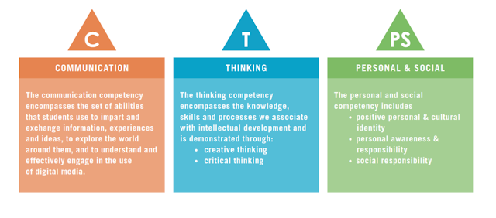

During June, I will ask the students to assess themselves using two of the Core Competencies. The goal is for students to learn to assess their own learning and progress when thinking about these broader categories of learning.

In the classroom, we usually ask students to draw a picture and/or write about the core competency. We also suggest to students that they can use photographs of their work to show a competency.

This week, we will look at the core competency of creativity. Creativity includes generating and developing new ideas. Students are asked to describe how they are creative. Here are some sample statements that a student might make:

* I get ideas when I play. My ideas are fun and make me happy.
* I can get new ideas or build on other people’s ideas.
* I build on other’s ideas and add new ideas of my own.
* I make my ideas work or I change what I am doing.

If your child would like to use photographs of their work to show their creativity, I would encourage you to look back at some of the projects that they did during our silly week, maker week, or art week.

The self-assessment sheet for creativity can be found here:

<http://sd41blogs.ca/mckennac/files/2020/06/Creativity.docx>

If your child prefers to use a photograph, please upload the photo to this Core Competency Self Assessment section of the student portfolio. 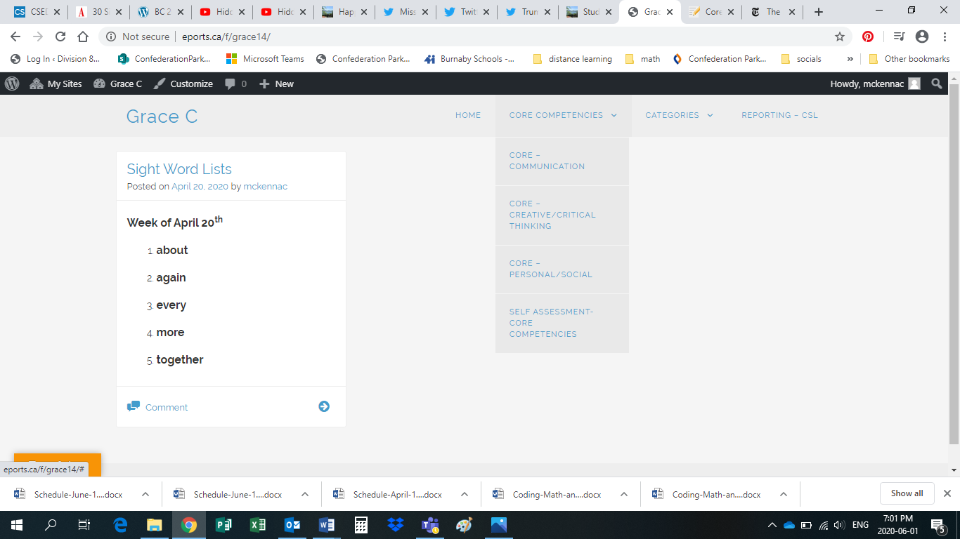

After you upload a photo, you can upload your child’s self-assessment in the comments section.

Or, you can send me the photo and your child’s writing by e-mail and I will upload it.