Art – Let’s Make Some Money
Here are some pictures of money from around the world.
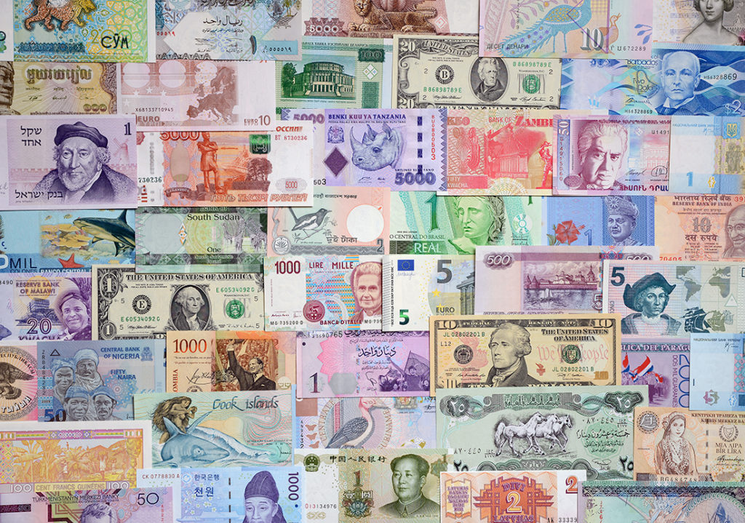
You may also have bills and coins from around the world.
What do you notice about the images and the colours?
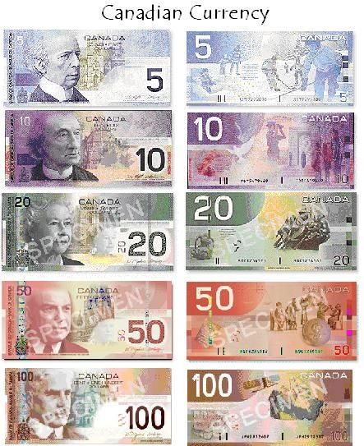
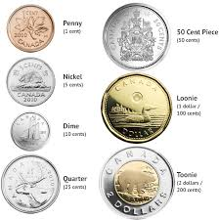
Here are some Canadian bills and coins.

Did you notice the faces on the bills? Usually, Canadian bills have the face of Queen Elizabeth or former Canadian prime ministers. Sometimes, the coins are used to honour Canadians who have done something important for our country.
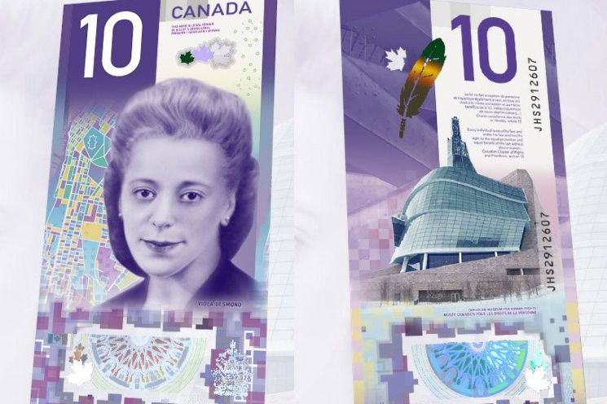
A few years ago, a bill was made for Viola Desmond. Here is a short video about her story.

Today, you are going to design your own money with your face on it. Let’s imagine that you do something amazing some day and they decide to put you on our Canadian money. What will it look like?
To make your money:
- Draw the front of the bill with a picture of you
- Draw the back of the bill – you can draw anything that you want on this side
- Colour the money – usually Canadian bills have one main colour but other bills my have more colours
- Add words – look at the pictures of money to decide what words you will need to include on your bill
- If you have time, design a coin

