Who Would Win Animal Project – Front Cover

Today, you are going to start working on making your Who Would Win Book. If you have not read one of these books or if you forget how they are organized, please take a look at this link which shows you an example.
You are going to start by making a cover for your book this week. Take a look at these covers to help you.
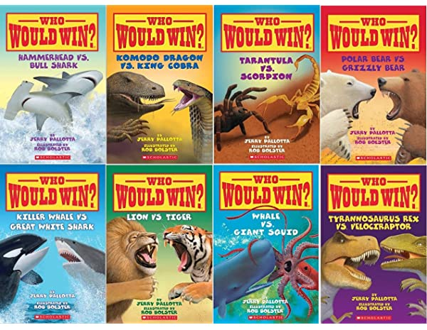
Your cover will need:
- Title – Who Would Win?
- Names of your two animals – Name of Canadian animal vs. African animal
- Name of author and illustrator – you
- Picture of each of your two animals

