Fitness Friday – Make Your Own Obstacle Course
Today, you are going to make an obstacle course for yourself. If you have somewhere to make it outside that would be great but you can make it inside as well.
Here are some pictures to give you ideas for your obstacle course.
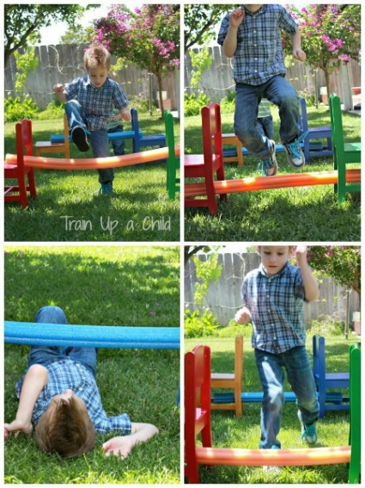

Source:http://www.learnplayimagine.com Source: Frugalfunf4boys.com

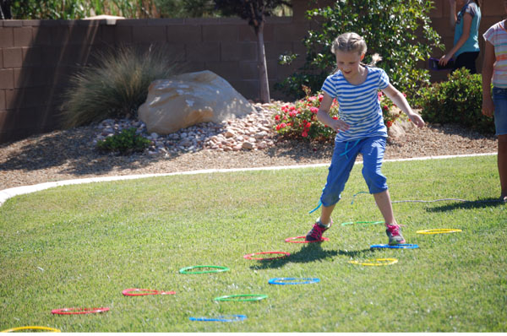

Source: onecreativemommy.com

Source: https://playtivities.com/obstacle-courses-for-kids/

How quickly can you get through the course?
How many times can you go around the course in five minutes?
Challenge a family member to a timed race. Have fun!

