**Nature School – Make Something**

Since it is Maker Week, you are going to make something in Nature School this week. During Nature School, students have built forts in the Gold Forest, made bird’s nests out of sticks, and made patterns and art using leaves and sticks. What will you make today?

Here are some ideas that you can think about:

Magic Nature Wands A tiny house for a _____________?

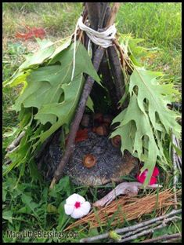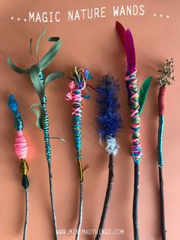

Or come up with your own ideas.