**Math – Making 100**

Last week, Marlon showed me a math tool that he has at home. He uses it to practice making bigger numbers like 100 and 200. Today, you are going to work on making 100.

Here is a picture (thanks to Marlon’s mom for sending it).

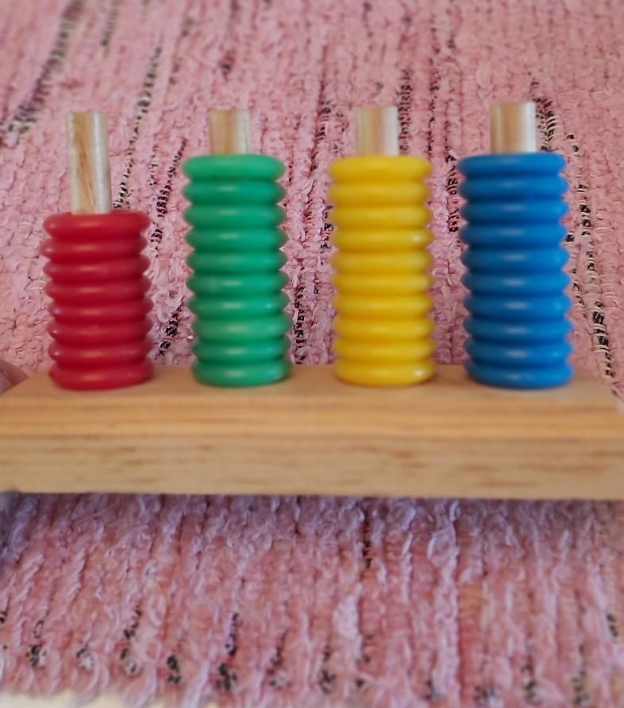This is it works:

Red = 50

Green = 20

Yellow = 10

Blue = 1

Using crayons or pencils, draw as many different ways as you can to show how you can make 100 using the different coloured rings.

Here is an example:

How many of your own examples can you make?