Math – Make Your Own Scale
When we measure, we are comparing. We can find things that are shorter or longer. We can also find things that are lighter or heavier. When we are measuring things that are lighter/heavier, we are measuring mass. Sometimes we call this weight but scientists and mathematicians call it mass.
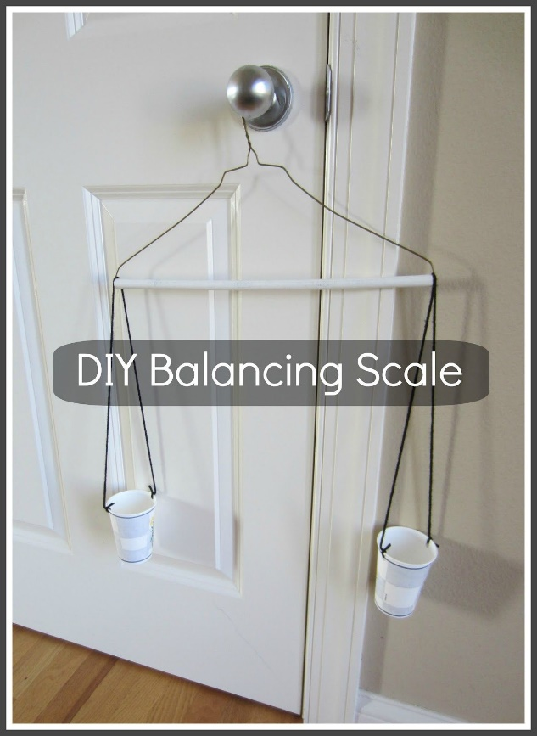
Today, you are going to create a balance scale to compare the mass of items in your house.
Start by making your scale.
You will need:
            - A clothing hanger
            - String or yarn
            - Two containers that are the same size
Use the picture to show you how to create your scale.

Once you have created your scale, choose an object that will you will use to compare. Put it on one side of the scale. Now find objects that are:, lighter, same, and heavier than your object. You could make a table.
Object:
Lighter | Same | Heavier

