Math – Castle Towers
The setting that was chosen for our class story was a castle. So today, you are going to work on a castle math activity.
Here is your task:
- Design a castle that has more than one tower
- You will have a number of floors to share between the towers
- Each tower must have a different number of floors in it (see example below)

I will use the number 6 as an example.
I have 6 floors to share between my towers.
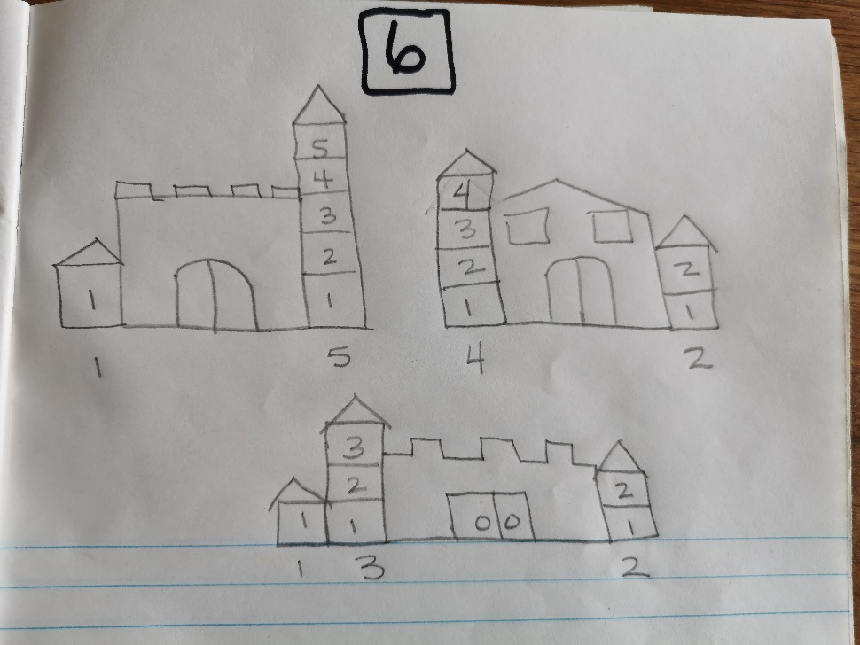
My combinations were:
1,5
4,2
1,3,2
Can you see any combinations that I missed?
3,3 would have looked nice but the task is to put a different number of floors in each tower.

Now it is your turn.
Pick a number that is greater than 6 and try it yoursef. Don’t make the number too big though.

How many different ways can you share your number between the towers?

More information about this activity can be found at: https://mathpickle.com/muse_6/

