Math – How Many?
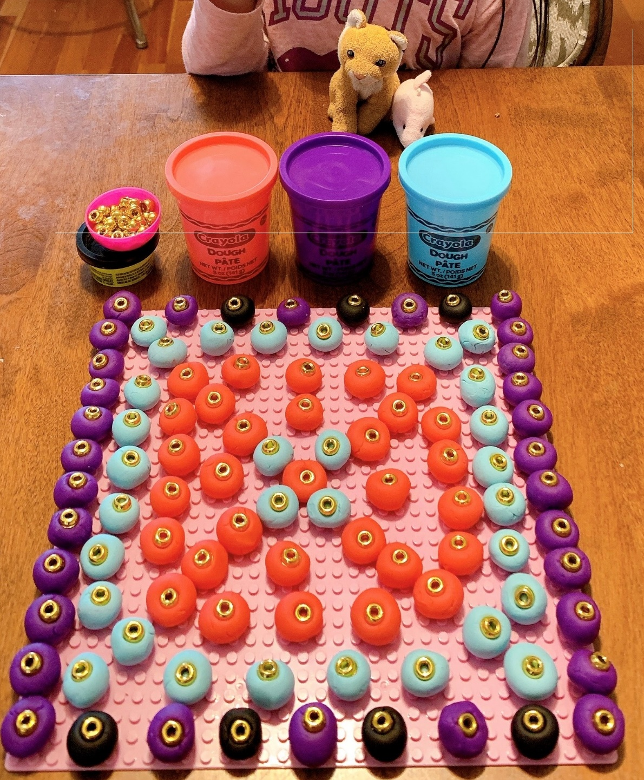
Look at Lila’s creation.

Look at this picture and think about the question: How many?
Try to list all of the things that can be counted.
Now count them.

