Language Arts – Creating Instructions
When you are making something you often need to follow instructions. The instructions might be in the form of pictures like origami instructions or instructions for how to build a book shelf.
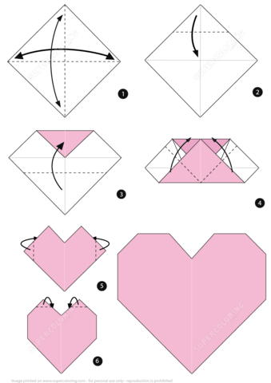
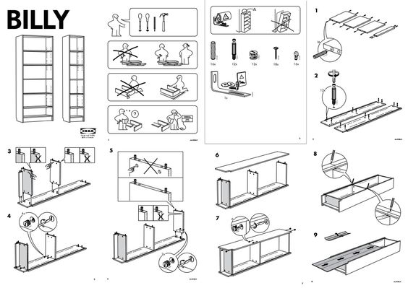

Instructions can also be written in words. A recipe is a set of instructions. When you play a board game, there are written instructions that teach you how to play.
Today, you are going to create instructions that explain how to do something.
- You can choose anything that you want. It can be something serious or something silly.
- You can use pictures or words or both for your instructions.
- Your instructions should be numbered.

We will try an example of this in our class meeting on Wednesday.

