Language Arts – Silly Super Heroes
Most Super Heroes have serious super powers. Match the superheroes below to their powers.
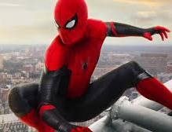
Incredible power to stretch

Able to stick to walls

Power to shrink and grow

Strength and indestructibility

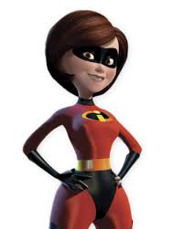
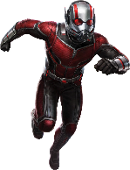

Now, it is time to create your own super hero,
BUT your superhero is going to have a silly super power.
What could that silly super power be?
Maybe your superhero has the power to make people giggle uncontrollably.
What other silly super powers can you think of?
When you have chosen a silly super power, you could:
- Give you silly super hero a name
- Draw your super hero in their superhero suit
- Make a comic strip or story about your superhero

Note: This is a writing activity that you can work on for a few days.

