Coding – Lego Coding Challenge

This coding activity is like the robot drawing activity from yesterday. This time you are going to make a lego sculpture and then try to ‘code’ a family member to create the same sculpture by giving them specific instructions.

Here are your instructions:
- Create two piles of lego that are the same. Each pile should have about 10 blocks and there should be a few different kids of blocks.
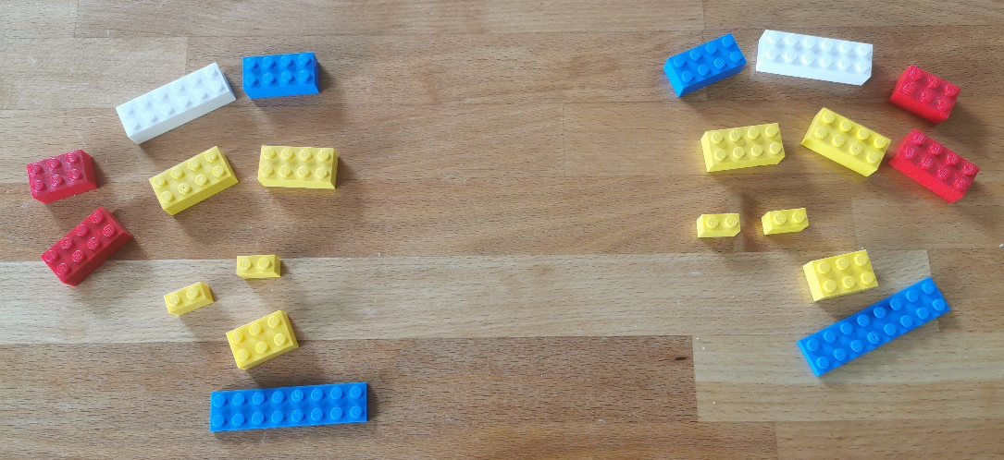
- Build a sculpture using 5 – 10 of the blocks depending on how difficult you want to make the challenge. Don’t let your partner see the sculpture – keep it hidden.
- Sit in a way that you can’t see what your partner is doing and that they can’t see your sculpture. (sit back to back or hide your sculptures behind something)
- Give your partner instructions to build a copy of your lego sculpture. Remember to be very specific. You can’t just say “take the yellow block and put it on the red block” if there are different sized yellow and red blocks.
- Remind your robot that they are not allowed to ask questions, they can just ask you to repeat instructions.
- When you are finished compare your sculptures. Take a picture.
- Now your partner can make a secret sculpture and try to get you to make it by giving you instructions.

For an extra challenge, try writing down your instructions.

